WFH Attendance & Employee Monitoring System
Product Requirements Document and Technical Specification


Dexa Group Software Engineer Technical Assessment
Author: Abdurrahman Khairi
Version 1.1, November 2026
© 2026 Abdurrahman Khairi. All Rights Reserved. Created strictly for Technical Assessment evaluation.

TABLE OF CONTENTS

TABLE OF CONTENTS 2
CHAPTER I DOCUMENT CONTROL AND COPYRIGHT POLICY 8
1.1 Intellectual property policy 8
CHAPTER II ENGINEERING PROLOGUE 9
2.1 Radical honesty and professional integrity 9
2.2 AI collaborative engineering 9
2.3 Research origin: Quora, Reddit and two practitioners 10
CHAPTER III BACKGROUND, PROBLEM STATEMENT, GOALS AND NON GOALS 11
3.1 Background and problem statement 11
3.2 Product and business goals 11
3.3 Non goals 12
CHAPTER IV USER PERSONAS, RBAC AND GLOBAL ASSUMPTIONS 13
4.1 SYSTEM_ADMIN: platform custodian 13
4.2 HR_ADMIN: workforce administrator 13
4.3 MANAGER: department head 13
4.4 EMPLOYEE: staff 14
4.5 Global assumptions 14
4.6 RBAC enforcement 14
4.7 RBAC permission matrix 15
CHAPTER V ARCHITECTURAL TOPOLOGY AND TECH STACK 16
5.1 Frontend presentation tier 17
5.2 API gateway and ingress tier 17
5.3 Internal TCP microservices tier 18
5.4 AI biometrics and infrastructure tier 18
CHAPTER VI FEATURE SPECIFICATIONS AND THE 12 END TO END FLOWS 20
6.1 Where the brief and the code differ 20
6.2 Master feature summary 21
6.3 Feature 1: Authentication, RBAC and 6 Digit Email OTP 22
6.3.1 Feature analysis and business goals 22
6.3.2 User and operational assumptions 22
6.3.3 Codebase function and module breakdown 22
6.3.4 End to end technical flow 23
6.3.5 Scope and current technical limitations 24
6.3.6 Future improvements 25
6.4 Feature 2: Biometric Face Enrollment with ArcFace Embeddings of 512 Dimensions 25
6.4.1 Feature analysis and business goals 25
6.4.2 User and operational assumptions 25
6.4.3 Codebase function and module breakdown 25
6.4.4 End to end technical flow 26
6.4.5 Scope and current technical limitations 28
6.4.6 Future improvements 29
6.5 Feature 3: Daily WFH Notice, Upward Escalation and Biometric Clock In 29
6.5.1 Feature analysis and business goals 29
6.5.2 User and operational assumptions 29
6.5.3 Codebase function and module breakdown 30
6.5.4 End to end technical flow 30
6.5.5 Scope and current technical limitations 33
6.5.6 Future improvements 33
6.6 Feature 4: Authoritative Server Timestamp and Anti Clock Tampering 33
6.6.1 Feature analysis and business goals 33
6.6.2 User and operational assumptions 33
6.6.3 Codebase function and module breakdown 34
6.6.4 End to end technical flow 34
6.6.5 Scope and current technical limitations 36
6.6.6 Future improvements 36
6.7 Feature 5: Clock Out, Working Duration, Punctuality and 1/173 Overtime 36
6.7.1 Feature analysis and business goals 36
6.7.2 User and operational assumptions 36
6.7.3 Codebase function and module breakdown 37
6.7.4 End to end technical flow 37
6.7.5 Scope and current technical limitations 39
6.7.6 Future improvements 39
6.7.7 Formulas used by the code 39
6.8 Feature 6: Leave, Sick, Overtime and Correction Requests with Direct Links 39
6.8.1 Feature analysis and business goals 39
6.8.2 User and operational assumptions 40
6.8.3 Codebase function and module breakdown 40
6.8.4 End to end technical flow 40
6.8.5 Scope and current technical limitations 41
6.8.6 Future improvements 42
6.9 Feature 7: Master Employee Management, Mandatory NIP and Soft Delete 42
6.9.1 Feature analysis and business goals 42
6.9.2 User and operational assumptions 42
6.9.3 Codebase function and module breakdown 42
6.9.4 End to end technical flow 42
6.9.5 Scope and current technical limitations 44
6.9.6 Future improvements 45
6.10 Feature 8: Dual Dashboards and the Photo Lightbox 45
6.10.1 Feature analysis and business goals 45
6.10.2 User and operational assumptions 45
6.10.3 Codebase function and module breakdown 45
6.10.4 End to end technical flow 45
6.10.5 Scope and current technical limitations 48
6.10.6 Future improvements 48
6.11 Feature 9: XLSX, CSV and Printable Export 48
6.11.1 Feature analysis and business goals 48
6.11.2 User and operational assumptions 48
6.11.3 Codebase function and module breakdown 48
6.11.4 End to end technical flow 49
6.11.5 Scope and current technical limitations 50
6.11.6 Future improvements 50
6.12 Feature 10: Hierarchical File Storage 51
6.12.1 Feature analysis and business goals 51
6.12.2 User and operational assumptions 51
6.12.3 Codebase function and module breakdown 51
6.12.4 End to end technical flow 51
6.12.5 Scope and current technical limitations 52
6.12.6 Future improvements 52
6.13 Feature 11: Database Studio 52
6.13.1 Feature analysis and business goals 52
6.13.2 User and operational assumptions 52
6.13.3 Codebase function and module breakdown 53
6.13.4 End to end technical flow 53
6.13.5 Scope and current technical limitations 54
6.13.6 Future improvements 55
6.14 Feature 12: Developer Support with Targeted SMTP Routing 55
6.14.1 Feature analysis and business goals 55
6.14.2 User and operational assumptions 55
6.14.3 Codebase function and module breakdown 55
6.14.4 End to end technical flow 56
6.14.5 Scope and current technical limitations 58
6.14.6 Future improvements 58
CHAPTER VII DATA ARCHITECTURE AND DATABASE SCHEMA 59
7.1 users 61
7.2 employees 61
7.3 departments 62
7.4 attendances 62
7.5 attendance_requests 64
7.6 Other tables 65
CHAPTER VIII REST API AND INTERNAL MESSAGE CONTRACTS 66
8.1 Authentication and onboarding (employee service) 66
8.2 Employees, biometrics and access requests 66
8.3 Attendance and requests (attendance service) 67
8.4 System, policy, support and Database Studio 68
8.5 Biometric service (FastAPI, internal) 69
CHAPTER IX NON FUNCTIONAL REQUIREMENTS, SECURITY AND LIMITATIONS 71
9.1 Performance targets 71
9.2 Security safeguards in place 71
9.3 Core system limitations 72
9.4 Known defects found during this review 72
CHAPTER X DEPLOYMENT ARCHITECTURE AND ROADMAP 75
10.1 Current scope: local execution only 75
10.2 Evaluation entry points 75
10.3 Seeded evaluation accounts 76
10.4 Future deployment roadmap 76
CHAPTER XI LOCAL INSTALLATION WALKTHROUGH 78
11.1 Scope and Architecture 78
11.1.1 Local Assessment Scope 78
11.1.2 The Six Components and Their Ports 78
11.2 Prerequisites and a Zero State Check 80
11.2.1 Step 1: Check Tool Versions 80
11.2.2 Step 2: Look at the project folder 81
11.2.3 Step 3: Make sure the ports are free 82
11.3 Environment Files 84
11.3.1 Copy the Templates 84
11.3.2 Environment Variable Reference 86
11.3.3 SMTP Email Options 89
11.3.4 Emails the System Sends 90
11.4 Method A, Docker Compose (Recommended) 92
11.4.1 Before Start: The Face Model 92
11.4.2 Step 1: Build and Start All Containers 92
11.4.3 Step 2: Check the Containers and their Ports 93
11.4.4 Step 3: Watch the Face Model Load 94
11.4.5 Step 4: Database Tables and Seed Accounts 94
11.5 Method B, Manual Local Installation 96
11.5.1 Step 1: Start MySQL Only 96
11.5.2 Step 2: Python Environment and The Face Engine 97
11.5.3 Step 3: Install and Start the NestJS Backend 99
11.5.4 Step 4: Install and Start the React Frontend 100
11.6 Check the Installation in the Browser 102
11.6.1 Step 1: Biometric Engine Swagger Page 102
11.6.2 Step 1.5: One to One Face Check Against the Engine 102
11.6.3 Step 2: API Gateway and The Microservice Links 104
11.6.4 Step 3: Real Email Delivery 105
11.6.5 Step 4: The Portal Sign In Page 105
11.6.6 Step 5: First sign in with a seeded account 105
11.6.7 Step 6: The Uploads Folder on Disk 107
11.7 Troubleshooting and Maintenance 108
11.7.1 The Camera Does Not Open 108
11.7.2 The Face Model is Slow or Missing 108
11.7.3 Duplicate Face Prevention and Sibling Exemption 108
11.7.4 Real Email Does Not Arrive 109
11.7.5 Face Enrollment Returns 409 Conflict 110
11.7.6 A Port is Already Taken 111
11.7.7 Useful reset and maintenance commands 111

CHAPTER I
DOCUMENT CONTROL AND COPYRIGHT POLICY
Field | Value
Project | WFH Attendance & Employee Monitoring System (Dexa Group Fullstack Technical Assessment)
Author | Abdurrahman Khairi
Document type | Product Requirements Document and technical specification
Status | Final. Describes the code in the repository as of 10 November 2026.
Repository layout | frontend/ (React 18), backend/ (NestJS monorepo with three apps), biometric-service/ (Python FastAPI), docker-compose.yml
Companion documents | Installation Guide WFH System Dexa Group_Abdurrahman Khairi.docx and User Manual WFH System Dexa Group_Abdurrahman Khairi.docx in the repository root. Chapter XI of this document repeats the installation walkthrough.
Copyright | © 2026 Abdurrahman Khairi. All Rights Reserved. Created strictly for Technical Assessment evaluation.

Intellectual property policy
- All Rights Reserved. The software is not open source. No MIT, Apache, GPL or other license is granted. Both backend/package.json and frontend/package.json declare "license": "UNLICENSED" and "author": "Abdurrahman Khairi".
- Source watermark. Every .ts, .tsx and .css source file opens with a five line copyright header that forbids commercial use, modification and distribution.
- Visible watermark. Every screen in the portal, including the sign in pages, modals and the print view, shows the footer: "© 2026 Abdurrahman Khairi, Created strictly for Technical Assessment evaluation. Unauthorized commercial use is prohibited".
- Photo watermark. Every attendance photo carries a copyright line burned into its pixels by the browser before upload.

CHAPTER II
ENGINEERING PROLOGUE

Radical honesty and professional integrity
This project is presented as what it is: a working enterprise prototype built for a demanding technical assessment. It is not dressed up as a finished commercial product, and it does not pretend to be flawless. Every feature described here runs in the repository today, and every gap that exists is written down in this document next to the feature it affects.
That choice is deliberate. A reviewer gains more from a system whose limits are mapped honestly than from one whose limits are hidden. Section 9.4 lists seventeen defects found while this PRD was checked against the code, one of which has since been fixed, from a guard that lets HR admins open the Database Studio to a date box that files a morning WFH notice for the wrong day. Each one names the file where it lives. An engineer who can find, explain and own the weak points of their own system is an engineer a team can trust with production code.

AI collaborative engineering
Abdurrahman Khairi acted as lead architect and systems engineer on this project. The author chose the architecture (an HTTP gateway in front of two TCP microservices and a Python biometric sidecar), set the business rules, defined the acceptance criteria, tested edge cases by hand and decided what shipped.
The author built the system in close partnership with two AI engineering agents, Antigravity and Claude Code. The agents worked as fast, well read collaborators: they drafted code to the specification the author set, proposed alternatives, reviewed diffs, chased down bugs and helped write documentation. They did not replace engineering judgment. Decisions about trade offs, such as running face matching inside the attendance service instead of the Python service, keeping the official clock on the server, and routing a manager's own requests upward to HR, were made by the author after discussing the options.
This document itself was produced the same way. The agents read the actual source files and cross checked every endpoint, column, constant and formula, and the author reviewed the result. Where the original brief and the code disagreed, the code was treated as the source of truth.

Research origin: Quora, Reddit, Senior R&D and Corporate Staff Interviews
Coding started only after a research phase. The author studied real discussions about remote work on Quora and Reddit, looking for the ways attendance systems fail in practice. Four patterns came up again and again:
- Buddy punching and photo reuse. Colleagues clocking in for each other, or one good selfie reused for weeks.
- Device clock manipulation. Staff moving the laptop clock back a few minutes to turn a late arrival into an on time one.
- Approval fatigue. Managers buried in emails, hunting through tables to find the one request they are meant to approve.
- Managers approving themselves. Department heads whose own WFH days nobody above them ever sees.
The author then tested these findings in direct conversations with a Senior R&D Engineer and a regular corporate staff member. They provided practical, on-the-ground insights into how employees actually experience working from home, morning WFH reporting, task accountability, attendance correction disputes, and the Indonesian 1/173 overtime convention. Their input shaped specific features:
Finding from research | Feature it produced
People change the device clock | Official clock in and clock out times come only from new Date() on the server (Feature 4)
Old photos get reused | EXIF capture time checks for uploads, plus SHA-256 and perceptual hash duplicate rejection (Features 3 and 4)
Managers approve their own WFH | Upward escalation: a manager's request goes to HR, with the System Admin in copy (Feature 3)
Approvers cannot find the request | Every request email carries a direct link that opens the exact request in the approval page (Feature 6)
Payroll needs overtime pay, not raw minutes | Automatic overtime pay using the 1/173 hourly rate with 1.5x and 2x multipliers (Feature 5)

CHAPTER III
BACKGROUND, PROBLEM STATEMENT, GOALS AND NON GOALS

Background and problem statement
Working from home creates verification and administrative problems that office attendance never had. The system was built around five of them:
# | Problem | How the system answers it
P1 | Unverified remote presence: people log attendance with no proof that they are who they say they are. | 1:1 face verification against an enrolled ArcFace embedding of 512 dimensions, browser liveness challenges (blink, turn left, turn right, hold front) and duplicate photo rejection.
P2 | Client clock manipulation: users move the laptop clock to hide a late arrival. | clock_in_time and clock_out_time are set only by the server (new Date() in attendance.service.ts).
P3 | The morning work plan and the attendance record live in different places. | Clock in requires an approved WFH request for the day and a written daily plan. Clock out requires a written daily accomplishment.
P4 | Slow approvals: managers search tables by hand to find leave, sick and correction requests. | One attendance_requests pipeline, email routing to the right approver, a direct link to the request, and automatic attendance updates on approval.
P5 | Photo proofs pile up on disk with random names, which slows HR audits. | Every file lands in uploads/<year>/<department>/<role>/<person>/<MM-month>/ with a readable name.

Product and business goals
ID | Goal | Status in the code
G1 | 1:1 facial verification with InsightFace ArcFace embeddings of 512 dimensions. | Implemented. The match threshold in the code is a similarity of 0.45.
G2 | Server authoritative timestamps and permanent Canvas watermarks. | Implemented.
G3 | Automatic work duration, punctuality and 1/173 overtime pay. | Implemented. Overtime starts after 540 minutes of work, with no break deduction.
G4 | One click approvals from email for managers and HR. | Implemented as a link to /manager/approvals?requestId=<uuid> that needs a normal sign in.
G5 | Meet the assessment stack: NestJS, MySQL 8.0 and TCP microservices; React 18 with custom components, dynamic filters and exports; Python FastAPI biometrics. | Implemented.

Non goals
- Live cloud production deployment. The system runs locally for assessment (Section 10).
- Multi shift or 24 hour rotating schedules. One corporate shift is assumed.
- 3D infrared liveness hardware. Liveness here is a 2D browser heuristic.
- Full payroll processing (PPh 21 income tax, BPJS contributions, payslips). The system produces payroll ready data only.
- Push channels (WebSockets), caches (Redis), message brokers and object storage. None of these are part of this version.

CHAPTER IV
USER PERSONAS, RBAC AND GLOBAL ASSUMPTIONS

The UserRole enum in libs/common/src/constants/enums.ts defines four roles. The role sits on users.role, and each user links to at most one employees row.

SYSTEM_ADMIN: platform custodian
- Seed account sysadmin@dexagroup.com (Abdurrahman Khairi, NIP DEXA-SYS-001).
- Owns the Database Studio (/system/database), company policy, and receives every support ticket as the To recipient. Can also open the HR dashboards, monitoring, employee records and approvals, because RolesGuard lets this role through every role check.
- Separation of duties. The System Admin cannot clock in or clock out: the gateway returns 403 on both routes, and the frontend sends this role away from /employee/*, /dashboard and /auth/enroll-face with a "Separation of Duties" message. The person who can edit any database row should not also be producing attendance records that feed payroll. That is why the role skips face enrollment too.
- Assumption: technically literate and comfortable editing raw rows.

HR_ADMIN: workforce administrator
- Seed account admin.hrd@dexagroup.com (HR Admin One, DEXA-2026-001).
- Runs employee records with soft delete and restore, reviews onboarding requests, uses the HRD dashboard, the monitoring page with the photo lightbox, exports, approvals for every department and company policy. Receives support tickets in Cc.
- Has an employee record, so HR admins enroll a face and clock in like any other staff member.
- Assumption: needs fast visual audits and spreadsheet exports for payroll cut offs.

MANAGER: department head
- Seed accounts manager.it@dexagroup.com (Manager One, IT & Digital Innovation) and manager.finance@dexagroup.com (Manager Two, Finance & Accounting). Both are created on the second start of the employee service.
- Reviews requests from their own department at /manager/approvals. The backend filters manager queries to the manager's department.
- Their own requests escalate upward: To the HR PIC, Cc the System Admin, the HR PIC and the manager.
- Assumption: a busy approver prefers a link in an email to hunting through menus.

EMPLOYEE: staff
- Seed accounts employee.one to employee.four@dexagroup.com. Employee Four starts unverified to show the first sign in flow.
- Enrolls a face once, sends WFH notices, clocks in and out with a live photo, reads a personal dashboard and history, submits leave, sick, overtime and correction requests, and contacts the developer.
- Assumption: a laptop or desktop browser with a webcam, or a phone photo with intact EXIF data for the upload fallback.

Global assumptions
- Everyone works in Asia/Jakarta time (WIB, UTC+7). APP_TIMEZONE = 'Asia/Jakarta' drives every date calculation.
- One attendance record per employee per WIB calendar day, enforced by the unique index UQ_attendance_employee_date.
- The company default is work from office with a WFH quota (1 day a week by default). WFH must be requested or noticed for each day.
- Department routing uses the department name stored on the employee, plus the manager and HR emails stored on departments.

RBAC enforcement
Layer | Mechanism | Behaviour
Gateway authentication | JwtAuthGuard | Verifies the Bearer token (HMAC HS256 through @nestjs/jwt), requires tokenType === 'access' and fills req.user.
Gateway authorization | RolesGuard with @Roles(...) | Passes when no roles are listed, when the role is listed, or when the user is SYSTEM_ADMIN or HR_ADMIN. The last rule is the cause of defect D1.
Service scoping | attendance-service | Manager queries for lists, summaries, exports and reviews are filtered to the manager's department.
Frontend routing | ProtectedRoute.tsx | Sends guests to /login, forces face enrollment, keeps the System Admin out of employee pages, and lets admins pass allowedRoles.

RBAC permission matrix
Capability | SYSTEM_ADMIN | HR_ADMIN | MANAGER | EMPLOYEE
Sign in, profile, change password | Yes | Yes | Yes | Yes
Face enrollment, clock in, clock out | No (blocked) | Yes | Yes | Yes
Submit WFH, leave, sick, overtime and correction requests | Yes (API) | Yes | Yes | Yes
Review requests | All | All | Own department | No
HRD dashboard, audit log, export | Yes | Yes | Own department (API) | No
Employee CRUD and onboarding review | Yes | Yes | No | No
Sibling biometric exemption | Yes | Yes | No | No
Company policy update | Yes | Yes | No | No
Database Studio | Yes | Reachable (defect D1) | No | No
Contact Developer | Yes | Yes | Yes | Yes
Resolve support tickets | Yes | Yes | No | No

CHAPTER V
ARCHITECTURAL TOPOLOGY AND TECH STACK

The system has four tiers and six containers. The browser talks only to nginx. nginx forwards API calls and photo URLs to the gateway. The gateway is the only HTTP entry to the backend: it calls the two microservices over NestJS TCP transport and the face engine over HTTP. Email leaves the system through an external SMTP provider, Gmail or Outlook, which is not a container.
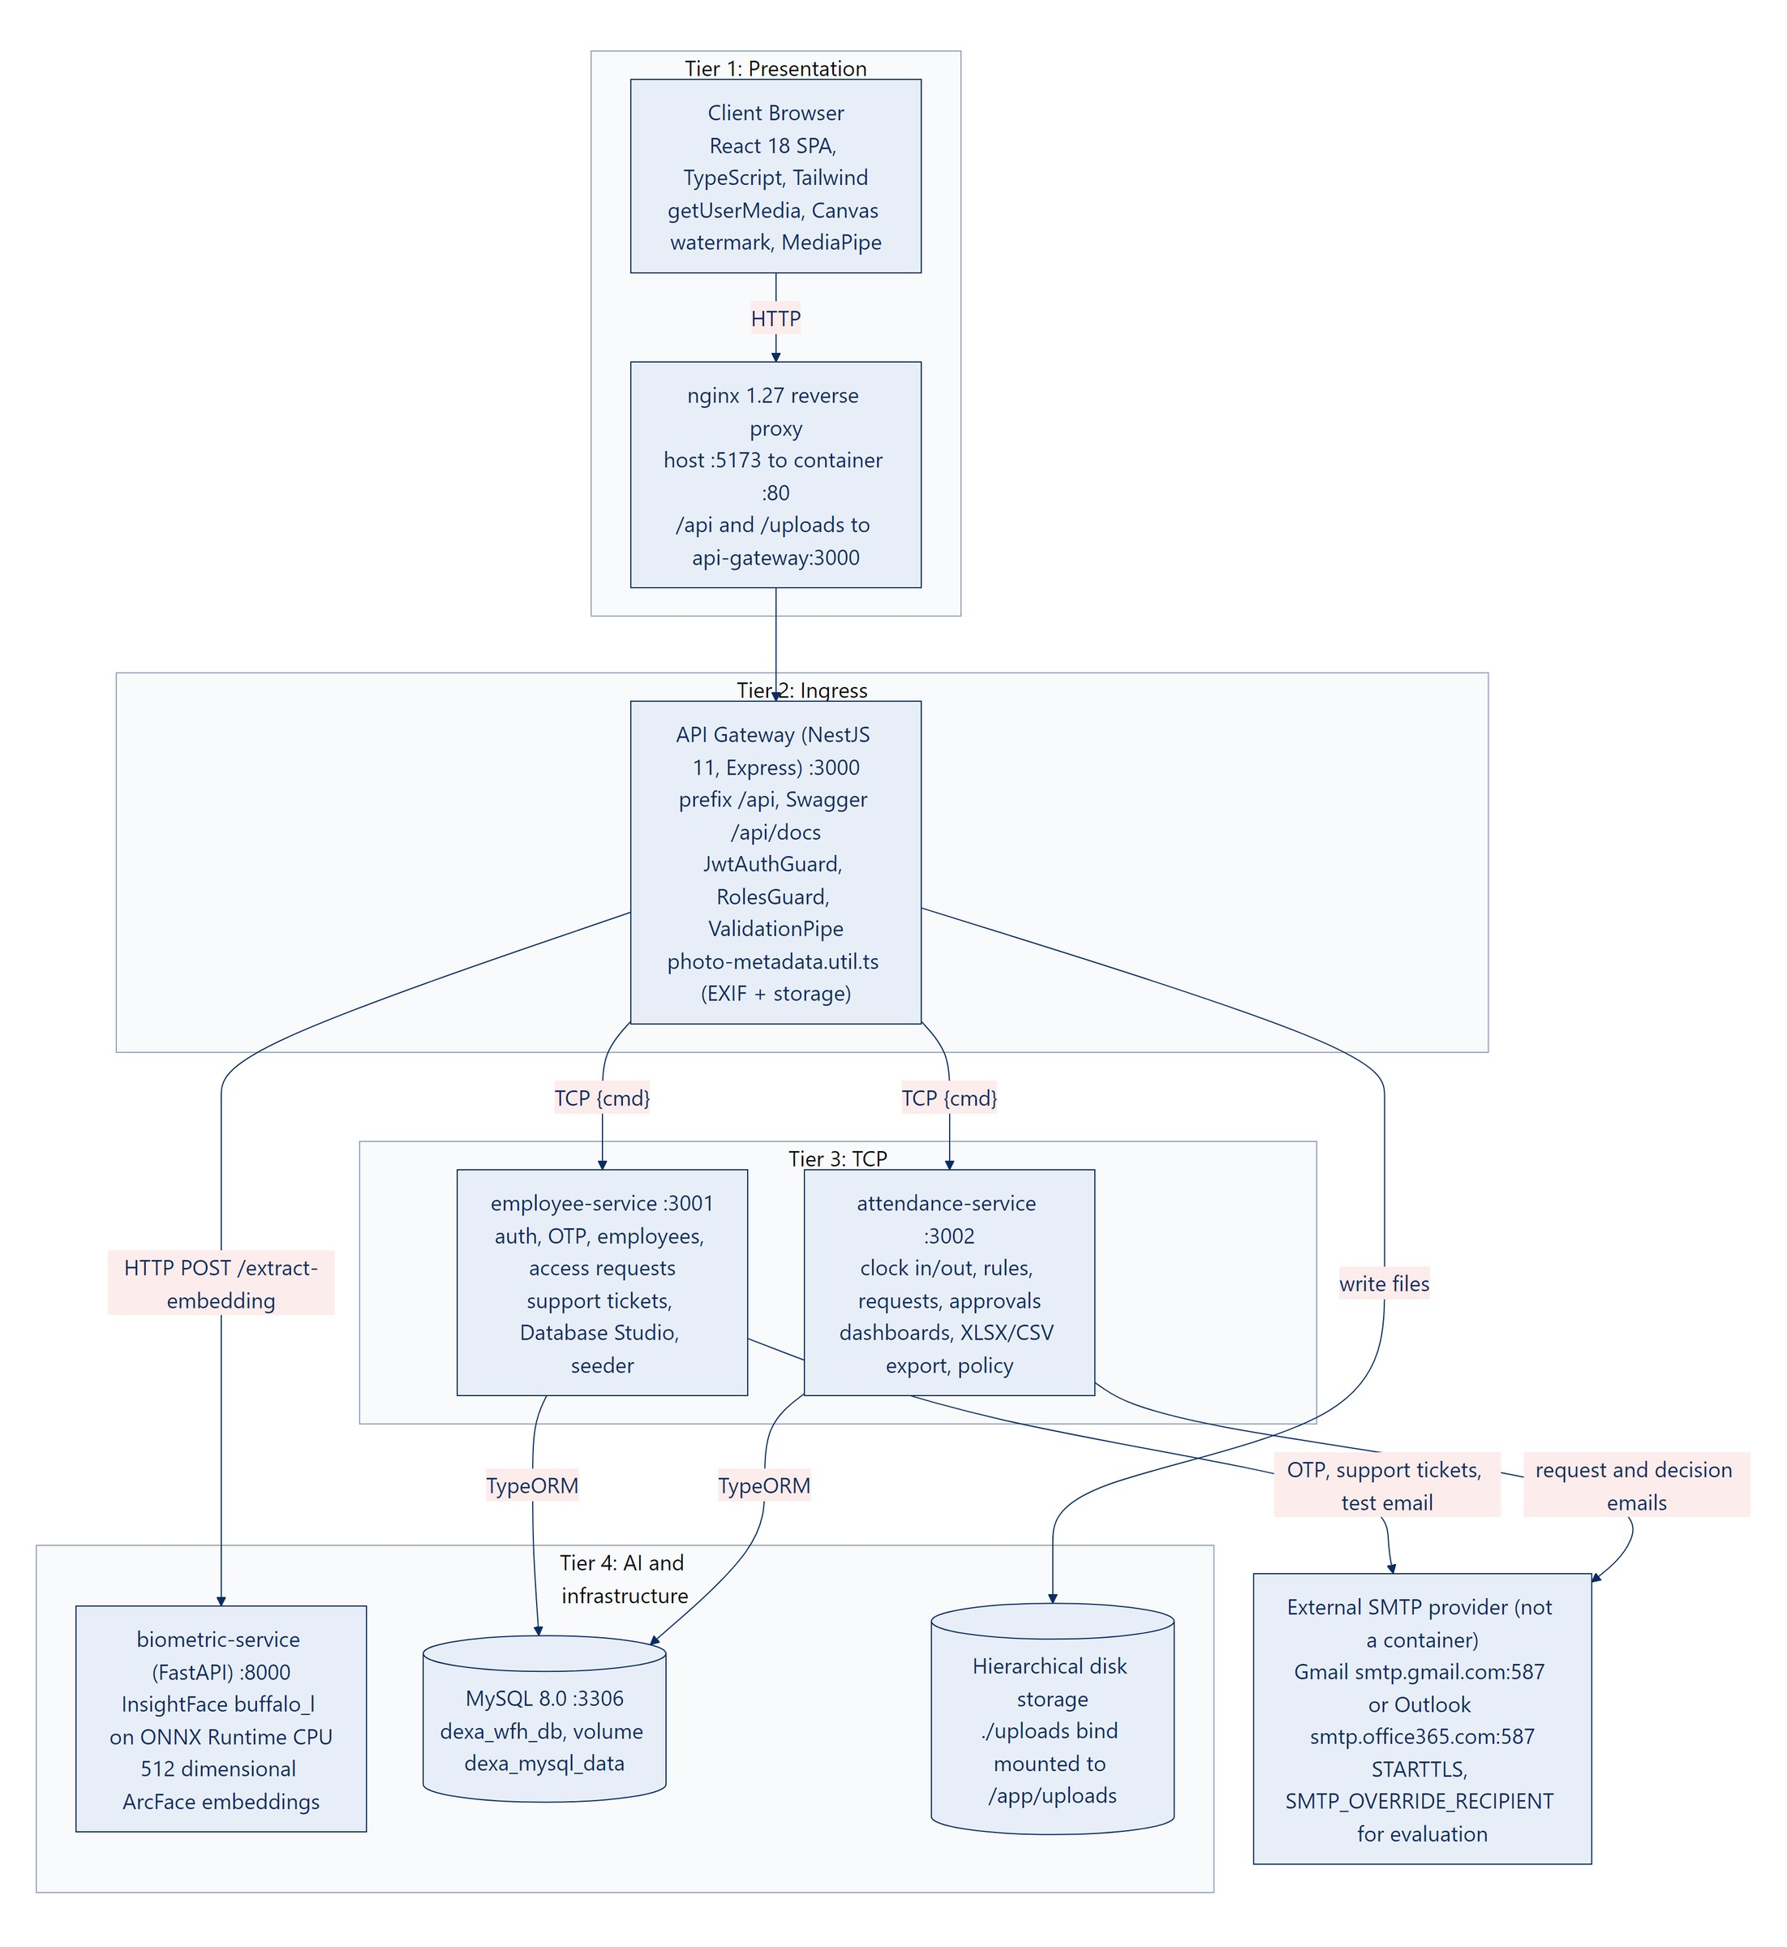
Figure 5.1: System architecture topology: four tiers, six containers, the external SMTP provider and the disk store.

Frontend presentation tier
Concern | Implementation
Framework | React 18.3, TypeScript 5.6, Vite 5.4, React Router 6. Only six runtime libraries: react, react-dom, react-router-dom, axios, lucide-react, @mediapipe/tasks-vision. Charts are built by hand from div elements.
Serving | A multi stage Dockerfile builds with Node 22 and serves with nginx:1.27-alpine on port 5173. nginx.conf proxies /api/ and /uploads/ to api-gateway:3000 and falls back to index.html. In development, vite.config.ts proxies the same paths.
Theme | Tailwind CSS 3.4 with class based dark mode. Corporate navy #0A2D62 for the sidebar and dark surfaces, Dexa red #D32F2F for accents in the white light theme. The choice is saved in localStorage (dexa_wfh_theme).
Typography | IBM Plex Sans for text, IBM Plex Mono for code. tabular-nums on the live clock, timestamps, NIP badges, Rupiah amounts and OTP boxes so digits do not jump.
HTTP client | src/api/client.ts: Axios with a 20 second timeout. A request interceptor adds the Bearer token. On a 401 the response interceptor calls POST /auth/refresh once, stores the new token pair and replays the request.
Notifications | Two channels for every action. A toast in the bottom right corner (green, red or blue, at most four at once), and the same message in the header Notification Center (kept in localStorage, capped at 40, with unread state). Every message has a where, what and why part, written without square brackets.
Hardware APIs | navigator.mediaDevices.getUserMedia (1280x720 ideal), Canvas 2D watermarking, MediaPipe FaceLandmarker served locally from /mediapipe/, optional geolocation.

API gateway and ingress tier
- NestJS 11 on Express, port 3000, global prefix /api, Swagger at /api/docs, global ValidationPipe with whitelist and transform, static serving of /uploads.
- Controllers: AuthController, EmployeesController, AttendanceController, SupportController, SystemController, DatabaseManagementController.
- JwtAuthGuard and RolesGuard protect routes. Tokens are HMAC HS256 signed.
- rpc.util.ts sends { cmd } patterns through two TCP ClientProxy instances with a 15 second timeout and maps transport failures to 502.
- BiometricClientService posts images to FastAPI POST /extract-embedding with a 10 second timeout.
- storage/photo-metadata.util.ts checks the file type (JPEG, PNG, WebP) and size (8 MB at most), reads EXIF dates with exif-parser, and writes the file into the folder tree described in Feature 10. Uploads stay in memory until the gateway writes them; only the resulting URL travels over TCP.

Internal TCP microservices tier
Service | Port | Responsibilities | Schema sync
employee-service | 3001 (TCP) | Sign in, token issue and refresh, 6 digit OTP for account verification and password reset, onboarding requests, employee CRUD with soft delete and restore, department directory, face embedding storage, support tickets and SMTP, Database Studio, and the seeder. | Owner. Creates tables when DB_SYNCHRONIZE=true.
attendance-service | 3002 (TCP) | Clock in and clock out (face similarity, duplicate photo checks, liveness gate, geofence, timestamp check), status and duration rules, 1/173 overtime pay, personal dashboard and history, HRD summary and audit log, XLSX and CSV export, company policy, and the request workflow with email routing and attendance sync. | Off, to avoid two services altering the schema at once.

AI biometrics and infrastructure tier
Component | Details
biometric-service | Python 3.10, FastAPI and Uvicorn on port 8000. InsightFace FaceAnalysis(name="buffalo_l") with det_size=(320,320) and det_thresh=0.55 (a face detection threshold), on ONNX Runtime CPU. The recognition model is ArcFace w600k_r50 (ResNet 50). It returns an L2 normalized vector of 512 floats, a SHA-256 image hash and a 64 bit average hash. The model loads at startup from the host folder ~/.insightface, mounted read only.
Where similarity is computed | Not in Python. The attendance service takes the dot product of the new vector and employees.face_embedding. Both vectors are L2 normalized, so the dot product is the cosine similarity. A match needs 0.45 or higher. The FastAPI /verify-face route exists with the same default but the backend does not call it.
dexa-wfh-mysql | MySQL 8.0 with TZ=Asia/Jakarta, database dexa_wfh_db, named volume dexa_mysql_data. TypeORM 0.3 with mysql2. Foreign keys use RESTRICT, SET NULL or CASCADE as listed in Section 7. The unique composite index (employee_id, attendance_date) guards one record per day. Employee creation runs in a database transaction.
External SMTP provider | Not a container. Both NestJS services send through Gmail (smtp.gmail.com:587) or Outlook (smtp.office365.com:587) with STARTTLS, signing in with SMTP_USER and SMTP_PASS. For Microsoft hosts the employee and attendance services also force STARTTLS and set a compatible cipher list. SMTP_OVERRIDE_RECIPIENT forwards every email meant for the @dexagroup.com demo accounts to one evaluation inbox and adds a banner naming the intended recipient.

CHAPTER VI
FEATURE SPECIFICATIONS AND THE 12 END TO END FLOWS

Where the brief and the code differ
The brief for this PRD described several behaviours that the code implements differently. The feature sections below follow the code. This table lists every difference in one place so a reviewer can see them at a glance.
Brief said | The code does
Cosine similarity of at least 0.55, computed in Python | Dot product of L2 normalized vectors in attendance-service, threshold 0.45. (0.55 is the face detection threshold in Python.)
FastAPI route /extract-face | The route is POST /extract-embedding.
Enrollment page /enroll-face | The page is /auth/enroll-face.
POST /api/attendances/wfh-notice | No such route. A WFH notice is an attendance request of type WFH_APPROVAL sent to POST /api/attendance-requests.
Manager notice goes to HR, Cc the manager | To the HR PIC, Cc sysadmin@dexagroup.com, the HR PIC and the manager.
Access token 15 minutes | Access token 8 hours, refresh token 7 days (both configurable).
60 minute break deduction | No break deduction. Duration is clock out minus clock in.
Overtime after 17:30 WIB | Overtime is duration minus 540 minutes, counted only if it reaches 30 minutes.
COMPLETED at 480 minutes or more, HALF_DAY below 480 | HALF_DAY below 240 minutes, otherwise COMPLETED.
Signed deep link /requests/review?token=... | Plain link /manager/approvals?requestId=<uuid> protected by the normal sign in and a department check.
Lightbox shows the ArcFace similarity score and EXIF status | The lightbox shows photos, server and capture times, the timestamp verification banner, notes, IP and device. The similarity score is stored but not shown there.
Excel export with overtime totals | 22 columns with overtime per row. There is no totals row.
Database Studio shows storage size and runs custom SQL with a timeout | Row counts and column metadata for 9 whitelisted tables, plus row level create, read, update and delete. No SQL runner and no size metrics.
Support modal pre filled with name, email, NIP and department | The modal shows the sender name and email read only. NIP and role are looked up on the server and added to the email body.
MySQL JSON storage of the face vector | Correct: employees.face_embedding is a JSON column.

Master feature summary
# | Feature | Main entry points | Owner service
1 | Authentication, RBAC and 6 digit email OTP | /login, /verify-account, /request-access | employee
2 | Biometric face enrollment (ArcFace, 512 dimensions) | /auth/enroll-face | gateway, biometric, employee
3 | Daily WFH notice, upward escalation and biometric clock in | /employee/attendance | attendance, biometric
4 | Authoritative server time and anti clock tampering | every clock in and clock out | attendance, gateway
5 | Clock out, duration, punctuality and 1/173 overtime | /employee/attendance | attendance
6 | Leave, sick, overtime and correction requests with direct links | /manager/approvals | attendance
7 | Master employee CRUD, mandatory NIP and soft delete | /hrd/employees | employee
8 | Dual dashboards and the photo lightbox | /hrd/dashboard, /hrd/monitoring, /employee/dashboard | attendance
9 | XLSX, CSV and printable export | /hrd/monitoring | attendance
10 | Hierarchical file storage | uploads/ | gateway
11 | Database Studio | /system/database | employee
12 | Developer support with targeted SMTP routing | header Support button | employee

Feature 1: Authentication, RBAC and 6 Digit Email OTP

Feature analysis and business goals
Daily sign in uses email and password and returns JWTs. Email OTP is used only twice in an account's life: to verify a new account and to reset a forgotten password. Because HR creates every account (directly or by approving an onboarding request), the first OTP proves the person owns the mailbox and is the moment they choose their own password.

User and operational assumptions
- The user can read their mailbox. In an evaluation setup every email is forwarded to the inbox in SMTP_OVERRIDE_RECIPIENT, because the demo accounts use @dexagroup.com addresses that cannot receive mail.
- There is no anonymous self registration that grants access. A public onboarding request only asks HR for an account.
- Seeded accounts are verified except Employee Four, whose first OTP (123456) is issued once at seed time and expires after 15 minutes like any other code.

Codebase function and module breakdown
Layer | Function, route or pattern | File
Gateway | AuthController: login, refresh, me, changePassword, requestAccess, verifyAccount, resendVerification, forgotPassword, resetPassword | api-gateway/src/auth/auth.controller.ts
Guards | JwtAuthGuard, RolesGuard, @Roles() | api-gateway/src/auth/
TCP patterns | auth.login, auth.refresh, auth.me, auth.change_password, auth.request_access, auth.verify_account, auth.resend_verification, auth.forgot_password, auth.reset_password | libs/common/src/constants/message-patterns.ts
Service | AuthService.login, issueTokens, verifyAccount; OtpService.issue and verify | employee-service/src/auth/
Frontend | LoginPage, VerifyAccountPage, ForgotPasswordPage, RequestAccessPage, OtpInputGroup, AuthContext | frontend/src/pages/auth/

End to end technical flow
- The user submits email and password at /login. The SPA calls POST /api/auth/login, and the gateway sends TCP auth.login.
- AuthService.login loads the user by lower cased email with the employee and department. Unknown email gives 401. An inactive user or employee gives 403.
- If is_verified is false, the service invalidates older codes, stores a new 6 digit code as a bcrypt hash with a 15 minute expiry, emails it, and returns 200 with requiresVerification: true. The password is not checked on this branch. The SPA moves to /verify-account.
- POST /api/auth/verify-account takes the email, the code and a new password that must pass the strong password rule. After five wrong attempts the code is locked. On success the password is hashed with bcrypt (cost 10), is_verified becomes true and a token pair is returned.
- For a verified account, bcrypt.compare checks the password. A mismatch gives 401. A match updates last_login_at and returns an access token (8 hours by default) and a refresh token (7 days), both carrying sub, email, role, employeeId, fullName, department and tokenType.
- When an access token expires, Axios calls POST /api/auth/refresh once and replays the failed request.
- Forgot password follows the same OTP path through /auth/forgot-password and /auth/reset-password.
- A new hire can file /request-access. HR approves through PATCH /api/access-requests/:id/approve, which creates the user and employee in one transaction and emails a verification code.
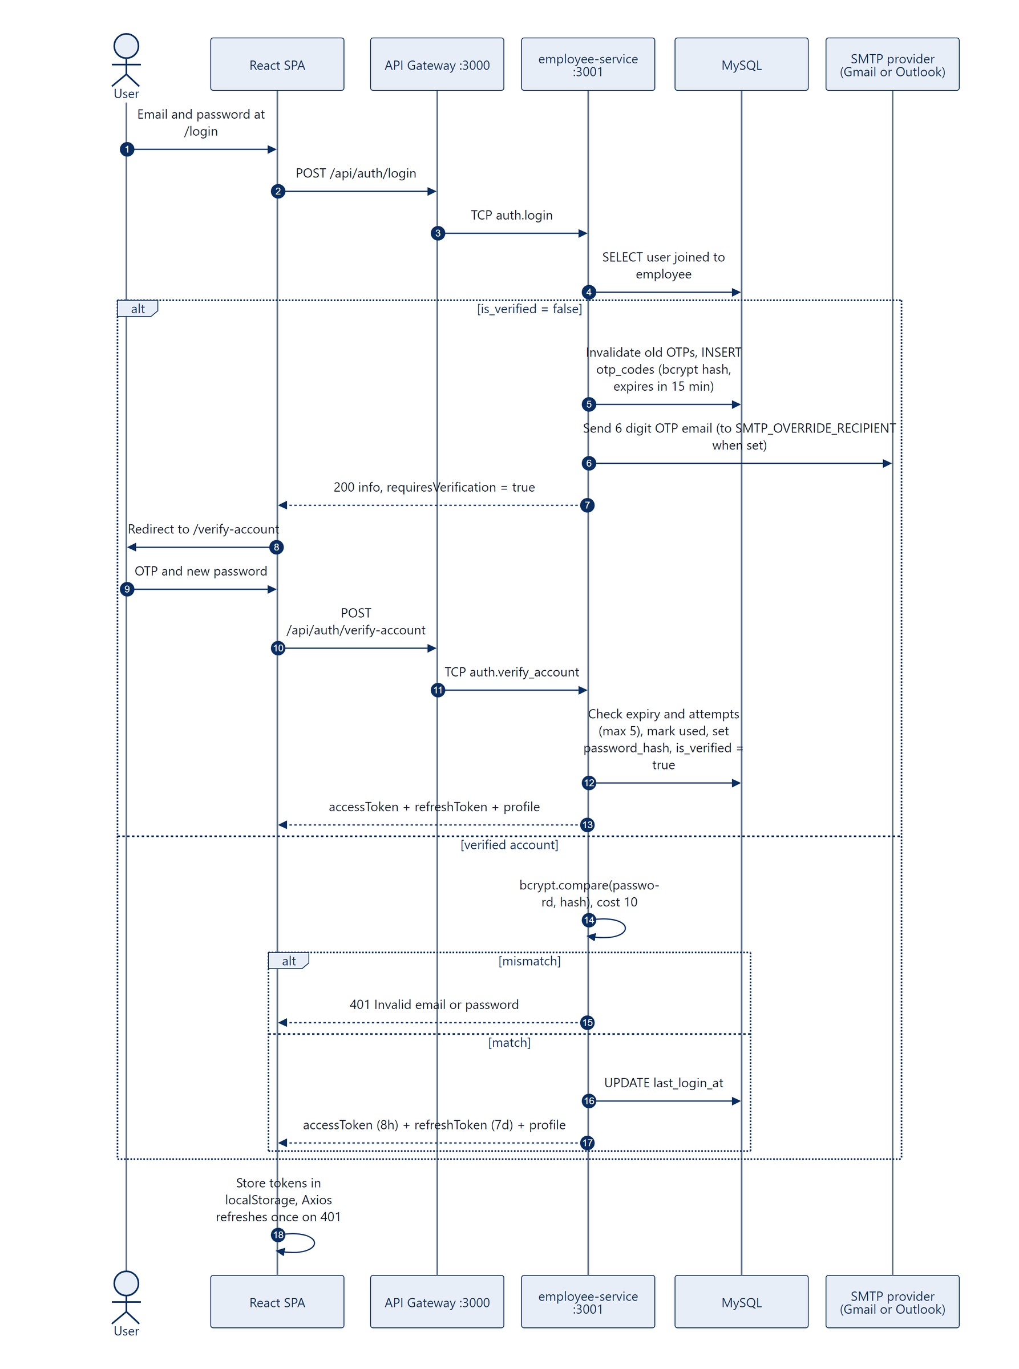
Figure 6.1: Sign in, first time verification with a 6 digit OTP, and token issue.

Scope and current technical limitations
- The unverified branch sends a new OTP on every sign in attempt without checking the password, and sign in reveals whether an email exists (defect D9).
- No rate limit on sign in, OTP issue or refresh beyond the 5 attempt cap per code.
- Refresh tokens are stateless. Signing out cannot revoke them.
- Tokens live in localStorage, readable by any script on the origin.
- The onboarding approve and reject buttons call a route the gateway does not expose, so they return 404 (defect D2).

Future improvements
- Rate limiting and a short cool down on OTP issue, with a generic "check your inbox" reply that does not reveal whether an account exists.
- Refresh token rotation with a server side store so sign out and password change revoke old tokens.
- Move tokens to secure, HTTP only cookies with CSRF protection.
- Fix the onboarding buttons to call /approve and /reject.
- Single sign on through the company identity provider (OIDC).

Feature 2: Biometric Face Enrollment with ArcFace Embeddings of 512 Dimensions

Feature analysis and business goals
Each operational user records one reference face. Every later clock in and clock out photo is compared 1:1 with that reference, which stops one person from clocking in for another.

User and operational assumptions
- A working webcam, even front lighting and exactly one face in frame.
- The buffalo_l model files exist in the host folder ~/.insightface, which the container mounts read only.
- The System Admin never enrolls (separation of duties).
- Two active employees must not share one face. A face that resembles another active employee is refused unless HR has granted that employee a sibling exemption.

Codebase function and module breakdown
Layer | Function, route or pattern | File
Frontend | FaceEnrollmentPage (route /auth/enroll-face), redirect in ProtectedRoute when isFaceEnrolled is false | frontend/src/pages/auth/FaceEnrollmentPage.tsx
Frontend | Conflict card on FaceEnrollmentPage for HTTP 409; Sibling Biometric Exemption switch in the edit form of MasterEmployeesPage | frontend/src/pages/auth/, pages/hrd/MasterEmployeesPage.tsx
Gateway | EmployeesController.enrollMyFace on POST /api/employees/me/enroll-face; BiometricClientService.extractEmbedding; persistAvatarFile | api-gateway/src/employee/, api-gateway/src/biometric/
Gateway | EmployeesController.toggleSiblingExemption on PATCH /api/employees/:id/sibling-exemption (HR_ADMIN) | api-gateway/src/employee/employees.controller.ts
FastAPI | POST /extract-embedding, FaceBiometricService.extract | biometric-service/main.py, service.py
TCP | employee.enroll_face | employee-service/src/employees/employees.service.ts
Service | EmployeesService.enrollFace, checkDuplicateFace (three tiers), toggleSiblingExemption | employee-service/src/employees/employees.service.ts
Database | employees.face_embedding (JSON), face_enrolled_at, face_enrolled_photo_url, is_sibling_exempt, sibling_exempt_reason, sibling_exempt_approved_by | libs/common/src/entities/employee.entity.ts

End to end technical flow
- After sign in, ProtectedRoute sends any user with an employee record and no face (except the System Admin) to /auth/enroll-face. isFaceEnrolled is true only when face_embedding is an array of 512 numbers.
- The page streams the webcam inside an oval guide, captures a JPEG at quality 0.95 and posts it as the multipart field photo.
- The gateway calls POST /extract-embedding. Anything other than SUCCESS with exactly one face returns 422 with a where, what and why message.
- The gateway saves the photo as avatar_<person>_<date>_<time>.jpg in the folder tree and sends TCP employee.enroll_face with the vector and the photo URL.
- The employee service checks that the vector holds 512 numbers, then runs checkDuplicateFace against the stored vector of every other active employee and keeps the closest match.
- Below a cosine similarity of 0.50 the face counts as unique.
- From 0.50 up to 0.90 the face counts as a possible sibling or twin. Without an exemption the service returns 409 Biometric conflict detected, naming the closest employee, their NIP and the percentage. When HR has set is_sibling_exempt, the service logs SIBLING_EXEMPTION_APPLIED with the approver and continues.
- At 0.90 or above the service returns 409 Duplicate face registration blocked, whatever the exemption says, because it treats the capture as the same face registered twice.
- A face that passes is stored in employees.face_embedding with the enrollment time and photo URL.
- The SPA refreshes the profile and opens /employee/attendance.
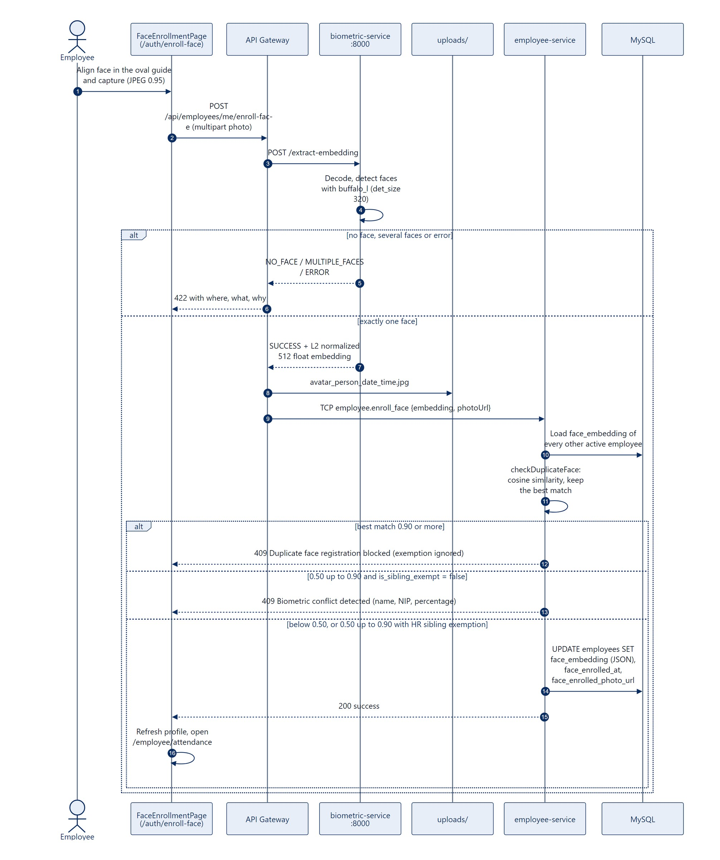
Figure 6.2: Face enrollment from webcam capture to the JSON vector in MySQL.

Scope and current technical limitations
- One reference image. No multi angle enrollment or template averaging.
- There is no liveness challenge on the enrollment page.
- Enrolling again is self service and overwrites the old vector without HR approval.
- The duplicate check loops over every active employee in Node. That suits a few thousand staff, not a very large workforce.
- The thresholds 0.50 and 0.90 are constants in the code. Deactivated employees are left out of the comparison, so reactivating one can create a pair of matching faces.
- The vector is plain JSON in MySQL, not encrypted at rest.
- On a cold start the model load can exceed the gateway's 10 second timeout, so the very first request after boot may fail and succeed on retry.

Future improvements
- Capture three angles and average the vectors for a steadier reference.
- Require liveness during enrollment and HR approval for any later change.
- Encrypt face_embedding at rest with a key held outside the database.
- Add a readiness endpoint on the biometric service so the gateway waits for the model instead of timing out.
- Move the one to many search into a vector index (for example pgvector or FAISS) and make both thresholds configurable per company.

Feature 3: Daily WFH Notice, Upward Escalation and Biometric Clock In

Feature analysis and business goals
Remote attendance is tied to an explicit WFH arrangement for the day that the approver can see. Only then does the system check identity and record the start of work with server time and a watermarked photo.
Upward escalation answers a gap found in research: managers whose own WFH days nobody above them reviews. A manager's request goes to HR, with the System Admin in copy.

User and operational assumptions
- The company default is work from office. WFH is an exception limited by a weekly quota (1 day by default, configurable 1 to 5).
- Each department has a manager email and an HR PIC email in departments. Defaults are used when they are missing.
- The user has enrolled a face.
- Policy mode is either STRICT_APPROVAL (a reviewer must approve) or NOTICE_ONLY (the request is approved at once).

Codebase function and module breakdown
Layer | Function, route or pattern | File
Frontend | EmployeeAttendancePage, LeaveAndCorrectionModal, CameraPhotoUpload (liveness, watermark) | frontend/src/pages/employee/, components/custom/
Gateway | AttendanceController.createRequest, verifyFacePreview, clockIn; persistPhotoProof | api-gateway/src/attendance/attendance.controller.ts
TCP | attendance_request.create, attendance.verify_face_preview, attendance.clock_in | attendance-service/src/attendance-service.controller.ts
Service | AttendanceRequestsService.create (quota, routing, email), AttendanceService.clockIn, evaluateClockIn | attendance-service/src/requests/, attendance/, libs/common/src/utils/attendance-rules.ts
Location | ProfilePage handleSetHomeFromDeviceGps with PATCH /api/employees/me/profile; calculateHaversineDistanceMeters; reverseGeocodeCoordinates (OpenStreetMap Nominatim) | frontend/src/pages/ProfilePage.tsx, libs/common/src/utils/attendance-rules.ts, reverse-geocoding.util.ts

End to end technical flow
- The user opens the WFH form. The SPA posts requestType: WFH_APPROVAL to POST /api/attendance-requests.
- The attendance service rejects a second pending or approved WFH request for the same date, and rejects the request if the ISO week (Monday to Sunday) already holds max_wfh_days_per_week requests.
- The request is saved as PENDING, or as APPROVED in NOTICE_ONLY mode.
- Email routing: from an EMPLOYEE or HR_ADMIN, To the department manager, Cc the HR PIC and the sender. From a MANAGER or SYSTEM_ADMIN, To the HR PIC (admin.hrd@dexagroup.com), Cc sysadmin@dexagroup.com, the HR PIC and the sender. Reply To is the submitter. With SMTP_OVERRIDE_RECIPIENT set, the To address becomes the evaluation inbox, the Cc list is dropped and a banner names the intended recipients.
- Once the request is approved, the attendance page unlocks. MediaPipe FaceLandmarker runs the liveness steps: align, identify, blink, turn left (yaw at most minus 14 degrees), turn right (yaw at least 14 degrees), hold front for 7 frames. It then captures automatically.
- A preview frame goes to POST /api/attendances/verify-face-preview, and the service answers whether the face is recognized (similarity of 0.45 or more).
- The Canvas burns a watermark into the pixels: a red DEXA GROUP WFH badge, a green biometric badge for live photos, the time in WIB, the NIP, name and department, and the copyright line.
- The user writes the daily plan and submits POST /api/attendances/clock-in with the photo and metadata.
- The gateway blocks the System Admin (403), extracts the vector, saves the photo with persistPhotoProof and sends TCP attendance.clock_in with the IP and user agent.
- The service sets serverNow = new Date(), rejects a second clock in today (409), checks for an approved WFH request (403 otherwise), rejects duplicate photos, compares faces (422 below 0.45), applies the liveness gate (422 below 0.85 on the live method), records the timestamp result, and saves ON_TIME or LATE.
- If the browser sent a location, the service measures the Haversine distance to the home location saved on the profile page, stores the distance and the street address from OpenStreetMap, and tags the session IN_HOME_RADIUS (100 meters or less) or OUT_OF_HOME_RADIUS. Without GPS or without a saved home location it tags LOCATION_UNAVAILABLE. Clock out records its own location the same way. The tag never blocks the request.
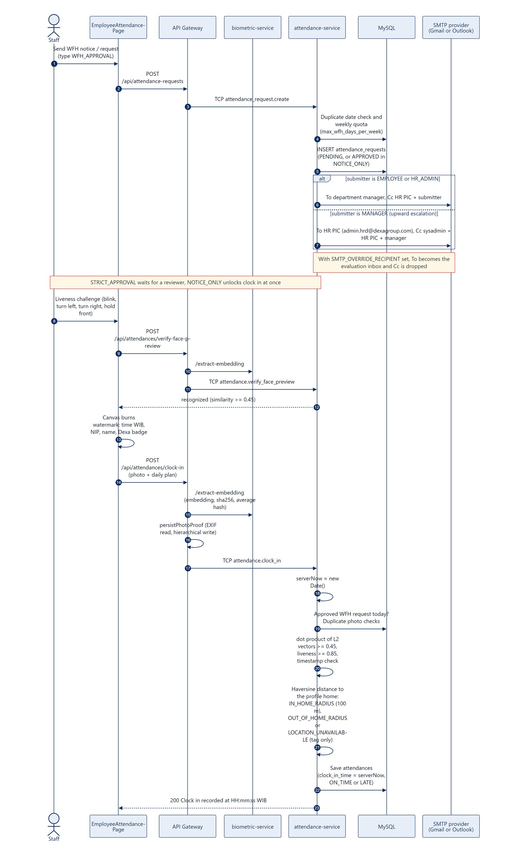
Figure 6.3: WFH notice with upward escalation, liveness, watermarking and the biometric clock in.

Scope and current technical limitations
- Liveness runs in the browser. The client currently sends livenessScore: 0.99 for every capture, so the server gate at 0.85 is not independent (defect D5).
- If the biometric service returns ERROR, clock in stores a default similarity of 0.92 without a comparison (defect D3).
- The daily plan is required in the form but optional in the backend DTO.
- The 100 meter home radius is informational. A clock in outside it is saved and tagged OUT_OF_HOME_RADIUS, although the profile page calls the rule strictly enforced (defect D14). The home location is whatever the employee saved from their own device.
- The date box in the notice form is filled with the UTC date, so between 00:00 and 07:00 WIB it suggests yesterday. A notice sent then is filed for the wrong day, uses the weekly quota and leaves clock in locked (defect D13).
- The watermark uses the device clock because of a field name mismatch in LiveServerClock (defect D6). The database time is still the server time.

Future improvements
- Server side liveness on a short video burst, so the score cannot be supplied by the client.
- Fail closed when the biometric service is unavailable, with a clear retry message.
- Use the server offset for the watermark by reading serverEpochMs.
- Let HR approve home locations and decide per department whether the radius should block a clock in.

Feature 4: Authoritative Server Timestamp and Anti Clock Tampering

Feature analysis and business goals
The official attendance time must not depend on the user's device, so moving the laptop clock cannot turn a late arrival into an on time one. Photo times are still recorded, but only to judge whether the photo is fresh.

User and operational assumptions
- The server clock is synchronized with NTP. Services use WIB conversion explicitly and MySQL runs with TZ=Asia/Jakarta.
- Uploaded photos come from phones or cameras that write EXIF DateTimeOriginal.

Codebase function and module breakdown
Layer | Function, route or pattern | File
Service | AttendanceService.clockIn and clockOut: const serverNow = new Date() | attendance-service/src/attendance/attendance.service.ts
Service | verifyPhotoTimestamp | attendance-service/src/attendance/attendance.service.ts
Gateway | persistPhotoProof, extractExifTimestamp (exif-parser) | api-gateway/src/storage/photo-metadata.util.ts
Gateway | GET /api/system/time (server clock for display) | api-gateway/src/system/system.controller.ts

End to end technical flow
- clock_in_time and clock_out_time are set only from serverNow inside the attendance service. No client value is ever written to them.
- The gateway resolves the photo time in order: EXIF DateTimeOriginal, then CreateDate, then ModifyDate, then the client's photoCapturedAt, then the server time. It is stored separately in clock_in_photo_captured_at or clock_out_photo_captured_at.
- For a live webcam photo, the timestamp is verified when it is within 5 minutes of server time.
- For an uploaded photo, it must be from the same WIB day, no more than 5 minutes in the future and no older than 12 hours.
- The result goes to is_timestamp_verified (or is_clock_out_timestamp_verified). HR sees it in the lightbox and can filter the audit log with verified=true or false.
- GET /api/system/time returns the server time, epoch and WIB strings for the header clock.
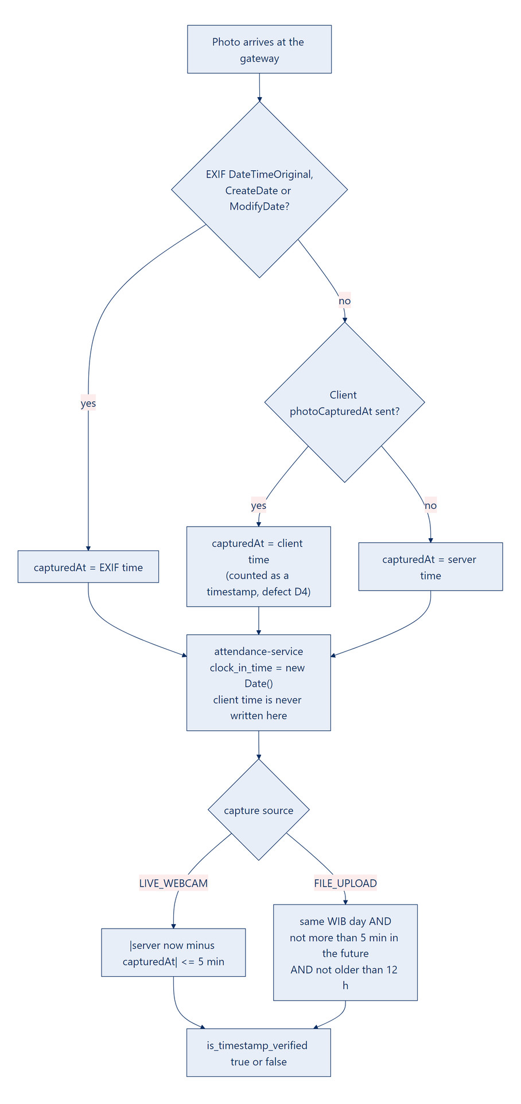
Figure 6.4: Server time is always the official time. EXIF and client times only decide the verification flag.

Scope and current technical limitations
- Request arrival is the official time, so a slow upload can record a time a few seconds after the user pressed capture.
- When the client sends photoCapturedAt, the gateway treats it as a timestamp even without EXIF data, so an upload can pass with a client supplied time (defect D4). In practice the portal always redraws the photo on a canvas, which removes the EXIF data, so uploads from the portal are judged on the time the browser sends (the file’s last modified time).
- The header clock shows device time because of defect D6.

Future improvements
- Count only real EXIF data as a timestamp for uploads.
- Fix the header clock to apply the server offset.
- Record the time the capture button was pressed, signed by a short lived server nonce, to measure upload delay.

Feature 5: Clock Out, Working Duration, Punctuality and 1/173 Overtime

Feature analysis and business goals
Each day closes with a written accomplishment and a proof photo. The system then computes everything payroll needs (duration, status, overtime minutes and overtime pay) the same way every time.

User and operational assumptions
- One standard schedule: start 08:30 WIB with a 15 minute grace period and a 9 hour span (540 minutes).
- Overtime pay follows the Indonesian 1/173 hourly rate (PP No. 35/2021): 1.5x for the first hour and 2x after that.
- HR keeps base_salary current (default IDR 12,000,000).
- Overtime is on when the company policy enable_overtime is true.

Codebase function and module breakdown
Layer | Function, route or pattern | File
Gateway | AttendanceController.clockOut on POST /api/attendances/clock-out | api-gateway/src/attendance/attendance.controller.ts
TCP | attendance.clock_out | attendance-service/src/attendance-service.controller.ts
Rules | evaluateClockIn, evaluateClockOut, calculateOvertimeAndPay | libs/common/src/utils/attendance-rules.ts
DTO | ClockOutDto (dailyAccomplishment at least 10 characters) | libs/common/src/dto/attendance.dto.ts

End to end technical flow
- The employee writes the daily accomplishment, captures a photo and submits POST /api/attendances/clock-out.
- The gateway blocks the System Admin, extracts the vector, saves the photo with the clock-out prefix and sends TCP attendance.clock_out.
- The service needs today's record with a clock in (400 otherwise) and no earlier clock out (409).
- clock_out_time is set to new Date(). The face must match at 0.45 or more (422 otherwise).
- Duration is the whole minutes between clock in and clock out. There is no break deduction. Below 240 minutes the status is HALF_DAY, otherwise COMPLETED.
- Overtime minutes are duration minus 540, kept only if 30 or more. If overtime is enabled, the service computes the pay and keeps the larger of this value and any value set by an approved overtime request.
- The response reads "Clock Out recorded at HH:mm:ss WIB" with hours worked and any overtime pay in Rupiah.
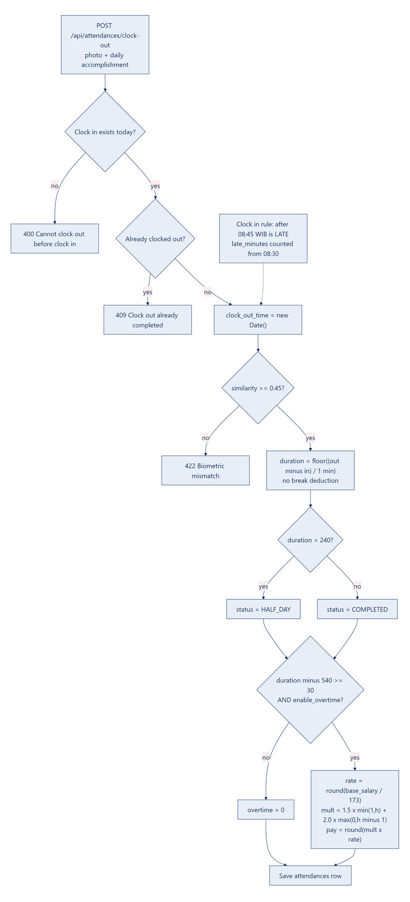
Figure 6.5: Clock out checks, duration, status and the 1/173 overtime calculation.

Scope and current technical limitations
- Overtime starts after 540 minutes of work, not at 17:30 on the wall clock. A late starter must stay later before overtime counts.
- Clock out replaces ON_TIME or LATE with COMPLETED or HALF_DAY. Lateness stays visible in late_minutes.
- No weekend or public holiday multipliers.
- Missing clock outs are marked MISSING_CLOCK_OUT only when data is next read. There is no scheduler.

Future improvements
- Shift templates per department so start time, span and break rules can differ.
- Holiday calendar with the rest day multipliers from PP No. 35/2021.
- A nightly job that closes missing clock outs and notifies the employee.
- An optional break deduction setting for companies that need it.

Formulas used by the code
is_late = clock_in_minutes > 08:30 + grace (15)
late_minutes = is_late ? clock_in_minutes - 08:30 : 0
duration = floor((clock_out - clock_in) / 60 000 ms)
status = duration < 240 ? HALF_DAY : COMPLETED
overtime_min = (duration - 540) >= 30 ? duration - 540 : 0
hourly_rate = round(base_salary / 173)
mult_hours = 1.5 * min(1, h) + 2.0 * max(0, h - 1) where h = overtime_min / 60
overtime_pay = round(mult_hours * hourly_rate)

Worked example: base salary IDR 12,000,000, clock in 08:30, clock out 20:00. Duration is 690 minutes, overtime is 150 minutes, the hourly rate is IDR 69,364, the multiplier hours are 1.5 + 2.0 x 1.5 = 4.5, and the overtime pay is IDR 312,138. With the defaults, a clock in at 08:45 is on time and one at 08:46 is late by 16 minutes, because late minutes count from 08:30.

Feature 6: Leave, Sick, Overtime and Correction Requests with Direct Links

Feature analysis and business goals
One request pipeline replaces scattered emails and spreadsheets. Every request is auditable, and an approval updates the official attendance record automatically.

User and operational assumptions
- The approver has a portal account. The email link relies on the normal sign in, not on an anonymous token.
- A supporting document is optional (a doctor's note, a VPN log).

Codebase function and module breakdown
Layer | Function, route or pattern | File
Frontend | LeaveAndCorrectionModal, ManagerApprovalsPage (reads ?requestId=) | frontend/src/components/custom/, pages/manager/
Gateway | createRequest, myRequests, findRequests, reviewRequest; persistAttachmentFile | api-gateway/src/attendance/attendance.controller.ts
TCP | attendance_request.create, .my, .find_all, .review | attendance-service/src/attendance-service.controller.ts
Service | AttendanceRequestsService.create, review, syncApprovedRequestToAttendance | attendance-service/src/requests/attendance-requests.service.ts

End to end technical flow
- The employee picks a type (WFH_APPROVAL, OVERTIME, CORRECTION, LEAVE or SICK), a date, a reason and an optional attachment (image or PDF, 8 MB at most) and submits POST /api/attendance-requests.
- The service checks the reason (at least 10 characters). A correction needs at least one time and a clock out after the clock in. Overtime needs the policy enabled and gets an estimated pay.
- The request is saved as PENDING with the resolved manager email and Cc list.
- The email carries a button to http://localhost:5173/manager/approvals?requestId=<uuid>.
- With SMTP_OVERRIDE_RECIPIENT set, the attendance service sends the email to that inbox instead, drops the Cc list and adds a banner naming the intended recipients.
- The approver clicks it, signs in if needed, and the approval page opens that request in a review modal. Approve or reject sends PATCH /api/attendance-requests/:id/review. A note is required to reject.
- A manager can only review their own department (403 otherwise), and only pending requests can be reviewed (400 otherwise).
- On approval the service upserts attendances for the employee and date. WFH sets wfh_approved. Leave sets ON_LEAVE. Sick sets SICK. Overtime recomputes overtime pay. A correction sets the requested times and recomputes status, late minutes, duration and overtime with the same rules as a live clock in and clock out.
- A decision email goes to the employee, with the manager and HR in copy.
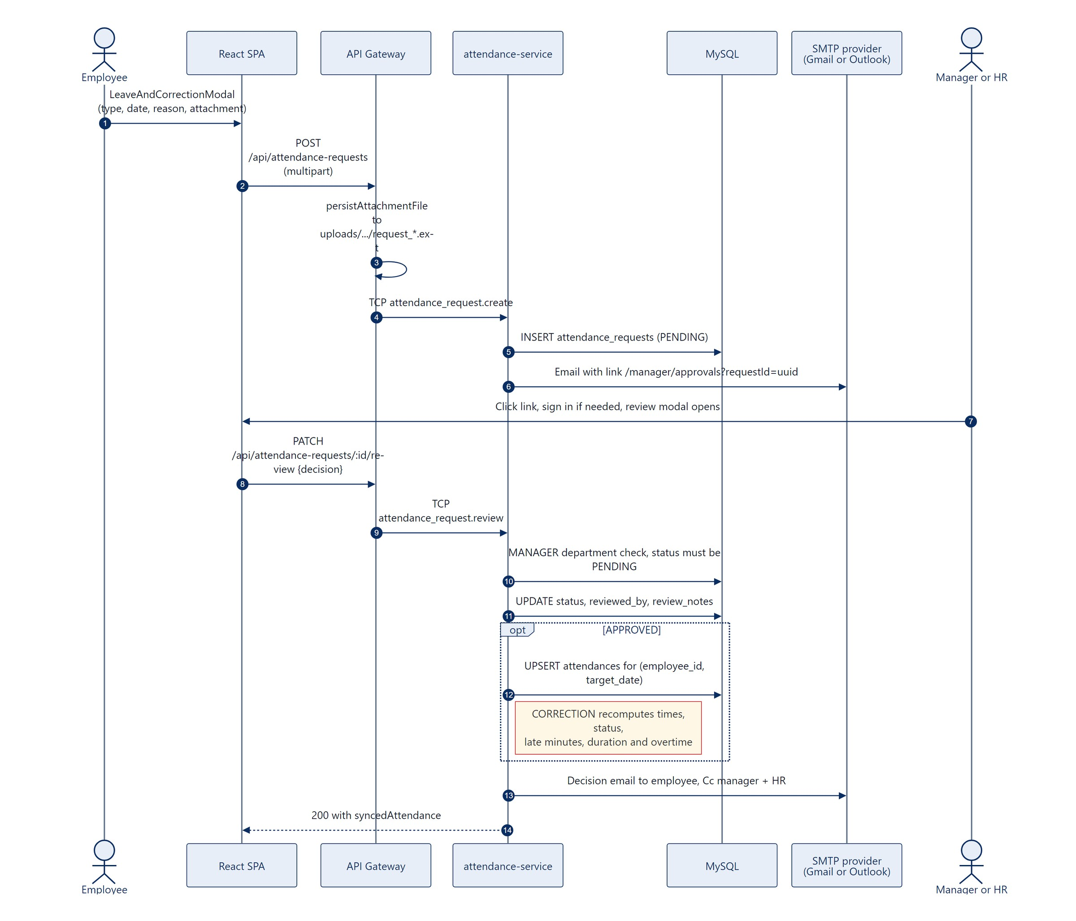
Figure 6.6: Request submission, the direct review link and the automatic attendance update.

Scope and current technical limitations
- The link is not signed. It carries the request ID, and security comes from the sign in and the department check. The host is fixed to http://localhost:5173.
- There is no leave balance ledger.
- email_dispatched now records the real result of the send. When SMTP_FROM carries a display name, the sender of request emails reads "Name (via Dexa WFH)>" with a stray bracket (defect D16).
- An approved correction marks the timestamp as verified, even though the times were typed by the employee.
- The request form fills its date with the UTC date, so before 07:00 WIB it suggests yesterday (defect D13).

Future improvements
- Signed, single use review links with an expiry, for one click approval from a phone.
- A leave entitlement ledger that debits approved leave days.
- Retry failed sends from a queue.
- Read the portal host from configuration.

Feature 7: Master Employee Management, Mandatory NIP and Soft Delete

Feature analysis and business goals
HR keeps one authoritative staff directory. Removing someone must never destroy the attendance history that payroll and audits rely on, so deletion is always a soft delete.

User and operational assumptions
- HR assigns NIPs, and each NIP is unique in the company.
- A deactivated employee must not sign in or clock in, but their records must stay searchable and exportable.

Codebase function and module breakdown
Layer | Function, route or pattern | File
Frontend | MasterEmployeesPage (route /hrd/employees) | frontend/src/pages/hrd/MasterEmployeesPage.tsx
Gateway | EmployeesController: findAll, findOne, create, update, softDelete, restore, resendOtp | api-gateway/src/employee/employees.controller.ts
TCP | employee.find_all, .create, .update, .soft_delete, .restore, .resend_verification | employee-service/src/employee-service.controller.ts
Service | EmployeesService.create (transaction), softDelete, restore | employee-service/src/employees/employees.service.ts
DTO | CreateEmployeeDto (NIP pattern ^[A-Z0-9-]{3,50}$) | libs/common/src/dto/employee.dto.ts

End to end technical flow
- HR opens /hrd/employees, which loads GET /api/employees?limit=100 with search, department, status, role and includeInactive filters.
- Create: the NIP is required in the form, checked by the DTO pattern, rejected with 400 when empty and 409 when taken (unique index UQ_employees_code). The email must also be unique. The phone field starts at +62 and the base salary at IDR 12,000,000.
- The user and employee rows are created in one transaction, and a verification OTP is emailed.
- Update PATCH /api/employees/:id changes profile, salary, status (ACTIVE or ON_LEAVE) and role, which is copied to users.role.
- Soft delete DELETE /api/employees/:id sets employees.is_active = false, status = INACTIVE, deleted_at = NOW() and users.is_active = false. No SQL DELETE runs. HR cannot deactivate their own account.
- Restore PATCH /api/employees/:id/restore reverses every field.
- History stays intact because attendances and attendance_requests reference employees with ON DELETE RESTRICT, and audit queries use withDeleted.
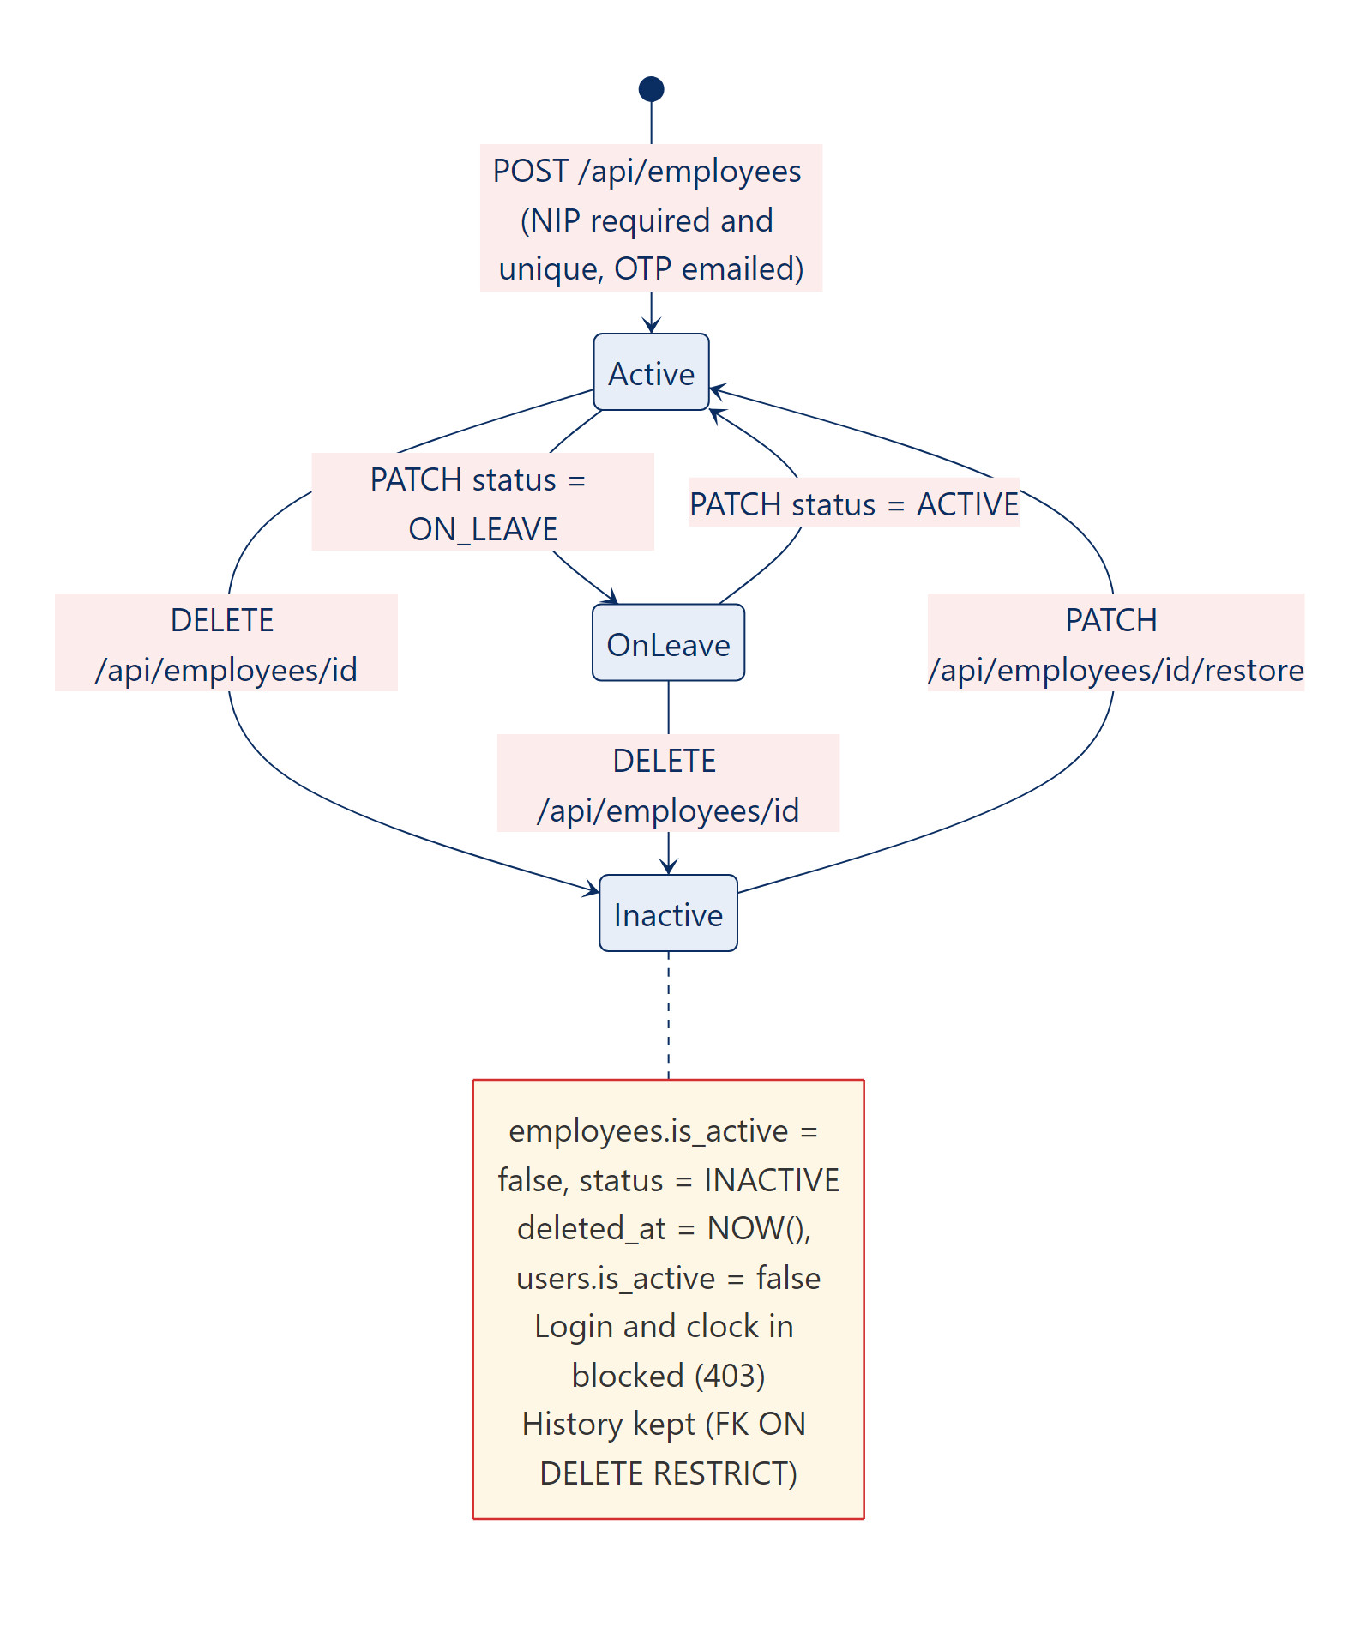
Figure 6.7: Employee life cycle with soft delete and restore.

Scope and current technical limitations
- The Database Studio can hard delete rows and bypass soft delete (foreign keys still block employees with attendance).
- No bulk import.
- The department is stored as a name on the employee, so renaming a department means updating employees.

Future improvements
- CSV or XLSX bulk import with a dry run report.
- Use department_id as the single source for routing and reporting.
- An audit trail of who changed which employee field and when.

Feature 8: Dual Dashboards and the Photo Lightbox

Feature analysis and business goals
HR gets a company wide picture of the day with a path down to each photo. Each employee gets a personal view of their own punctuality and hours.

User and operational assumptions
- "Real time" means fresh data on page load and refresh. There is no push channel.
- An employee counts as present when they have a clock in and are not on leave or sick.

Codebase function and module breakdown
Layer | Function, route or pattern | File
Frontend | HrdDashboardPage, AttendanceMonitoringPage, PhotoLightboxModal, EmployeeDashboardPage | frontend/src/pages/hrd/, pages/employee/
Frontend | AttendanceLocationMapModal (Leaflet with OpenStreetMap tiles, clock in, clock out and home pins, 100 meter circle) opened from the Map button of each audit row | frontend/src/components/custom/AttendanceLocationMapModal.tsx
Gateway | GET /api/attendances/summary, GET /api/attendances, GET /api/attendances/my-dashboard | api-gateway/src/attendance/attendance.controller.ts
TCP | attendance.summary, attendance.find_all, attendance.my_dashboard | attendance-service/src/attendance-service.controller.ts
Service | getSummary, buildFilteredQuery, getMyDashboard | attendance-service/src/attendance/attendance.service.ts

End to end technical flow
- HRD dashboard: GET /api/attendances/summary?date= loads active employees and the day's rows and aggregates them in the service. Six KPI cards (active employees, present, on time, late, on leave or sick, timestamp audit), a department breakdown, a 7 day trend and a recent photo feed. Managers see only their department.
- Monitoring and audit log: GET /api/attendances with date range, department, status, verified flag and search (name, NIP, email, plan, accomplishment). It uses a TypeORM QueryBuilder with a left join on the employee, bound parameters and pagination.
- Clicking a thumbnail opens the lightbox: clock in and clock out photos with their burned in watermarks, server time and capture time for each, the timestamp verification banner, daily plan, accomplishment, duration, late minutes, IP and device.
- Employee dashboard: GET /api/attendances/my-dashboard returns the punctuality score, average hours against the 8.0 hour target, overtime pay and minutes, weekly WFH quota, today's status, a 14 day duration bar chart built from div bars with a dashed 8.0 hour line, the punctuality split and recent sessions and requests.
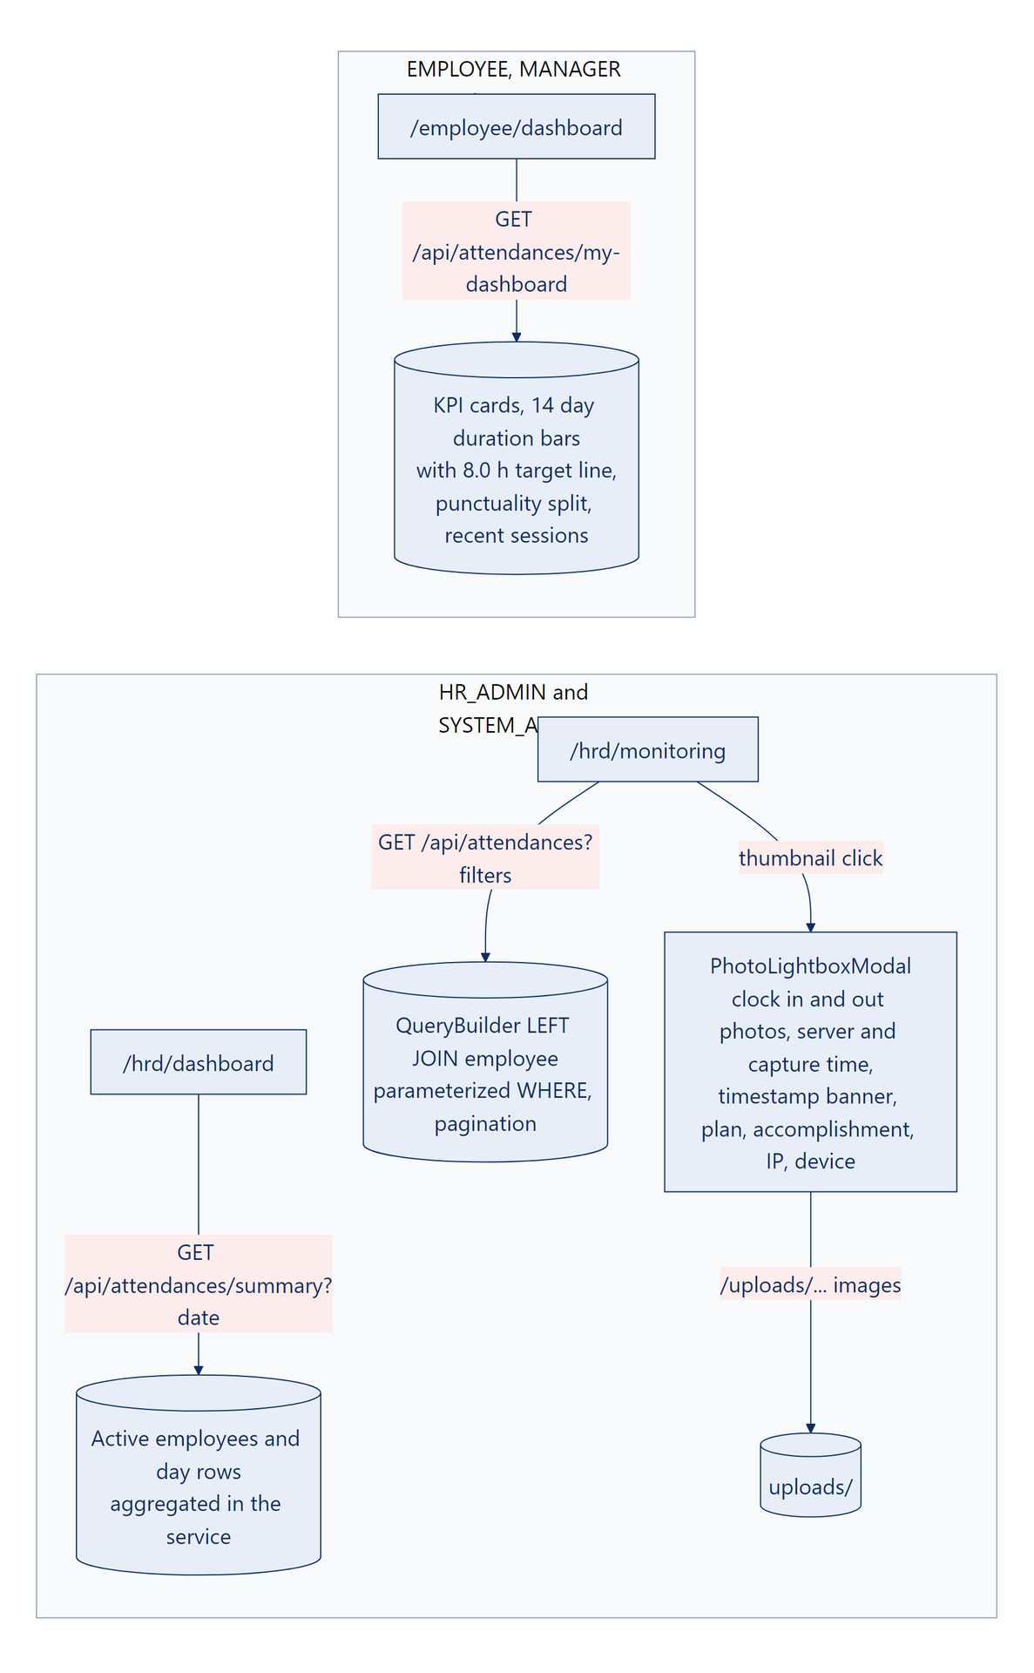
Figure 6.8: HR monitoring with the lightbox, next to the personal employee dashboard.

Scope and current technical limitations
- Aggregation happens in Node memory, not with SQL GROUP BY. Fine at assessment scale, not for very large data.
- The lightbox does not show the similarity score, liveness score or perceptual hash, although all are stored. Location has its own map window.
- Without a saved home location the map window says No Clock In GPS submitted, even when coordinates were saved (defect D15).
- The audit page fetches up to 100 rows per page.

Future improvements
- Move the summary aggregation into SQL or a daily summary table.
- Show similarity and liveness scores in the lightbox for HR.
- Live updates through server sent events during the morning clock in window.

Feature 9: XLSX, CSV and Printable Export

Feature analysis and business goals
HR and payroll get the same filtered data they see on screen, in formats their tools already read, including overtime pay, with no retyping.

User and operational assumptions
- Exports stay below 5,000 rows.
- Excel, Google Sheets and payroll importers are the consumers.

Codebase function and module breakdown
Layer | Function, route or pattern | File
Frontend | Export .XLSX, Export .CSV and Print / PDF buttons on AttendanceMonitoringPage | frontend/src/pages/hrd/AttendanceMonitoringPage.tsx
Gateway | GET /api/attendances/export (sets Content-Disposition and X-Export-Row-Count) | api-gateway/src/attendance/attendance.controller.ts
TCP | attendance.export | attendance-service/src/attendance-service.controller.ts
Service | ExportService.export with ExcelJS | attendance-service/src/export/export.service.ts

End to end technical flow
- HR sets filters and clicks Excel or CSV. The SPA calls GET /api/attendances/export?format=xlsx|csv with the same filters (HR_ADMIN, MANAGER or SYSTEM_ADMIN; managers limited to their department).
- The service reuses buildFilteredQuery with take(5000) and builds an ExcelJS workbook, sheet "WFH Attendance & Payroll Recap", with 22 columns from NIP and name through duration, overtime minutes, multiplier hours, overtime pay, late minutes, status, photo source, timestamp check, plan and accomplishment. The header row is bold white on blue, and a copyright row closes the sheet.
- CSV comes from the same workbook through the ExcelJS CSV writer.
- The file is base64 encoded and returned over TCP. The gateway decodes it and sends Dexa_WFH_Attendance_Payroll_Report_<date>.<ext>.
- For PDF, the page calls window.print(). The print stylesheet hides navigation, and the browser saves the view as a PDF.
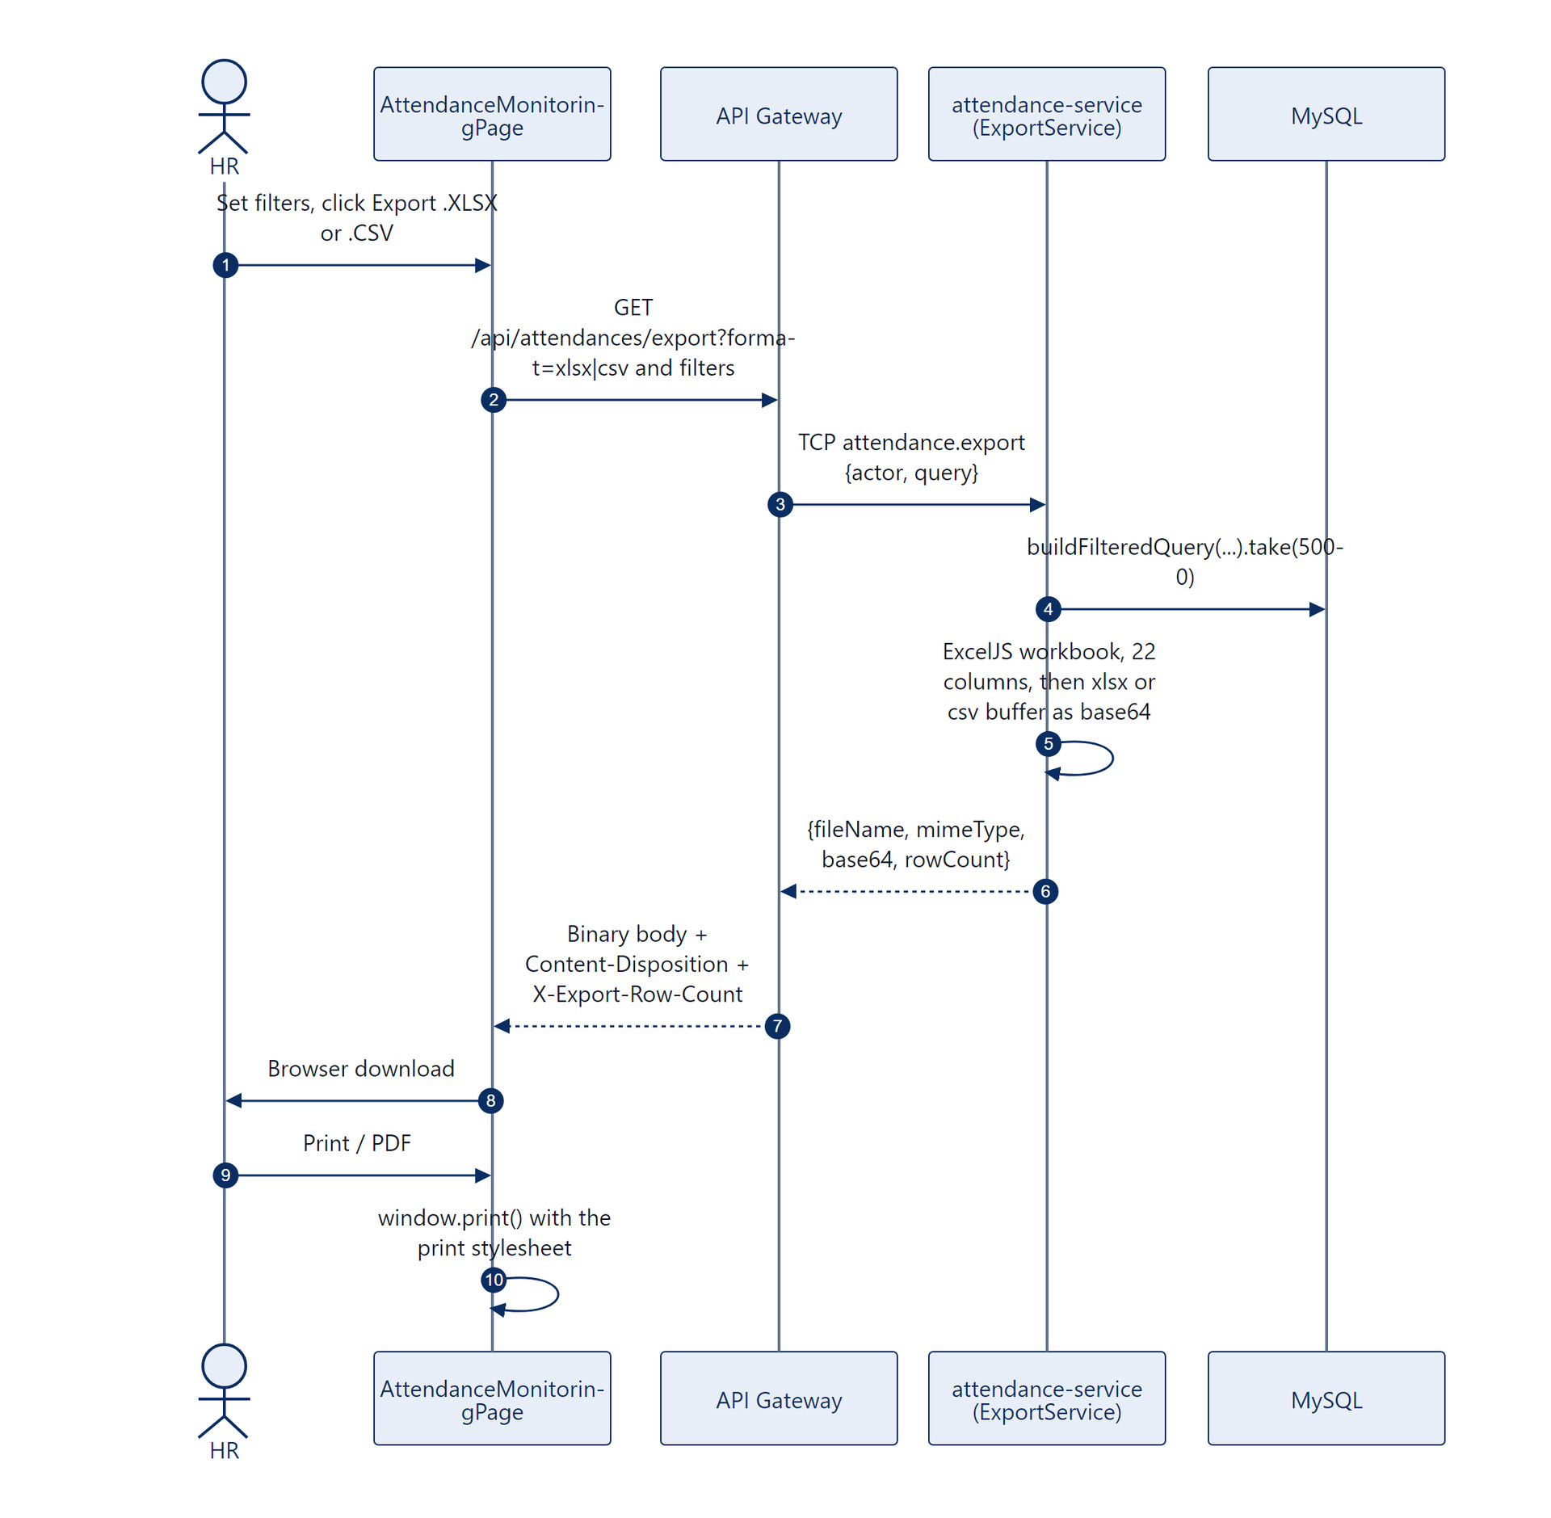
Figure 6.9: One filtered dataset exported as XLSX, CSV or a printable page.

Scope and current technical limitations
- Not a true stream: the file is built in memory and travels as base64 over TCP (about a third larger).
- Capped at 5,000 rows. No totals row or per employee subtotals.
- PDF depends on the browser print engine.

Future improvements
- Stream large exports from the gateway with ExcelJS streaming writers.
- Add a totals sheet per employee for payroll cut off.
- Server generated PDF with a fixed layout and signature block.

Feature 10: Hierarchical File Storage

Feature analysis and business goals
Evidence files should be easy for a person to browse and for an auditor to trace, instead of one flat folder of random names.

User and operational assumptions
- One node with a local or bind mounted disk (./uploads to /app/uploads).

Codebase function and module breakdown
Layer | Function, route or pattern | File
Gateway | buildOrganizedDirectory, buildOrganizedFilename, resolveRoleFolder, slugify | api-gateway/src/storage/photo-metadata.util.ts
Gateway | persistPhotoProof, persistAttachmentFile, persistAvatarFile | same file
Gateway | Static serving of /uploads | api-gateway/src/main.ts

End to end technical flow
- Uploads arrive in memory (Multer memoryStorage).
- The department and full name are turned into slugs: lower case, accents removed, other characters replaced.
- resolveRoleFolder returns manager for MANAGER, HR_ADMIN and SYSTEM_ADMIN, and employee for everyone else.
- The folder is uploads/<year>/<department>/<role folder>/<person>/<MM-monthname>/.
- The name is <prefix>_<person>_<YYYY-MM-DD>_<HH-mm-ss>.<ext> with the prefix clock-in, clock-out, request or avatar. A clash in the same second adds a random 3 digit suffix.
- The file is written, and the URL /uploads/... is stored in the database and served by the gateway through nginx.
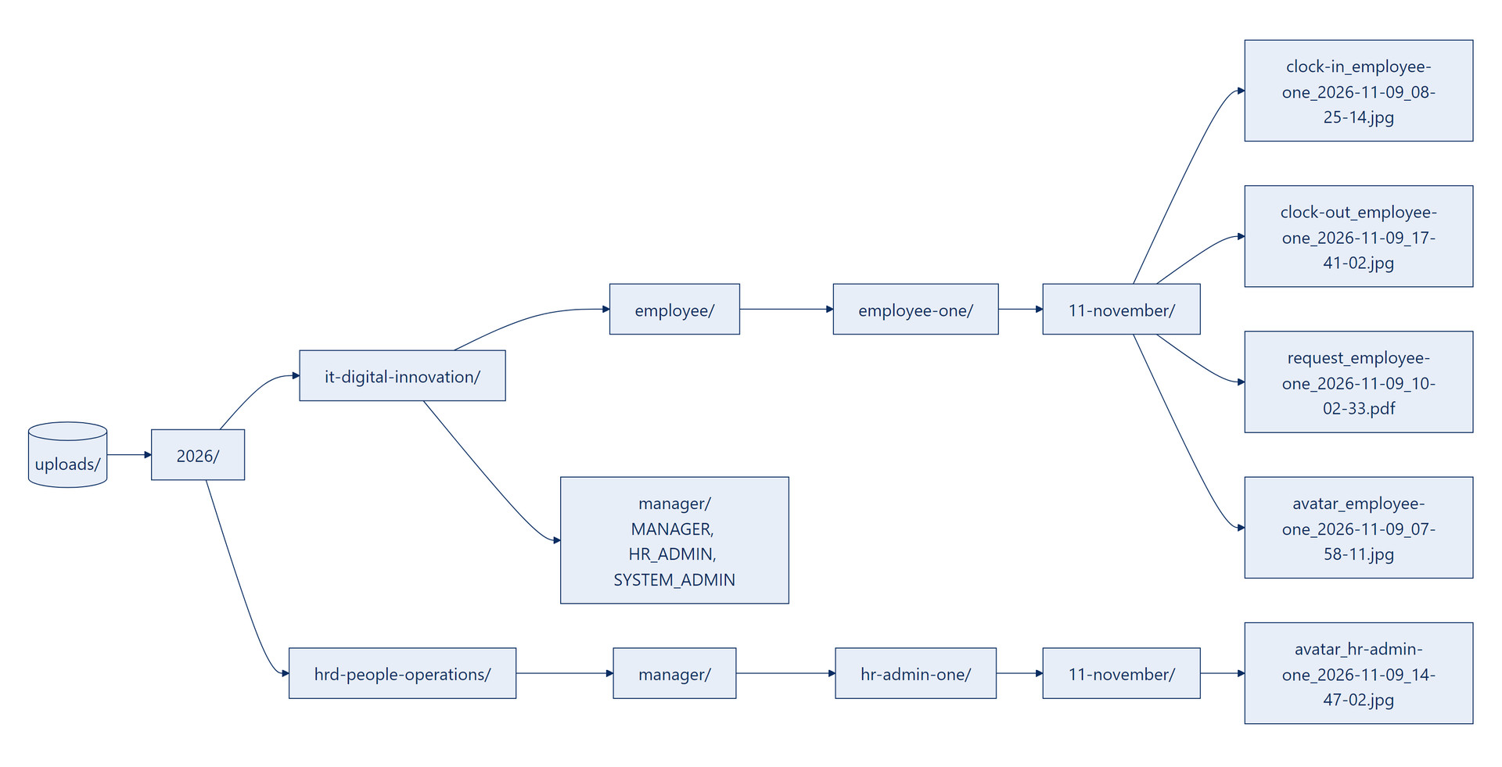
Figure 6.10: The storage tree, with the real enrollment file from the installation test run.

Scope and current technical limitations
- Year, month and time in the path come from the container clock (UTC in Docker), so names can read 7 hours behind WIB (defect D11).
- /uploads is served without authentication. Anyone with a URL can open the image (defect D10).
- Local disk only. No retention policy.

Future improvements
- An S3 compatible adapter (S3, GCS or MinIO) that keeps the same key hierarchy and serves files through pre signed URLs.
- Build folder and file names from WIB.
- Retention rules per file type, for example deleting raw photos after the payroll period closes.

Feature 11: Database Studio

Feature analysis and business goals
The platform custodian can inspect and repair data during evaluation inside the portal, without opening a separate SQL client.

User and operational assumptions
- The operator understands the schema and what deleting a row means.
- Only the nine application tables are in scope.

Codebase function and module breakdown
Layer | Function, route or pattern | File
Frontend | SystemDatabaseManagementPage (route /system/database) | frontend/src/pages/system/
Gateway | DatabaseManagementController: tables, rows, row, insert, update, delete | api-gateway/src/database-management/
TCP | database.get_tables, .get_rows, .get_row, .insert_row, .update_row, .delete_row | employee-service/src/database-management/

End to end technical flow
- GET /api/system/database/tables returns, for each whitelisted table (users, employees, departments, attendances, attendance_requests, access_requests, otp_codes, support_tickets, system_settings), its display name, primary key, live row count and column metadata.
- GET /api/system/database/:table pages through rows (limit at most 100) with search across text columns and sorting on known columns. password_hash comes back masked.
- Insert, update and delete work on one row at a time. A new users row hashes its password with bcrypt. Primary keys cannot change.
- Delete is a hard delete. A foreign key violation returns 409.
- The page can export the current table view to CSV in the browser.
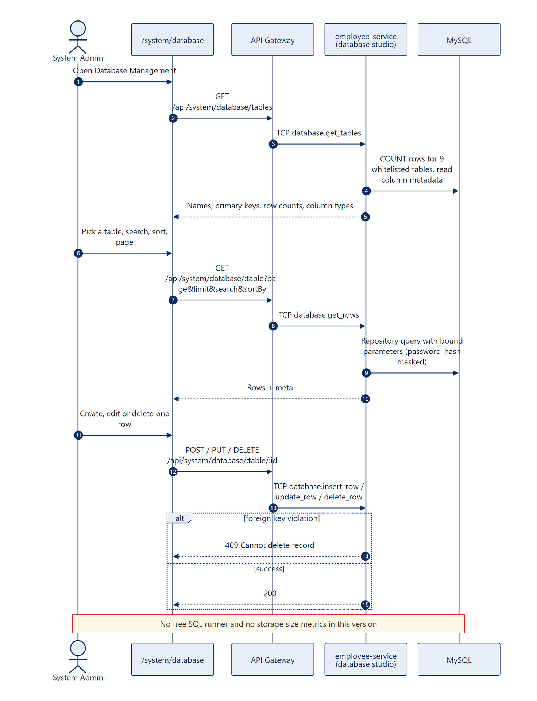
Figure 6.11: Database Studio requests from the browser to the whitelisted repositories.

Scope and current technical limitations
- There is no free SQL runner and no storage size metric. Every operation goes through TypeORM repositories with bound parameters.
- No log of who changed which row.
- HR admins can reach the page and the API because of defect D1.

Future improvements
- Enforce SYSTEM_ADMIN only access in both RolesGuard and ProtectedRoute.
- A read only SQL console with a statement timeout and an allow list, if custom queries are really needed.
- Table size and index size from information_schema.
- An audit log of every write.

Feature 12: Developer Support with Targeted SMTP Routing

Feature analysis and business goals
Anyone can report a problem from any page. The report reaches the people who can fix it, and replies go straight back to the reporter.

User and operational assumptions
- At least one active System Admin exists. A fallback address is used if not.

Codebase function and module breakdown
Layer | Function, route or pattern | File
Frontend | ContactDeveloperModal, opened from the header Support button | frontend/src/components/custom/ContactDeveloperModal.tsx
Gateway | SupportController: contactDeveloper, findTickets, resolve, sendTestEmail (POST /api/support/test-email, HR_ADMIN and SYSTEM_ADMIN) | api-gateway/src/support/
TCP | support.contact_developer, support.find_tickets, support.resolve, support.test_email | employee-service/src/support/
Mail | MailService.sendContactDeveloperEmail, sendOtpEmail, sendTestEmail, safeSend (override routing, Gmail and Outlook STARTTLS settings) | employee-service/src/mail/mail.service.ts

End to end technical flow
- The Support button opens the modal. The sender shows read only as name and email. The user picks a category (ATTENDANCE_ISSUE by default, ACCOUNT_ACCESS, BUG, OTHER), a module, a subject (5 to 200 characters) and a message (10 to 4,000 characters).
- The SPA posts POST /api/support/contact-developer, and the gateway sends TCP support.contact_developer.
- The service saves a support_tickets row as OPEN.
- Recipients: To every active SYSTEM_ADMIN (fallback sysadmin@dexagroup.com), Cc every active HR_ADMIN and the sender. When SMTP_FROM is set the email goes out From that address, with Reply To set to the user; otherwise From is the user. The body adds the role and NIP looked up on the server, and the ticket ID.
- With SMTP_OVERRIDE_RECIPIENT set, the To address becomes the evaluation inbox and a banner names the intended recipient. The Cc list stays, so real SMTP reports the @dexagroup.com copies as undeliverable (defect D17).
- After a successful send, email_delivered becomes true.
- Admins see all tickets (latest 50) and others see their own through GET /api/support/tickets. HR resolves with PATCH /api/support/tickets/:id/resolve.
- HR and System Admin can call POST /api/support/test-email to send a diagnostic email that reports the SMTP host, port, sender and final recipient.
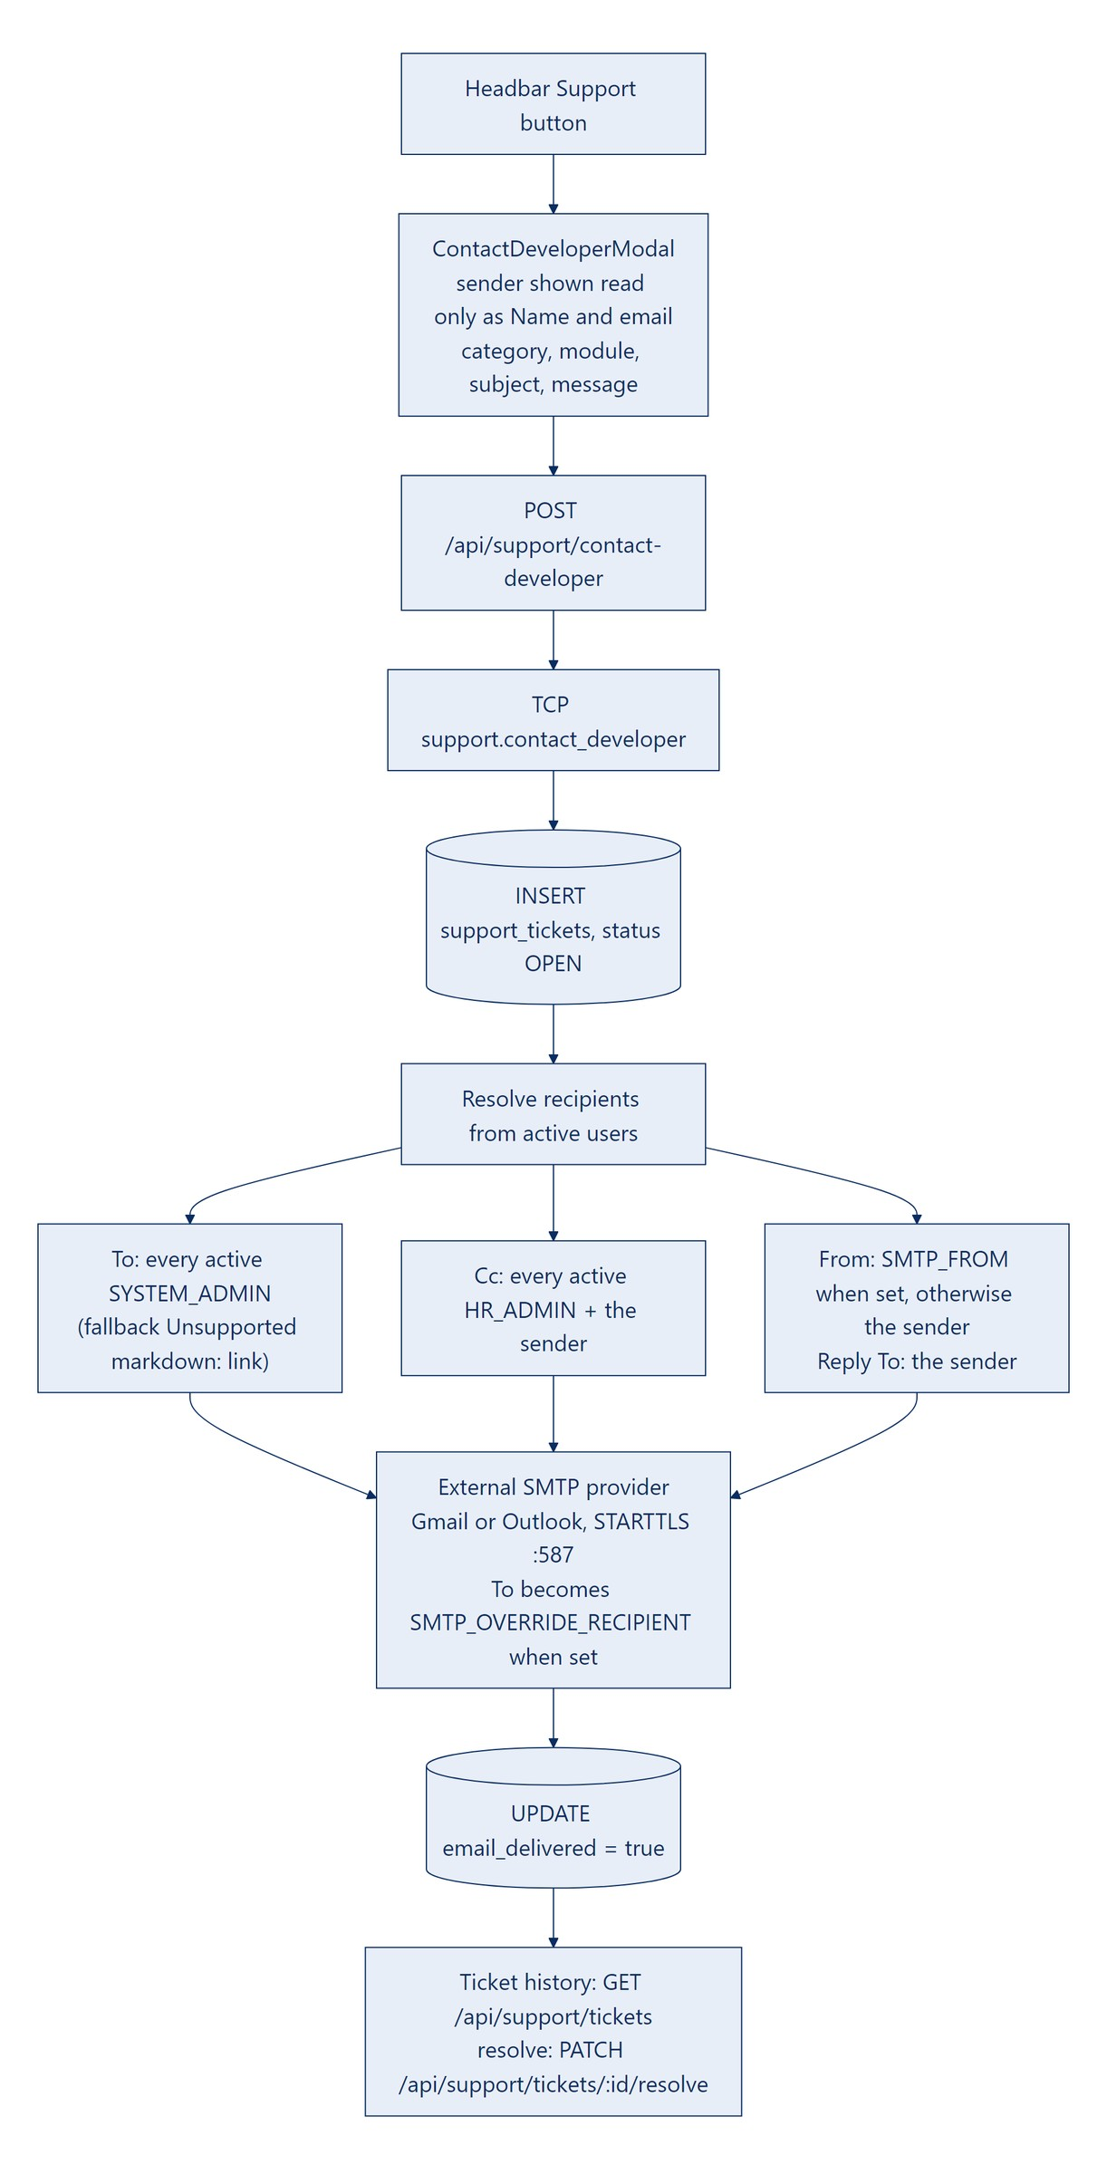
Figure 6.12: Support ticket routing to System Admins, HR Admins and the sender.

Scope and current technical limitations
- Gmail and Outlook rewrite or refuse a From address that is not the signed in SMTP account, so SMTP_FROM should use the account address.
- No threaded replies inside the app.
- DEVELOPER_SUPPORT_EMAIL is not used by the routing.

Future improvements
- OAuth2 sign in for Gmail and Microsoft 365 instead of app passwords.
- Ticket comments and status history inside the portal.
- Attach a screenshot and the last browser console errors automatically.

CHAPTER VII
DATA ARCHITECTURE AND DATABASE SCHEMA
Nine TypeORM entities in libs/common/src/entities/ make up the schema. Every primary key is a UUID except system_settings, which holds one row with the ID DEFAULT.
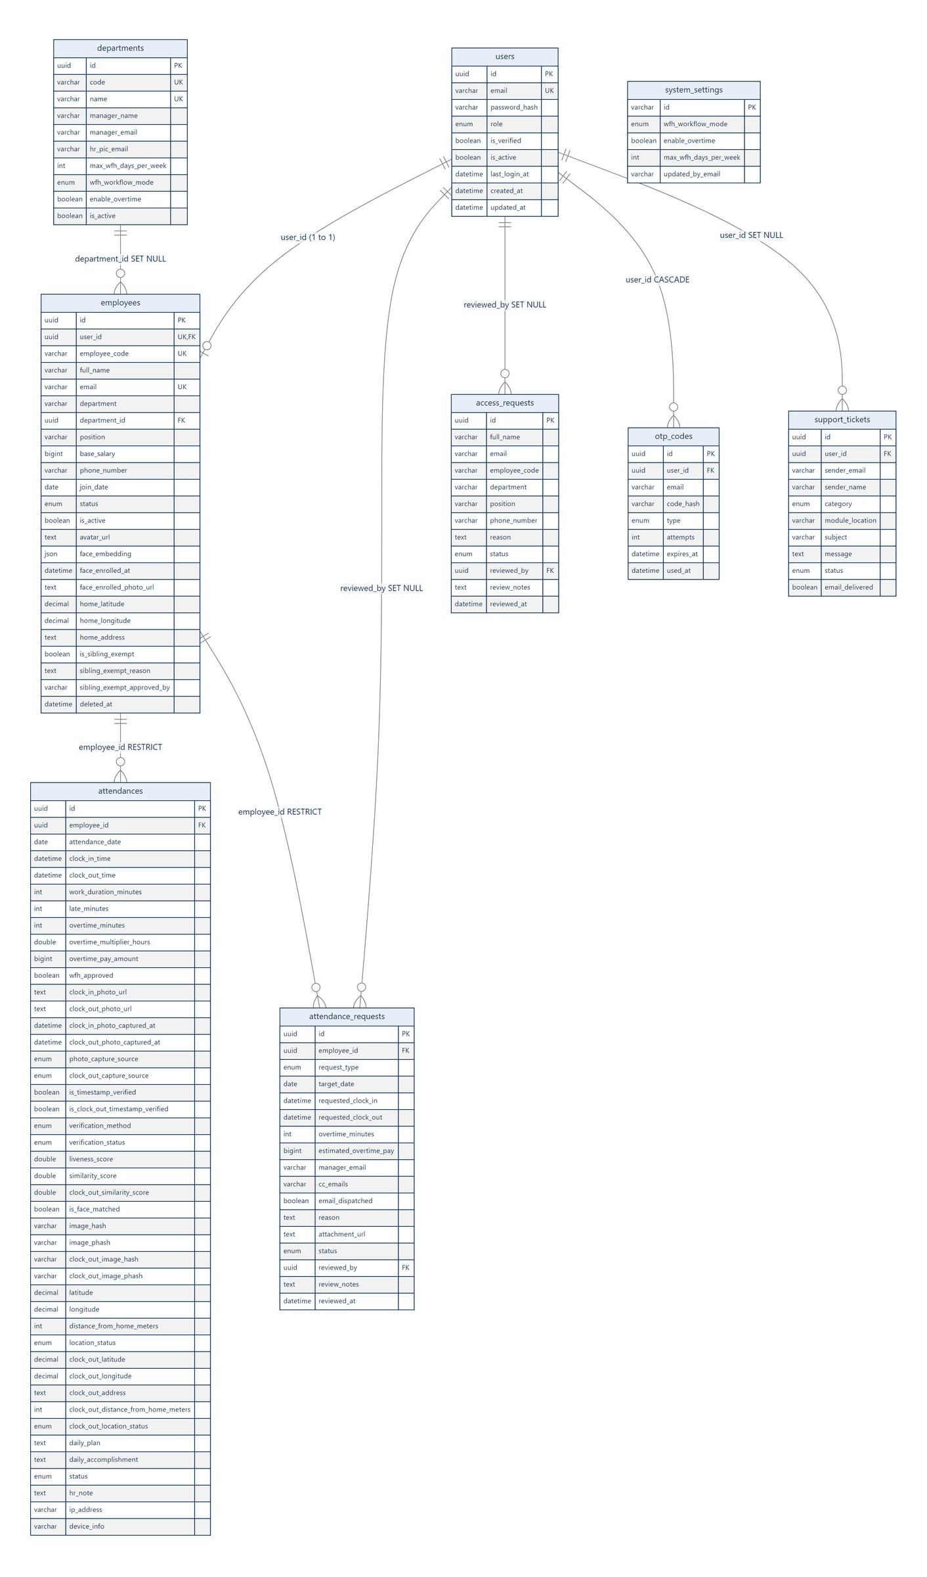
Figure 7.1: Entity relationship diagram with every table, column, key and foreign key rule.

users
Column | Type | Constraints and default
id | uuid | PK
email | varchar(150) | UNIQUE UQ_users_email
password_hash | varchar(255) | bcrypt, excluded from default selects
role | enum SYSTEM_ADMIN, HR_ADMIN, MANAGER, EMPLOYEE | default EMPLOYEE
is_verified | boolean | default false
is_active | boolean | default true
last_login_at | datetime | nullable
created_at, updated_at | datetime | automatic

employees
Column | Type | Constraints and default
id | uuid | PK
user_id | uuid | UNIQUE, FK to users.id (RESTRICT)
employee_code (NIP) | varchar(50) | UNIQUE UQ_employees_code, required
full_name | varchar(150)
email | varchar(150) | UNIQUE UQ_employees_email
department | varchar(100) | index IDX_employees_department
department_id | uuid | nullable FK to departments.id (SET NULL)
position | varchar(100)
base_salary | bigint | default 12,000,000
phone_number | varchar(30) | nullable
join_date | date
status | enum ACTIVE, INACTIVE, ON_LEAVE | default ACTIVE, indexed
is_active | boolean | default true (soft delete flag)
avatar_url, face_enrolled_photo_url | text | nullable
face_embedding | json | nullable, 512 floats
face_enrolled_at | datetime | nullable
home_latitude, home_longitude, home_address | decimal(10,8), decimal(11,8), text | nullable
is_sibling_exempt, sibling_exempt_reason, sibling_exempt_approved_by | boolean, text, varchar(150) | default false; set by HR through the sibling exemption
created_at, updated_at | datetime | automatic
deleted_at | datetime | nullable, TypeORM @DeleteDateColumn

departments
Column | Type | Constraints and default
id | uuid | PK
code | varchar(30) | UNIQUE (for example DEPT-IT)
name | varchar(100) | UNIQUE
manager_name, manager_email | varchar(150) | approval routing
hr_pic_email | varchar(150) | default admin.hrd@dexagroup.com
max_wfh_days_per_week | int | default 1
wfh_workflow_mode | enum STRICT_APPROVAL, NOTICE_ONLY | default STRICT_APPROVAL
enable_overtime, is_active | boolean | default true

attendances
Indexes: `UQ_attendance_employee_date` UNIQUE on (`employee_id`, `attendance_date`), IDX_attendance_date, IDX_attendance_status, IDX_attendances_phash (employee_id, image_phash) and IDX_attendances_out_phash (employee_id, clock_out_image_phash).
Column | Type | Notes
id | uuid | PK
employee_id | uuid | FK to employees.id (RESTRICT)
attendance_date | date | WIB calendar day
clock_in_time, clock_out_time | datetime | set by the server only
work_duration_minutes, late_minutes, overtime_minutes | int | computed by the rules in Feature 5
overtime_multiplier_hours | double | default 0
overtime_pay_amount | bigint | IDR
wfh_approved | boolean | set by an approved WFH request
clock_in_photo_url, clock_out_photo_url | text | /uploads/...
clock_in_photo_captured_at, clock_out_photo_captured_at | datetime | EXIF or client capture time
photo_capture_source, clock_out_capture_source | enum LIVE_WEBCAM, FILE_UPLOAD
is_timestamp_verified, is_clock_out_timestamp_verified | boolean | Feature 4 result
verification_method | enum LIVE_CAMERA_LIVENESS, MANUAL_FILE_UPLOAD
verification_status | enum (5 values) | only VERIFIED_LIVE_BIOMETRIC and MANUAL_FACE_MATCHED_PENDING_REVIEW are written
liveness_score, similarity_score, clock_out_similarity_score | double | scores
is_face_matched, is_clock_out_face_matched | boolean
image_hash, clock_out_image_hash | varchar(64) | SHA-256
image_phash, clock_out_image_phash | varchar(64) | average hash, 16 hex characters
latitude, longitude, address, distance_from_home_meters | decimal, text, int | optional browser location
location_status | enum IN_HOME_RADIUS, OUT_OF_HOME_RADIUS, LOCATION_UNAVAILABLE | informational
clock_out_latitude, clock_out_longitude, clock_out_address, clock_out_distance_from_home_meters, clock_out_location_status | decimal, text, int, enum | clock out location, same rules as clock in
daily_plan, daily_accomplishment, hr_note | text
status | enum ON_TIME, LATE, HALF_DAY, COMPLETED, MISSING_CLOCK_OUT, ON_LEAVE, SICK
ip_address, device_info | varchar(64), varchar(255)
exif_captured_at, exif_metadata, fallback_reason, liveness_challenge_type | various | defined but not written today

attendance_requests
Indexes: IDX_att_req_employee_date (employee_id, target_date) and IDX_att_req_status.
Column | Type | Notes
id | uuid | PK
employee_id | uuid | FK to employees.id (RESTRICT)
request_type | enum WFH_APPROVAL, OVERTIME, LEAVE, SICK, CORRECTION
target_date | date
requested_clock_in, requested_clock_out | datetime | corrections only
overtime_minutes, estimated_overtime_pay | int, bigint | overtime only
manager_email, cc_emails | varchar | resolved routing
email_dispatched | boolean | default false
reason | text | at least 10 characters
attachment_url | text | nullable
status | enum PENDING, APPROVED, REJECTED | default PENDING
reviewed_by | uuid | FK to users.id (SET NULL)
review_notes, reviewed_at | text, datetime

Other tables
Table | Columns and rules
access_requests | id PK, full_name, email (indexed with status), employee_code, department, position, phone_number, reason, status (PENDING, APPROVED, REJECTED), reviewed_by FK to users (SET NULL), review_notes, reviewed_at, created_at.
otp_codes | id PK, user_id FK to users (CASCADE), email (indexed with type), code_hash (bcrypt, never plain), type (ACCOUNT_VERIFICATION, FORGOT_PASSWORD), attempts, expires_at, used_at, created_at.
support_tickets | id PK, user_id FK to users (SET NULL), sender_email, sender_name, category (BUG, ACCOUNT_ACCESS, ATTENDANCE_ISSUE, OTHER), module_location, subject, message, status (OPEN, RESOLVED, indexed), email_delivered, created_at.
system_settings | One row with id = DEFAULT: wfh_workflow_mode, enable_overtime, max_wfh_days_per_week, updated_by_email, timestamps. Created on first read. Saving it also copies the values to every department, and it takes precedence over department values.

CHAPTER VIII
REST API AND INTERNAL MESSAGE CONTRACTS
Every gateway path starts with /api. "JWT" means JwtAuthGuard. SYSTEM_ADMIN and HR_ADMIN pass every role check (defect D1). JSON replies use the envelope { statusCode, type, where, what, why, data, meta }.

Authentication and onboarding (employee service)
Method | Gateway path | TCP pattern | Roles | Request | Response
POST | /auth/login | auth.login | Public | {email, password} | 200 tokens, 200 requiresVerification, 401, 403
POST | /auth/refresh | auth.refresh | Public | {refreshToken} | 200, 401
GET | /auth/me | auth.me | JWT | none | 200 profile
PATCH | /auth/change-password | auth.change_password | JWT | {currentPassword, newPassword} | 200, 400
GET | /auth/departments | employee.department_directory | Public | none | 200
POST | /auth/request-access | auth.request_access | Public | RequestAccessDto | 200, 409
POST | /auth/verify-account | auth.verify_account | Public | {email, otp, newPassword} | 200 tokens, 400, 429
POST | /auth/resend-verification | auth.resend_verification | Public | {email} | 200, 400, 404
POST | /auth/forgot-password | auth.forgot_password | Public | {email} | 200, 404
POST | /auth/reset-password | auth.reset_password | Public | {email, otp, newPassword} | 200, 400, 429

Employees, biometrics and access requests
Method | Gateway path | TCP pattern or FastAPI | Roles | Request | Response
POST | /employees/me/enroll-face | FastAPI /extract-embedding, then employee.enroll_face | JWT | multipart photo | 200, 400, 409, 422
GET | /employees/departments | employee.departments | JWT | none | 200
GET | /employees/department-directory | employee.department_directory | JWT | none | 200
PATCH | /employees/me/profile | employee.update_profile | JWT | fullName, phoneNumber, homeAddress, homeLatitude, homeLongitude | 200, 400
GET | /employees | employee.find_all | HR_ADMIN | page, limit, search, department, status, role, includeInactive | 200
GET | /employees/:id | employee.find_one | HR_ADMIN | none | 200, 404
POST | /employees | employee.create | HR_ADMIN | CreateEmployeeDto | 200, 400, 409
PATCH | /employees/:id | employee.update | HR_ADMIN | UpdateEmployeeDto | 200, 404, 409
DELETE | /employees/:id | employee.soft_delete | HR_ADMIN | none | 200, 400, 404
PATCH | /employees/:id/restore | employee.restore | HR_ADMIN | none | 200, 404
PATCH | /employees/:id/sibling-exemption | employee.toggle_sibling_exemption | HR_ADMIN | {isSiblingExempt, reason} | 200, 404
POST | /employees/:id/resend-otp | employee.resend_verification | HR_ADMIN | none | 200, 400, 404
GET | /access-requests | access_request.find_all | HR_ADMIN | ?status | 200
PATCH | /access-requests/:id/approve | access_request.approve | HR_ADMIN | {role, joinDate, reviewNotes} | 200, 400, 404
PATCH | /access-requests/:id/reject | access_request.reject | HR_ADMIN | {reviewNotes} | 200, 400, 404

Attendance and requests (attendance service)
Method | Gateway path | TCP pattern or FastAPI | Roles | Request | Response
POST | /attendances/verify-face-preview | FastAPI, then attendance.verify_face_preview | JWT | multipart photo | 200
POST | /attendances/clock-in | FastAPI, then attendance.clock_in | JWT (not SYSTEM_ADMIN) | photo + ClockInDto | 200, 400, 403, 409, 422
POST | /attendances/clock-out | FastAPI, then attendance.clock_out | JWT (not SYSTEM_ADMIN) | photo + ClockOutDto | 200, 400, 409, 422
GET | /attendances/today | attendance.today | JWT | none | 200
GET | /attendances/my-history | attendance.my_history | JWT | page, limit, dates | 200
GET | /attendances/my-dashboard | attendance.my_dashboard | JWT | none | 200
GET | /attendances/summary | attendance.summary | HR_ADMIN, MANAGER | ?date | 200
GET | /attendances/export | attendance.export | HR_ADMIN, MANAGER | format + filters | 200 file
GET | /attendances | attendance.find_all | HR_ADMIN, MANAGER | filters, page, limit | 200
GET | /attendances/:id | attendance.find_one | JWT | none | 200, 404
POST | /attendance-requests | attendance_request.create | JWT | multipart attachment + DTO | 200, 400, 409
GET | /attendance-requests/my | attendance_request.my | JWT | none | 200
GET | /attendance-requests | attendance_request.find_all | HR_ADMIN, MANAGER | status, type, search, page | 200
PATCH | /attendance-requests/:id/review | attendance_request.review | HR_ADMIN, MANAGER | {decision, reviewNotes} | 200, 400, 403, 404

System, policy, support and Database Studio
Method | Gateway path | TCP pattern | Roles | Request | Response
GET | /system/time | gateway only | Public | none | 200
GET | /system/health | gateway only | Public | none | 200
GET | /system/policy | attendance.get_policy | Public | none | 200
PATCH | /system/policy | attendance.update_policy | HR_ADMIN, SYSTEM_ADMIN | UpdatePolicyDto | 200, 403
POST | /support/contact-developer | support.contact_developer | JWT | ContactDeveloperDto | 200
GET | /support/tickets | support.find_tickets | JWT | none | 200
PATCH | /support/tickets/:id/resolve | support.resolve | HR_ADMIN | none | 200, 404
POST | /support/test-email | support.test_email | HR_ADMIN, SYSTEM_ADMIN | {targetEmail} | 200
GET | /system/database/tables | database.get_tables | SYSTEM_ADMIN | none | 200
GET | /system/database/:table | database.get_rows | SYSTEM_ADMIN | page, limit, search, sort | 200, 400
GET | /system/database/:table/:id | database.get_row | SYSTEM_ADMIN | none | 200, 404
POST | /system/database/:table | database.insert_row | SYSTEM_ADMIN | JSON row | 200, 400
PUT | /system/database/:table/:id | database.update_row | SYSTEM_ADMIN | JSON fields | 200, 400, 404
DELETE | /system/database/:table/:id | database.delete_row | SYSTEM_ADMIN | none | 200, 404, 409

Biometric service (FastAPI, internal)
Method | Path | Called by | Request | Response
GET | /health | Docker health check | none | {status: HEALTHY, model, embedding_dimensions: 512}
POST | /extract-embedding | BiometricClientService.extractEmbedding | multipart file | status, face count, embedding of 512, bbox, detection score, image_hash, image_phash
POST | /verify-face | not called | file, reference_embedding, threshold (0.45) | {is_match, similarity, threshold}

CHAPTER IX
NON FUNCTIONAL REQUIREMENTS, SECURITY AND LIMITATIONS

Performance targets
Area | Target and current behaviour
Biometric inference | Target of about 200 ms per frame on CPU with det_size 320x320. This was not formally benchmarked. The gateway allows 10 seconds per call.
Face comparison | A dot product of 512 numbers, well under a millisecond.
Gateway to microservice | 15 second timeout per TCP call, 502 on transport failure.
Lists | At most 100 rows per page.
Export | At most 5,000 rows, built in memory, base64 over TCP. Not yet a true stream.
Uploads | 8 MB per image or attachment (nginx allows a 15 MB body).

Security safeguards in place
Safeguard | Implementation
SQL injection | TypeORM repositories and QueryBuilder with bound parameters everywhere. The Database Studio limits table names to a whitelist and sort columns to entity metadata.
XSS | React escapes rendered values. (Email templates insert user reasons without escaping, which matters only to mail clients.)
Passwords | bcrypt with cost 10. password_hash is excluded from default selects and masked in the Database Studio.
OTP | Codes stored as bcrypt hashes, 15 minute expiry, 5 attempt lock, older codes invalidated on reissue.
Tokens | HMAC HS256 signed access and refresh tokens with separate secrets and a tokenType claim.
Input validation | Global ValidationPipe with whitelist and class validator DTOs (NIP, phone, OTP, HH:mm and strong password patterns).
Time | Official times come from the server only.
Photo reuse | SHA-256 exact match and average hash near match rejection per employee.
Duplicate faces | One to many cosine check at enrollment against every active employee. A sibling exemption must be granted by HR and never covers a match of 0.90 or more.
Separation of duties | The System Admin is blocked from attendance at the gateway and in the UI.
Error hygiene | Structured where, what and why errors from global filters. No stack traces in responses.

Note: About signed tokens
The brief listed signed review links as a safeguard. The code uses signed JWTs for sessions, but the review link in emails is a plain request ID. See Feature 6.

Core system limitations
- Lighting, shadow and head pose. ArcFace needs a clear frontal face. Low light, strong back light, masks or a head turned far from the camera (roughly beyond 45 degrees) can drop similarity below 0.45 or produce NO_FACE. The upload fallback still needs a face match, and those records are marked for review.
- One shift. Start time, grace, half day threshold and the 540 minute overtime span assume a single 08:30 to 17:30 WIB schedule. Rotating shifts would need shift templates.
- Local disk storage. Files live in a bind mounted folder on one machine. Scaling across nodes needs object storage.
- Server time versus slow uploads. The official time is when the request arrives. On a slow connection it can be a few seconds after the user pressed capture.
Further constraints: liveness is 2D and runs in the browser; dashboards aggregate in memory; there is no scheduler; email links point to http://localhost:5173; and the demo passwords and default JWT secrets must change before any real use.

Known defects found during this review
# | Severity | Finding | Where
D1 | High | RolesGuard and ProtectedRoute always admit HR_ADMIN, so the System Admin only Database Studio is reachable by HR. | roles.guard.ts, ProtectedRoute.tsx
D2 | High | The onboarding review UI calls PATCH /access-requests/:id/review, which does not exist. Approve and reject return 404. | MasterEmployeesPage.tsx
D3 | Medium | When FastAPI returns ERROR, clock in and clock out store a default similarity of 0.92 with no comparison. | attendance.service.ts
D4 | Medium | A client photoCapturedAt counts as a timestamp, so uploads without EXIF can pass verification. | photo-metadata.util.ts
D5 | Medium | The client sends livenessScore: 0.99 for every capture, and the preview proceeds as recognized if its call fails. | CameraPhotoUpload.tsx
D6 | Medium | LiveServerClock reads serverTimestampMs, but the API returns serverEpochMs, so the header clock and watermark use device time. | LiveServerClock.tsx
D7 | Low | Template variable names differ from the code: JWT_ACCESS_SECRET against JWT_SECRET, LATE_GRACE_MINUTES against WORK_GRACE_MINUTES. OTP_EXPIRES_MINUTES and UPLOAD_DIR are unused. | .env.example, docker-compose.yml
D8 | Fixed | Fixed after the first review. email_dispatched now records the real result of the send. | attendance-requests.service.ts
D9 | Low | Unverified sign in reissues an OTP without a password check, and sign in reveals unregistered emails. | auth.service.ts
D10 | Low | GET /attendances/:id has no ownership check, and /uploads is public. | attendance.controller.ts, main.ts
D11 | Low | Folder and file names use the container clock, not WIB. | photo-metadata.util.ts
D12 | Info | /verify-face and several attendance columns are defined but unused. | various
D13 | Medium | The WFH notice and request form fills its date with the UTC date, so between 00:00 and 07:00 WIB it suggests yesterday. A notice sent then is filed for the wrong day and clock in stays locked. Export file names use the UTC date too. | LeaveAndCorrectionModal.tsx
D14 | Low | The profile page says the 100 meter home radius is strictly enforced, but clock in and clock out only tag the distance. | ProfilePage.tsx, attendance.service.ts
D15 | Low | Without a saved home location the map window says No Clock In GPS submitted, although the coordinates were saved. | AttendanceLocationMapModal.tsx
D16 | Low | Request emails wrap SMTP_FROM in a second display name, so the sender reads "Name (via Dexa WFH)>". Delivery is not affected. | attendance-requests.service.ts
D17 | Info | With SMTP_OVERRIDE_RECIPIENT set, support tickets keep their Cc list, so real SMTP reports the @dexagroup.com copies as undeliverable. | mail.service.ts

CHAPTER X
DEPLOYMENT ARCHITECTURE AND ROADMAP

Current scope: local execution only
This is a Fullstack Technical Assessment. The system runs locally with Docker Compose and is intentionally not deployed to a public cloud server. There is no public URL, no managed database and no production secret store. The goal is that a reviewer can run the whole topology on one machine, deterministically, and inspect every layer, including the stored photo evidence. The only outside account needed is a Gmail or Outlook mailbox for email.
Container | Image or build | Host port | Waits for
dexa-wfh-mysql | mysql:8.0 | 3306 | none
dexa-wfh-biometric-service | ./biometric-service (Python 3.10 slim) | 8000 | none (mounts ~/.insightface read only)
dexa-wfh-employee-service | ./backend (Node 22 alpine) | 3001 | MySQL and biometric healthy
dexa-wfh-attendance-service | ./backend | 3002 | employee service healthy
dexa-wfh-api-gateway | ./backend | 3000 | both microservices healthy (mounts ./uploads)
dexa-wfh-frontend | ./frontend (Vite build, nginx 1.27) | 5173 (to 80) | gateway healthy

The order is enforced with depends_on and health conditions. MySQL data persists in the volume dexa_mysql_data, and evidence files in the host folder ./uploads. Email goes out through the SMTP account in .env. Chapter XI shows a full run from an empty folder to a signed in session, with real output.

Evaluation entry points
What | Address
Web portal | http://localhost:5173
API base | http://localhost:3000/api
Swagger | http://localhost:3000/api/docs
Emails | the inbox set in SMTP_OVERRIDE_RECIPIENT
Biometric engine | http://localhost:8000/health and http://localhost:8000/docs

Seeded evaluation accounts
Role | Name | Email | Password
SYSTEM_ADMIN | Abdurrahman Khairi | sysadmin@dexagroup.com | AdminDexa2026!
HR_ADMIN | HR Admin One | admin.hrd@dexagroup.com | AdminDexa2026!
MANAGER | Manager One (IT) | manager.it@dexagroup.com | ManagerDexa2026!
MANAGER | Manager Two (Finance) | manager.finance@dexagroup.com | ManagerDexa2026!
EMPLOYEE | Employee One, Two, Three | employee.one@dexagroup.com and so on | EmployeeDexa2026!
EMPLOYEE (unverified) | Employee Four | employee.four@dexagroup.com | set during OTP verification

Note: Manager accounts
A fresh database receives six accounts on the first start of the employee service. The two manager accounts are added the next time it starts, so run docker compose restart employee-service once after the first boot.

Future deployment roadmap
The local setup above is the right shape for an assessment. A production rollout for Dexa Group would change it in eight steps:
- Container orchestration and auto scaling. Move from docker-compose.yml to managed Kubernetes (EKS or GKE). Give the CPU heavy biometric-service a Horizontal Pod Autoscaler tuned for the 08:00 to 08:30 WIB clock in peak, and keep the TCP services behind internal cluster services.
- Cloud object storage. Replace the local /app/uploads volume with AWS S3, Google Cloud Storage or an on premise MinIO cluster. Keep the year/department/role/person/month/ key layout and serve images through short lived pre signed URLs, which also closes defect D10.
- Production email and queueing. Today the services send through a Gmail or Outlook account with an app password. Production should use a company relay or a provider such as AWS SES or SendGrid on the company domain with SPF, DKIM and DMARC, OAuth2 instead of passwords, and a Redis and BullMQ queue with retries so an email spike never slows an HTTP response.
- Managed database, backups and replicas. Move to Amazon RDS or Cloud SQL for MySQL with point in time recovery, enforced TLS connections, and a read replica for heavy payroll exports and dashboards.
- CI/CD, HTTPS and observability. GitHub Actions or GitLab CI to run tests, type checks and image builds on every merge. An nginx ingress with TLS certificates. Secrets (JWT keys, database and SMTP credentials) in HashiCorp Vault or Sealed Secrets. Prometheus, Grafana and Loki for metrics, latency and central logs, with an alert on biometric inference time during the morning peak.
- Identity and sessions. Single sign on through the company identity provider (OIDC), refresh token rotation with a server side store so sign out really ends a session, and tokens in HTTP only cookies.
- Biometric capacity. A GPU node pool with ONNX Runtime CUDA or TensorRT for the morning peak, a readiness endpoint so the gateway waits for the model, and a vector index for the one to many duplicate face check.
- Data protection and retention. Face embeddings encrypted at rest with keys held outside the database, evidence served only through signed URLs, retention rules per file type, and restores of the database backups tested on a schedule.

CHAPTER XI
LOCAL INSTALLATION WALKTHROUGH
This chapter repeats the local installation walkthrough from the companion Installation Guide, so the PRD can be read on its own. The steps, outputs and screenshots come from a real installation of the current code on a clean folder.

Scope and Architecture

Local Assessment Scope
This project is built for local technical evaluation. You run everything on your own computer. The only outside account you need is a Gmail or Outlook mailbox, which the system uses to send its email.
- Email goes out through a real SMTP account, Google Gmail or Microsoft Outlook, set in the root .env. There is no local mail catcher. With SMTP_OVERRIDE_RECIPIENT set, every one time code, approval email and support ticket lands in your own inbox.
- Photos and attachments are written to the local disk under uploads/, sorted by year, department, role, person and month.
- Face recognition runs on your CPU with InsightFace and ONNX Runtime. The only download it needs is the buffalo_l model, once.

The Six Components and Their Ports
# | Component | Technology | Port (host) | What it does
1 | Frontend portal | React 18, Vite 5, Tailwind CSS. In Docker it is built and served by nginx. | 5173 (container port 80) | The web portal you sign in to. nginx forwards /api and /uploads to the gateway.
2 | API Gateway | NestJS 11 on Express, Node 22 | 3000 | The only HTTP entry point. Checks tokens and roles, accepts photo uploads, reads EXIF data, and passes work to the two microservices over TCP. Swagger lives at /api/docs.
3 | Employee microservice | NestJS 11 TCP microservice, TypeORM | 3001 (TCP, not HTTP) | Sign in, tokens, one time codes, employee records, access requests, support tickets and the Database Studio. It also creates the tables and seeds the demo accounts.
4 | Attendance microservice | NestJS 11 TCP microservice, TypeORM, ExcelJS | 3002 (TCP, not HTTP) | Clock in and clock out, face match scoring, status rules, requests and approvals, dashboards, exports and the company WFH policy.
5 | Biometric engine | Python 3.10, FastAPI, Uvicorn, InsightFace buffalo_l on ONNX Runtime (CPU) | 8000 | Turns a face photo into a 512 dimensional ArcFace vector. Swagger lives at /docs.
6 | Database | MySQL 8.0 | 3306 | Nine tables, kept in the Docker volume dexa_mysql_data.

Docker Compose starts them in a fixed order and waits for each health check: MySQL and the biometric engine first, then the employee service (which creates the tables), then the attendance service, then the gateway, and the frontend last.

Prerequisites and a Zero State Check

Step 1: Check Tool Versions
Open PowerShell (or any terminal) and check what you have. For the Docker method you only need Docker Desktop with Compose v2. For the manual method you also need Node.js and Python.
Tool | Needed for | Version to use | Version on the test machine
Docker Desktop (or Docker Engine) | Method A and the database in Method B | 24 or newer, with WSL 2 on Windows | 29.1.3
Docker Compose | Both methods | v2 plugin (docker compose, with a space) | v5.0.1
Node.js and npm | Method B | Node 22 LTS (the Dockerfiles use node:22-alpine) | Node 22.11.0, npm 10.9.0
Python | Method B | 3.10 (the Dockerfile uses python:3.10-slim) | 3.10.6

node -v
npm -v
python --version
docker -v
docker compose version

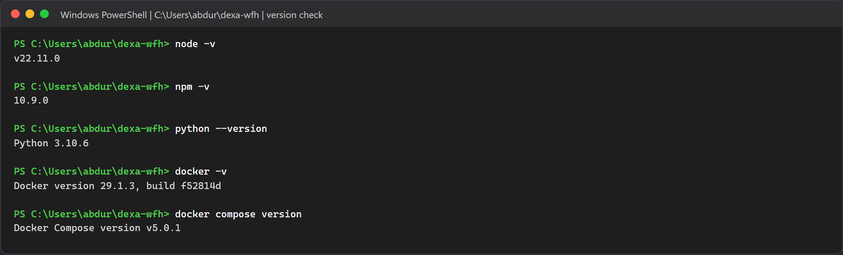
Figure 11.1: Real version output on the test machine.
You also want a webcam for the face steps, at least 8 GB of RAM (16 GB is more comfortable with six containers), and about 6 GB of free disk space for the images, the database and the face model. For email you need a Gmail account with two step verification and an App Password, or an Outlook account that allows SMTP sign in.

Step 2: Look at the project folder
The repository is a small monorepo. Each folder maps to one or more of the components above.
Folder | What is inside
backend/ | One NestJS workspace with three apps (api-gateway, employee-service, attendance-service) and a shared library in libs/common for entities, DTOs, enums and rules. One Dockerfile builds all three.
biometric-service/ | The FastAPI face engine: main.py, service.py, requirements.txt and its Dockerfile.
frontend/ | The React app, its Vite config and the nginx config used in Docker.
database/ | Optional SQL files. You do not need to run them, because the app creates its own tables.
uploads/ | Where Docker mode stores photos. It starts empty apart from .gitkeep.
docker-compose.yml | Defines all six services, their ports, health checks and start order.

Get-ChildItem -Force -Name

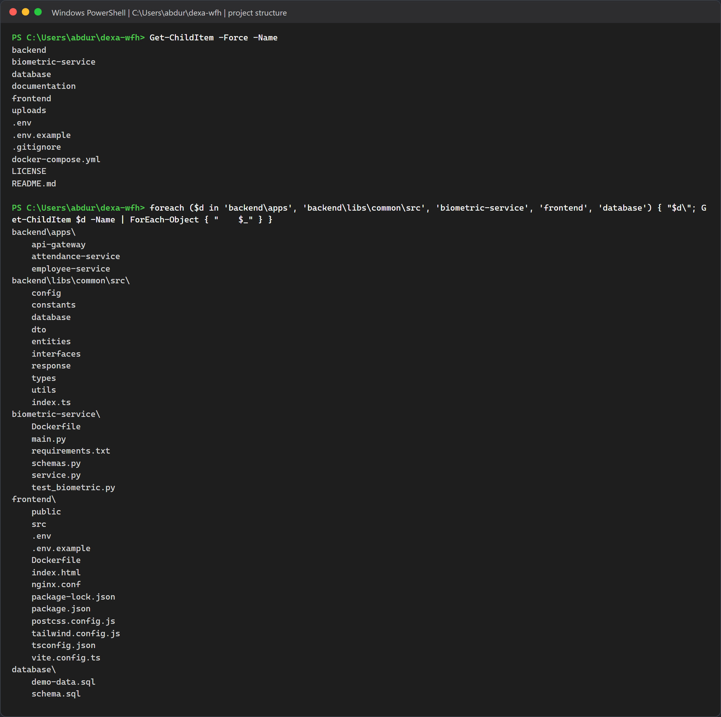
Figure 11.2: The top level of the clean copy and the main subfolders. The three .env files in this listing were created in section 11.3.

Step 3: Make sure the ports are free
The stack needs six ports. If another program already holds one of them, the matching container will fail to start. Run this check before you install anything:
foreach ($p in 3000,3001,3002,3306,5173,8000) {
$c = Get-NetTCPConnection -State Listen -LocalPort $p -ErrorAction SilentlyContinue
"{0,-6} {1}" -f $p, $(if ($c) { 'IN USE by PID ' + $c[0].OwningProcess } else { 'free' })
}

On macOS or Linux, lsof -i :3306 does the same job for one port. On Windows, netstat -ano | findstr :3306 works too.
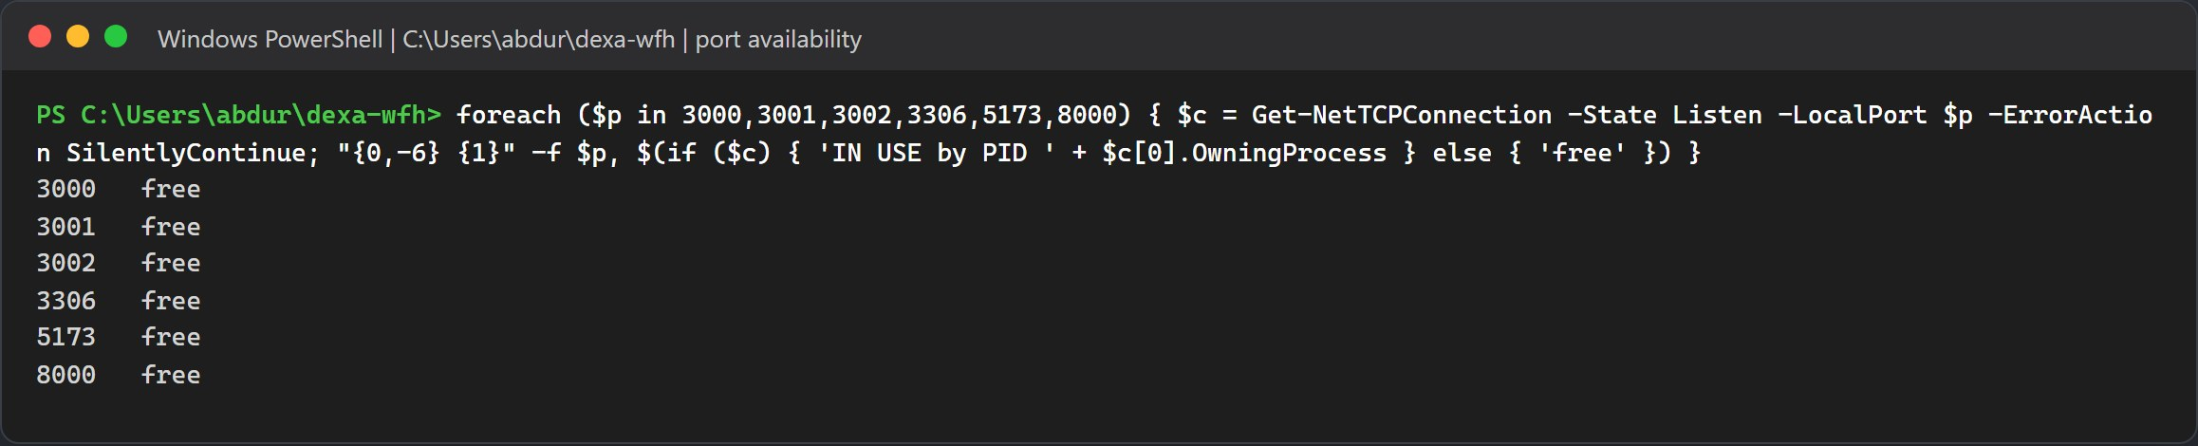
Figure 11.3: All six ports reported free before the installation started.

Environment Files

Copy the Templates
The repository ships three templates. Copy each one to a real .env file:
Copy-Item .env.example .env
Copy-Item backend\.env.example backend\.env
Copy-Item frontend\.env.example frontend\.env

On macOS, Linux or Git Bash use cp .env.example .env and so on. The biometric service has no .env file at all. It only reads INSIGHTFACE_HOME and FORCE_GPU from the shell.
Warning: Fill in your SMTP account before the first start
The template ships with placeholders: SMTP_USER=your_email@gmail.com, SMTP_PASS=your_16_digit_app_password, and the same address in SMTP_FROM and SMTP_OVERRIDE_RECIPIENT. Replace them with your own values in the root .env before you run Docker. With the placeholders the stack still starts, but every email fails with an authentication error, and Employee Four cannot be activated because the activation code never arrives. Keep the single quotes around the SMTP_FROM value; without them Docker Compose stops with unexpected character "<" in variable name.

Here is what each file is for:
- Root `.env`: Docker Compose reads it to fill the ${VAR:-default} placeholders in docker-compose.yml. Every placeholder already has a default, so Docker also works with no .env at all. The NestJS apps read it too when you run them by hand.
- `backend/.env`: holds the same keys as the root file. The backend loads backend/.env first and then the root .env, so this copy is only useful for backend specific overrides.
- `frontend/.env`: holds VITE_API_BASE_URL=/api and an empty VITE_BACKEND_ORIGIN. Both are the defaults, so the file is optional.
These are the active lines of the root template, with its comment lines left out:
DB_TYPE=mysql
DB_HOST=127.0.0.1
DB_PORT=3306
DB_USERNAME=dexa_user
DB_PASSWORD=dexa_password_2026
DB_DATABASE=dexa_wfh_db
DB_SYNCHRONIZE=true
DB_LOGGING=false
API_GATEWAY_PORT=3000
EMPLOYEE_SERVICE_HOST=127.0.0.1
EMPLOYEE_SERVICE_PORT=3001
ATTENDANCE_SERVICE_HOST=127.0.0.1
ATTENDANCE_SERVICE_PORT=3002
JWT_ACCESS_SECRET=dexa-wfh-jwt-access-secret-2026-abdurrahman-khairi
JWT_REFRESH_SECRET=dexa-wfh-jwt-refresh-secret-2026-abdurrahman-khairi
JWT_ACCESS_EXPIRES_IN=8h
JWT_REFRESH_EXPIRES_IN=7d
OTP_EXPIRES_MINUTES=10
WORK_START_TIME=08:30
LATE_GRACE_MINUTES=15
HALF_DAY_THRESHOLD_MINUTES=240
SMTP_HOST=smtp.gmail.com
SMTP_PORT=587
SMTP_SECURE=false
SMTP_USER=your_email@gmail.com
SMTP_PASS=your_16_digit_app_password
SMTP_FROM='"Dexa Group WFH Monitoring" <your_email@gmail.com>'
SMTP_OVERRIDE_RECIPIENT=your_email@gmail.com
SYSTEM_NOREPLY_EMAIL=noreply-wfh@dexagroup.com
DEVELOPER_SUPPORT_EMAIL=abdurrahman.khairi@dexagroup.com
UPLOAD_DIR=./uploads

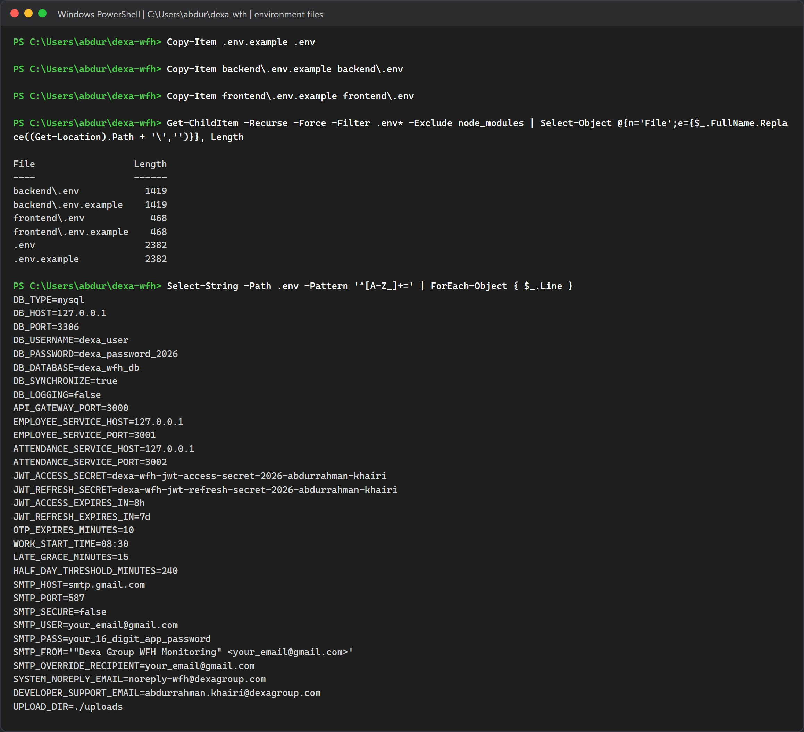
Figure 11.4: The three .env files created from their templates, and the values inside the root .env.

Environment Variable Reference
Inside Docker, the containers talk to each other by service name (mysql, biometric-service, employee-service, attendance-service). Those host names are written straight into docker-compose.yml and ignore your .env. When you run the apps by hand on your computer, everything is 127.0.0.1. The SMTP host is the exception: it is a real mail server on the internet in both methods.
Variable | Read by | Value in Docker | Value in Method B | What it controls
DB_HOST | employee and attendance services | mysql | 127.0.0.1 | Database host.
DB_PORT | employee and attendance services | 3306 inside the network | 3306 | Database port. Setting it in the root .env also changes the host port Docker publishes.
DB_USERNAME, DB_PASSWORD, DB_DATABASE | both services and the MySQL container | dexa_user, dexa_password_2026, dexa_wfh_db | same | Credentials. The MySQL container creates this user and database on its first start.
DB_SYNCHRONIZE | employee service | true (attendance gets false) | true | Lets TypeORM create the tables. Only the employee service is allowed to.
EMPLOYEE_SERVICE_HOST and _PORT | gateway and employee service | employee-service, 3001 | 127.0.0.1, 3001 | TCP link to the employee service.
ATTENDANCE_SERVICE_HOST and _PORT | gateway and attendance service | attendance-service, 3002 | 127.0.0.1, 3002 | TCP link to the attendance service.
BIOMETRIC_SERVICE_URL | gateway and both services | http://biometric-service:8000 | not set, so the code uses http://127.0.0.1:8000 | Where the face engine lives.
JWT_SECRET | gateway and employee service | not set, so both use dexa-wfh-secret-2026 | same | Secret that signs access tokens. The template calls it JWT_ACCESS_SECRET, but the code reads JWT_SECRET.
JWT_REFRESH_SECRET | employee service | template value | template value | Secret for refresh tokens.
JWT_ACCESS_EXPIRES_IN, JWT_REFRESH_EXPIRES_IN | employee service | 8h, 7d | 8h, 7d | Token lifetimes.
WORK_START_TIME, HALF_DAY_THRESHOLD_MINUTES | attendance service | 08:30, 240 | same | Shift start (WIB) and the minimum minutes for a full day.
WORK_GRACE_MINUTES | attendance service | not set, so 15 | not set, so 15 | Grace period before a clock in counts as late. The template calls it LATE_GRACE_MINUTES, which the code does not read.
SMTP_HOST, SMTP_PORT | both services | smtp.gmail.com, 587 | smtp.gmail.com, 587 | The SMTP server. Gmail is the default; switch to smtp.office365.com for Outlook.
SMTP_SECURE, SMTP_USER, SMTP_PASS | both services | false, your address, your App Password | same, from backend/.env | TLS mode and SMTP sign in. Keep false for port 587; the connection then upgrades with STARTTLS. Port 465 switches to direct TLS on its own. Gmail and Outlook refuse mail without a sign in.
SMTP_FROM | both services | template value | template value | Sender address on every email. When it is empty, the sender becomes SMTP_USER, or the system address when that is empty too.
SMTP_OVERRIDE_RECIPIENT | employee and attendance services | your inbox | your inbox | When set, every email goes to this one address with a yellow banner naming the original recipient. The attendance service also drops the CC list; the employee service keeps it on support tickets.
OTP_EXPIRES_MINUTES | nothing | ignored | ignored | One time codes always expire after 15 minutes. That value is a constant in the code.
UPLOAD_DIR | nothing | ignored | ignored | Photos always go to uploads inside the folder the gateway runs from: /app/uploads in Docker (mapped to the root uploads/), backend/uploads in Method B.
VITE_API_BASE_URL | frontend build | /api | /api | Base URL for API calls. There is no VITE_API_URL variable in this project.
VITE_API_PROXY_TARGET | Vite dev server | not used | optional, default http://localhost:3000 | Where npm run dev forwards /api and /uploads.
NODE_ENV | employee service | production | not set | When it is not production, API responses include the one time code as a hint, which helps local testing.

SMTP Email Options
Section 5 of the root .env.example holds two blocks. Option A, Gmail, is active. To use Outlook, comment out the Option A lines and remove the # in front of the six lines of Option B. Fill in your own address and password either way, and keep only one block active.
# 5. SMTP Email Configuration (Real-World Gmail & Outlook Auto-Emailing)
# Option A (Active): Google Gmail SMTP (STARTTLS on port 587, 16 character Google App Password)
SMTP_HOST=smtp.gmail.com
SMTP_PORT=587
SMTP_SECURE=false
SMTP_USER=your_email@gmail.com
SMTP_PASS=your_16_digit_app_password
SMTP_FROM='"Dexa Group WFH Monitoring" <your_email@gmail.com>'

# Option B: Microsoft Outlook / Office 365 SMTP (STARTTLS on port 587):
# SMTP_HOST=smtp.office365.com
# SMTP_PORT=587
# SMTP_SECURE=false
# SMTP_USER=your_email@outlook.com
# SMTP_PASS=your_outlook_password
# SMTP_FROM='"Dexa Group WFH Monitoring" <your_email@outlook.com>'

# Smart Evaluation Forwarding (delivers every email for the @dexagroup.com demo accounts to this inbox):
SMTP_OVERRIDE_RECIPIENT=your_email@gmail.com

- Option A, Gmail. SMTP_PASS must be a 16 character Google App Password, not your normal Google password. section 11.7 explains how to create one. Gmail sends as the account in SMTP_USER and replaces any other sender address unless it is a verified alias, so use that same Gmail address in SMTP_FROM.
- Option B, Outlook and Office 365. Use your full Outlook address as SMTP_USER. When the host contains office365.com or outlook.com, both services force STARTTLS and apply a cipher setting for Microsoft servers. Your account or tenant must still allow SMTP sign in with a password (see section 11.7).
- SMTP_FROM. The sender shown on every email. Use the address you sign in with, and keep the single quotes around the whole value.
- SMTP_OVERRIDE_RECIPIENT. Your own inbox for evaluation. Leave it set while you test: the demo accounts use @dexagroup.com addresses that cannot receive real mail, so without it the activation codes and approval emails are lost. Method B reads backend/.env first, so put the same SMTP values there too.
Note: Recreate the containers after you edit .env
Docker hands environment values to a container only when it creates it, so docker compose restart keeps the old SMTP settings. Run docker compose up -d instead, which recreates every container whose settings changed. In Method B, stop npm run start:dev with Ctrl+C and start it again.

Emails the System Sends
Every email below goes out through the SMTP account in .env. With SMTP_OVERRIDE_RECIPIENT set, the To address of each one becomes your own inbox.
Email | Sent by | Who receives it, and when
Account activation code (6 digits, valid 15 minutes) | employee service | The account's own address, when an account that is not yet verified signs in, or when HR resends the code.
Password reset code | employee service | The account's own address, from Forgot Password.
WFH, overtime, leave, sick or correction request | attendance service | To the department manager, CC the department HR contact (admin.hrd@dexagroup.com by default) and the requester. A request from a Manager or System Admin goes up to the HR contact instead, with sysadmin@dexagroup.com added to CC. Under the NOTICE_ONLY policy a WFH request is approved at once and the email is a notice. The review button opens /manager/approvals?requestId=<id>, and the reviewer still has to sign in.
Approval decision | attendance service | To the requester, CC the manager and admin.hrd@dexagroup.com, when a request is approved or rejected.
Support ticket (Contact Developer) | employee service | To every active System Admin, CC every active HR Admin and the sender.
SMTP test email | employee service | The targetEmail address, or the caller's own address. Sent by POST /api/support/test-email, for HR Admin and System Admin only.

Method A, Docker Compose (Recommended)

This is the quickest way to get the whole system running. One command builds five images, pulls MySQL, and starts all six containers in the right order.

Before Start: The Face Model
The biometric container does not download its model. It mounts your own model folder, %USERPROFILE%\.insightface on Windows or ~/.insightface on macOS and Linux, as read only. Make sure models/buffalo_l with its five .onnx files exists there before the first start. The simplest way is to download the release zip and unpack it:
New-Item -ItemType Directory -Force "$env:USERPROFILE\.insightface\models\buffalo_l" | Out-Null
Invoke-WebRequest -Uri "https://github.com/deepinsight/insightface/releases/download/v0.7/buffalo_l.zip" `
-OutFile "$env:USERPROFILE\.insightface\models\buffalo_l.zip"
Expand-Archive "$env:USERPROFILE\.insightface\models\buffalo_l.zip" `
-DestinationPath "$env:USERPROFILE\.insightface\models\buffalo_l" -Force

If unpacking creates a nested buffalo_l\buffalo_l folder, move the five files up one level.

Step 1: Build and Start All Containers
docker compose up --build -d

Here is what gets built:
- `biometric-service`: Python 3.10 slim plus build tools, OpenCV, ONNX Runtime and InsightFace.
- `employee-service`, `attendance-service`, `api-gateway`: three images from the same backend Dockerfile. Each runs npm install and npm run build on Node 22.
- `frontend`: a Node 22 build stage that runs vite build, then an nginx image that serves the result.
MySQL is pulled as a ready made image. With -d, the command returns once the frontend container has started. Before that, it waits for each health check in turn, and you can watch the Healthy lines appear in that order.
On the test machine the command took about three and a half minutes. Docker reused the cached npm install layers from an earlier build, but it ran pip install for the biometric image again (about two and a half minutes of that time) and rebuilt the application code. On a computer that has never built these images, expect it to take longer, because every package has to be downloaded first.
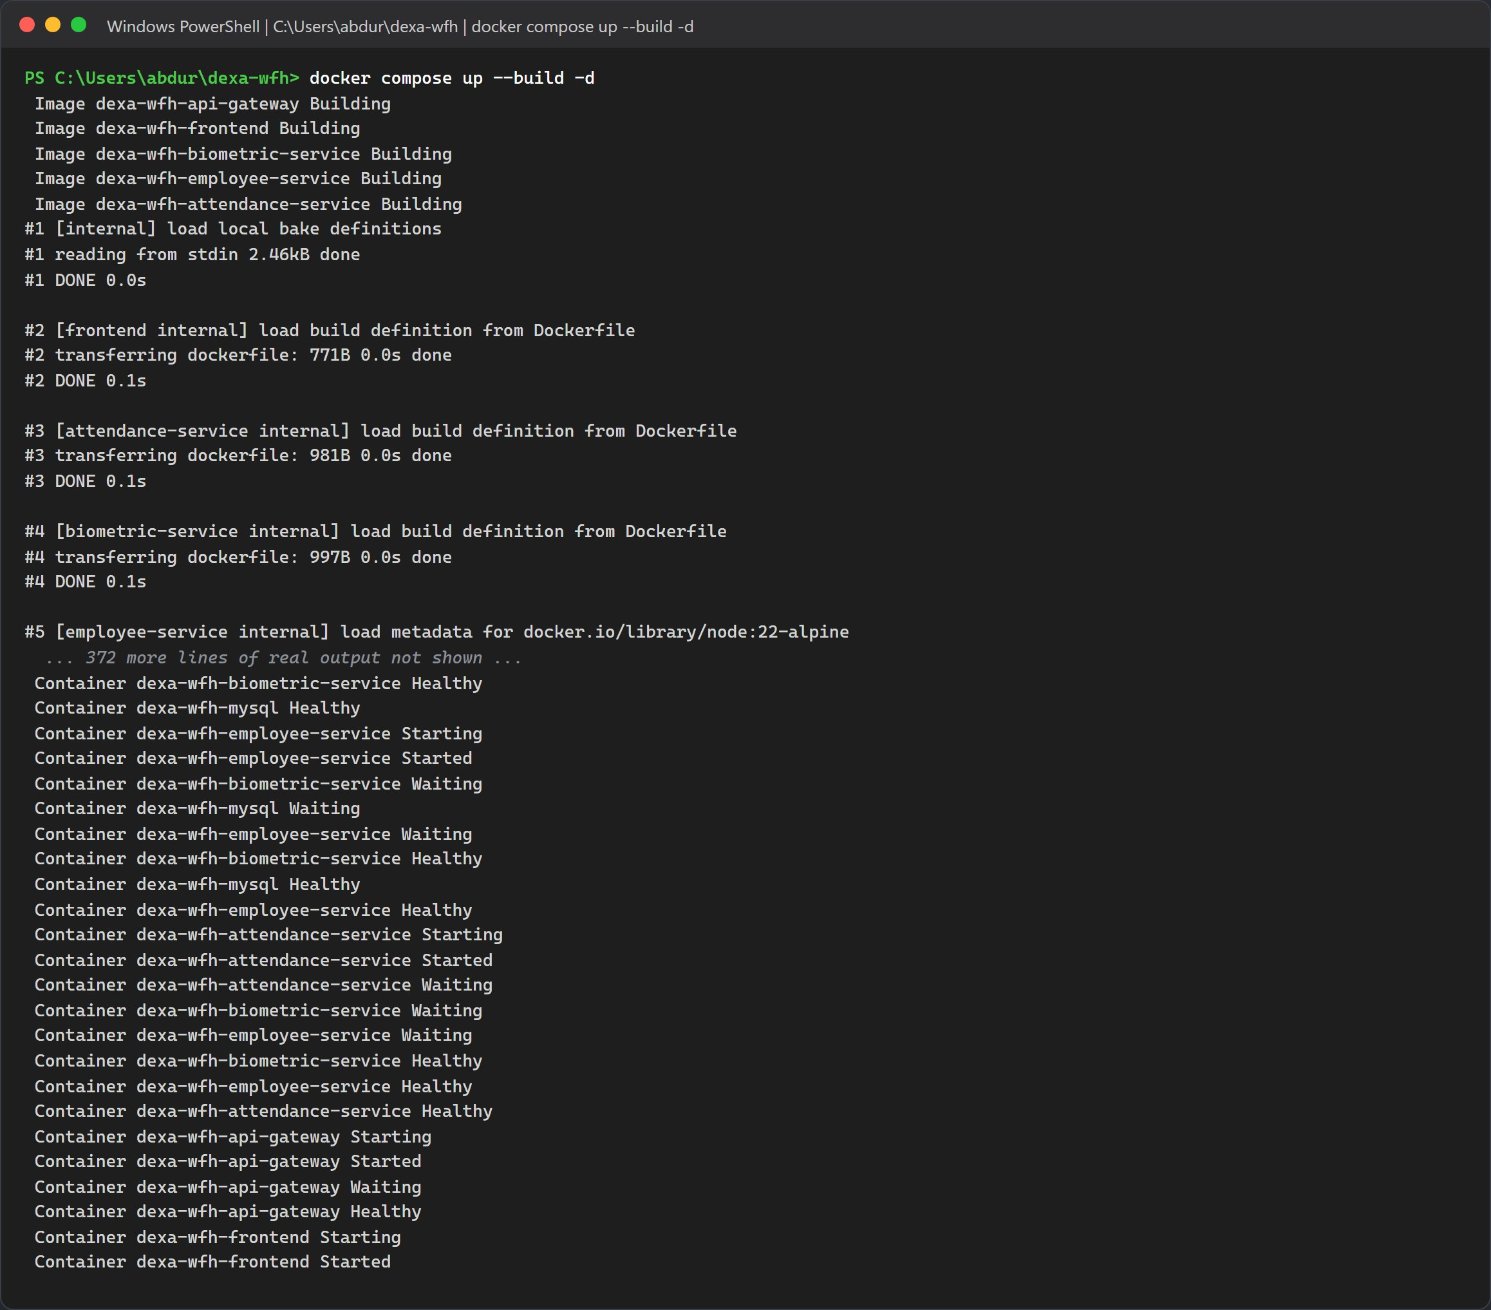
Figure 11.5: The start and the end of the real build output, ending with every container started.

Step 2: Check the Containers and their Ports
docker compose ps

Five containers should report healthy. The frontend has no health check, so it only shows Up. The ports column should match the table in section 11.1.
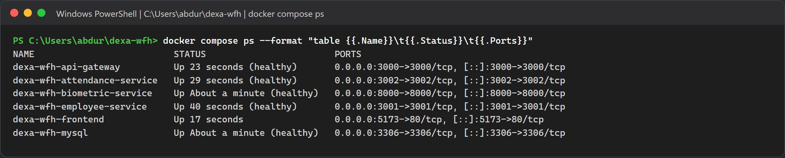
Figure 11.6: All six containers running, with their host port bindings.

Step 3: Watch the Face Model Load
When the biometric container starts, it loads the five buffalo_l ONNX models into memory before it answers any request. On the test machine this took about 28 seconds inside Docker. ArcFace (w600k_r50.onnx, a ResNet 50 network) is the model that produces the 512 dimensional face vectors. ONNX Runtime runs it on the CPU.
To prove the engine works end to end, send it one sample photo and read the log:
curl.exe -s http://localhost:8000/health
curl.exe -s -o NUL -w "HTTP %{http_code}\n" -F "file=@sample-face.jpg" http://localhost:8000/extract-embedding
docker compose logs biometric-service

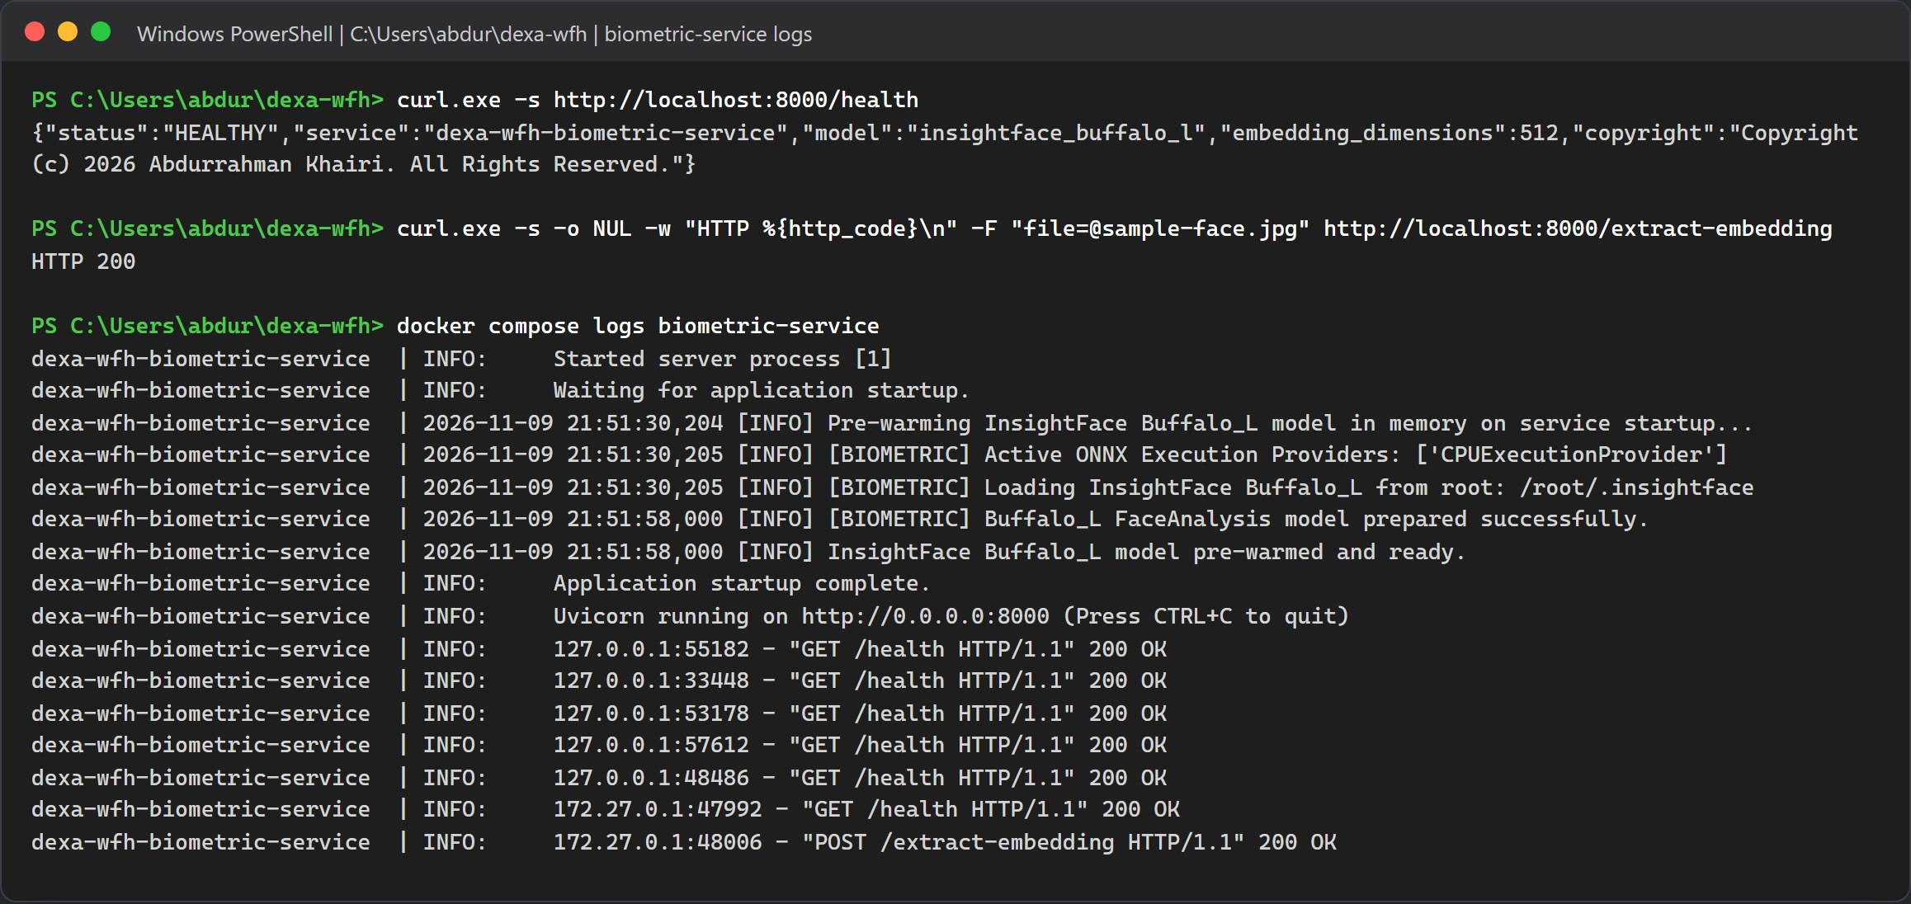
Figure 11.7: The health response, a successful embedding request, and the log lines showing the CPU provider, the model folder and Uvicorn on port 8000.
Note: If the model folder is missing
The container still reports healthy, but every face enrollment and clock in will fail. Check that models/buffalo_l exists in your home folder and run docker compose restart biometric-service.

Step 4: Database Tables and Seed Accounts
There is no migration or seed command to type. When the employee service starts, TypeORM creates all nine tables, and the seeder fills an empty database with five departments and six accounts.
The two manager accounts are only added on the next start of the employee service. Run this once after the first boot:
docker compose logs employee-service | findstr /i "seed provision already listening"
docker compose restart employee-service
docker compose logs --since 1m employee-service | findstr /i "provision already listening"

On macOS or Linux, use grep -iE in place of findstr /i. Then list the accounts straight from MySQL:
docker compose exec mysql mysql -udexa_user -pdexa_password_2026 dexa_wfh_db -e "SELECT u.email, u.role, u.is_verified, e.employee_code FROM users u LEFT JOIN employees e ON e.user_id = u.id ORDER BY u.role, u.email;"

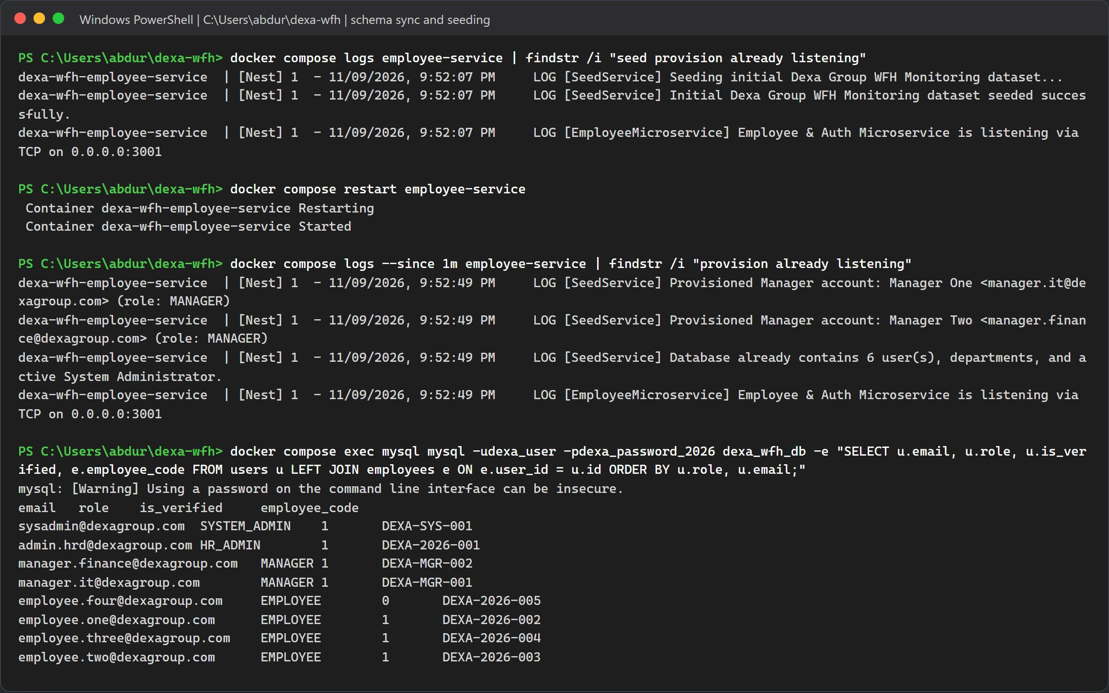
Figure 11.8: First boot seeds the dataset, the restart adds Manager One and Manager Two, and MySQL lists all eight accounts.
Warning: Skipping the restart
Without the restart, manager.it@dexagroup.com and manager.finance@dexagroup.com do not exist. Employee requests still email the managers, but nobody can sign in as a manager to approve them.

Method B, Manual Local Installation

Use this method when you want to change code and see it reload. MySQL still runs in Docker. The face engine, the three NestJS apps and the Vite dev server run directly on your computer. Each long running process gets its own terminal.
Note: Do not mix the two methods
If the Method A containers are still running, stop them first with docker compose down. Otherwise ports 3000, 3001, 3002, 5173 and 8000 are already taken.

Step 1: Start MySQL Only
docker compose down
docker compose up -d mysql
docker compose ps
docker compose exec mysql mysql -udexa_user -pdexa_password_2026 -e "SHOW DATABASES; SELECT VERSION();"

Name the service. A bare docker compose up -d would start the whole stack again. docker compose down without -v keeps the database volume, so the accounts seeded in section 11.4 are still there.
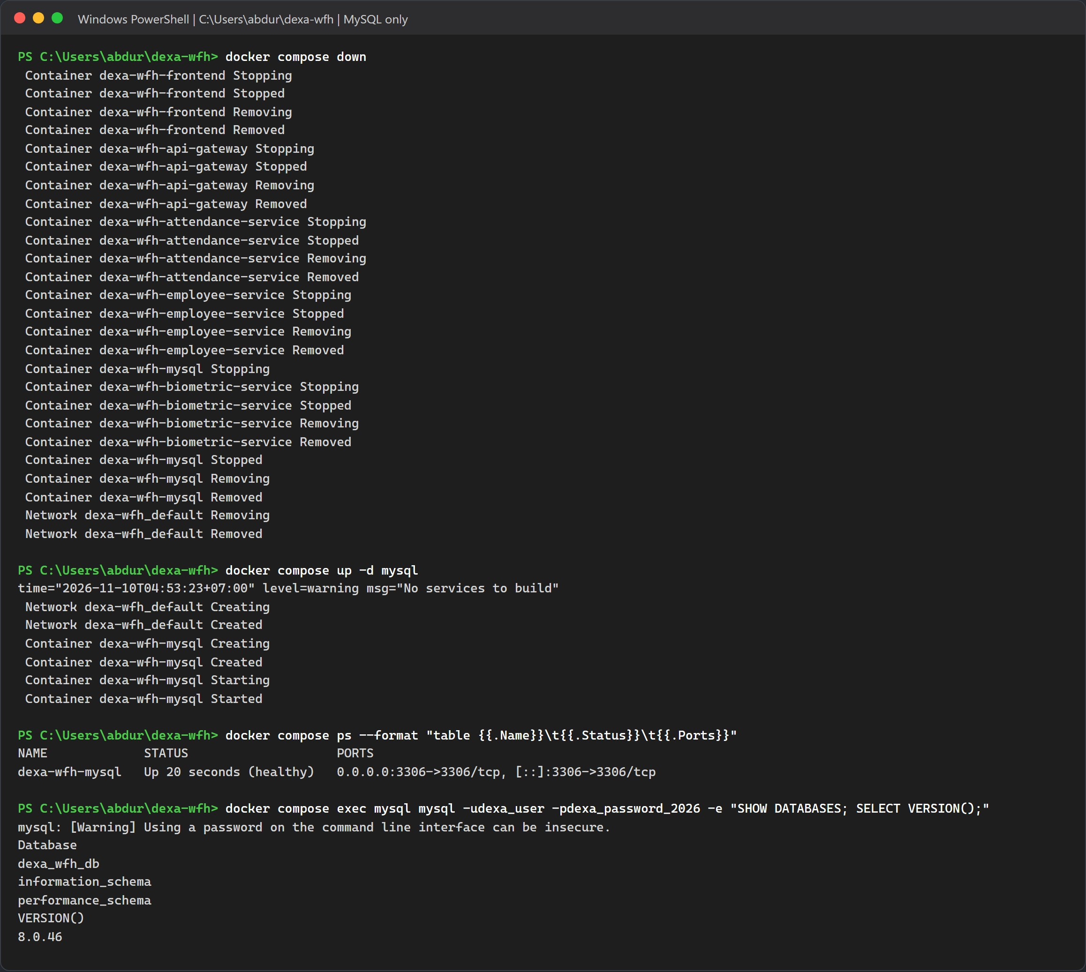
Figure 11.9: MySQL 8.0 healthy and the dexa_wfh_db database present.

Step 2: Python Environment and The Face Engine
In a new terminal:
cd biometric-service
python -m venv .venv
.\.venv\Scripts\Activate.ps1
pip install -r requirements.txt

On macOS or Linux, activate with source .venv/bin/activate. If PowerShell refuses to run the activation script, run Set-ExecutionPolicy -Scope CurrentUser RemoteSigned once.
On the test machine pip took a little under three minutes. It installed InsightFace 2.1, ONNX Runtime 1.23.2, NumPy 2.2.6 and OpenCV headless 5.0.0.93 as ready made wheels, so no C++ compiler was needed. The requirements file only sets minimum versions (>=), so pip picks the newest release on the day you install. Your versions may differ from these.
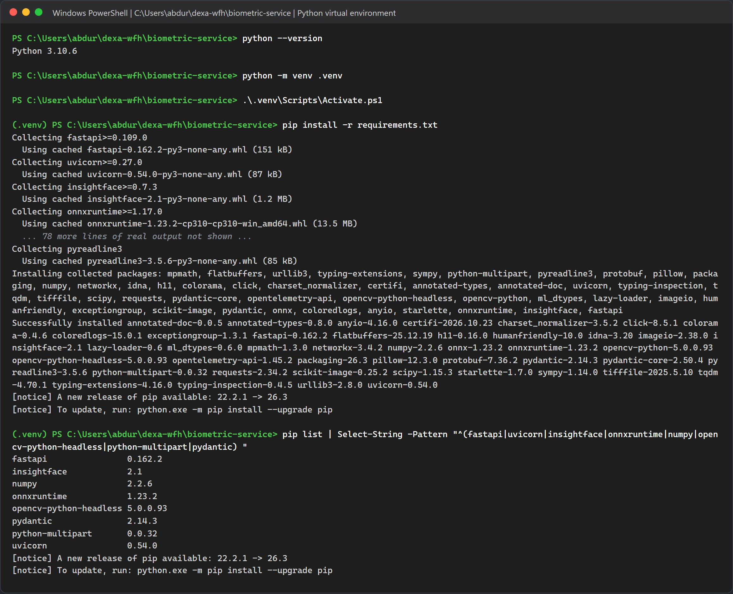
Figure 11.10: Creating the virtual environment, the start and end of pip install, and the key packages it installed.
Now start the engine:
uvicorn main:app --host 0.0.0.0 --port 8000 --reload

It reads the model from your own ~/.insightface folder. If buffalo_l is missing there, InsightFace downloads it the first time it loads. python main.py also works if you do not want auto reload.
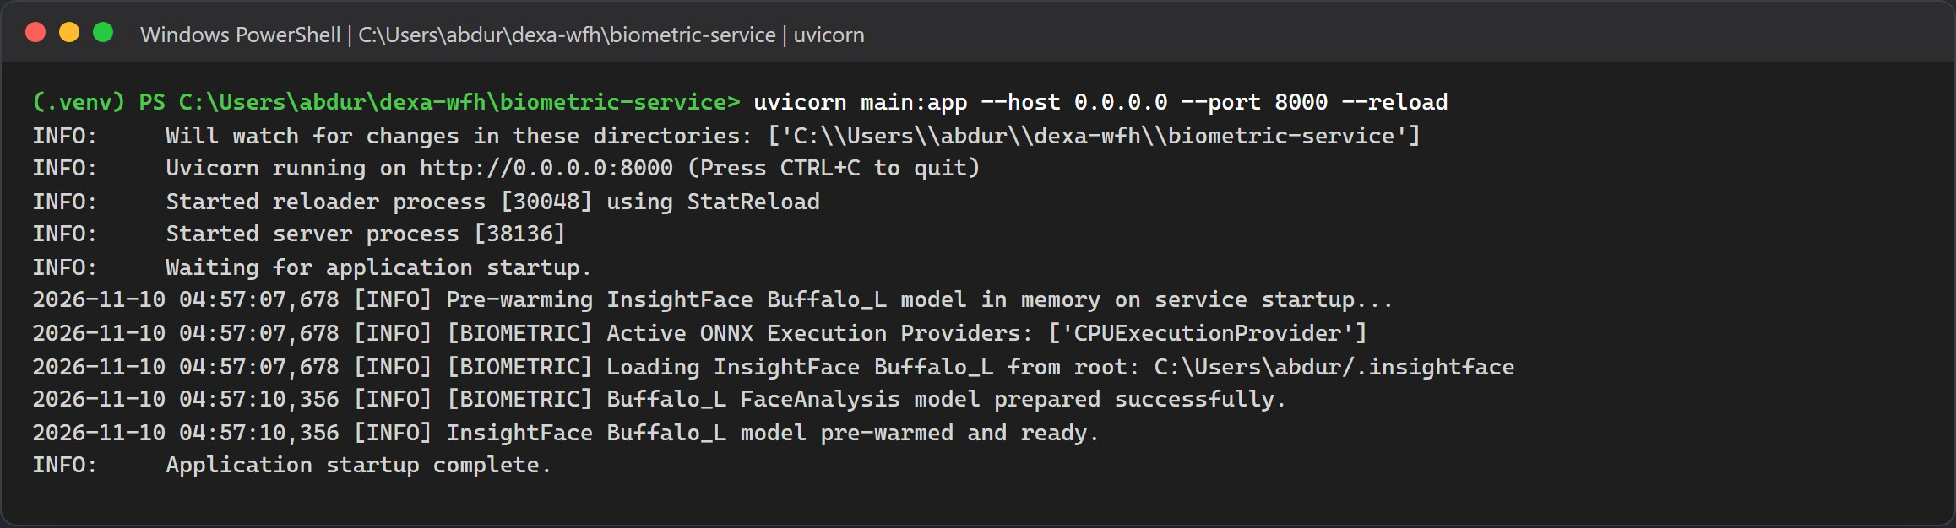
Figure 11.11: Uvicorn listening on port 8000, with the model loaded from the local .insightface folder in under three seconds.

Step 3: Install and Start the NestJS Backend
In another terminal:
cd backend
npm install
npm run start:dev

On the test machine npm install added 598 packages in 45 seconds. The deprecation and audit warnings come from third party packages and do not stop the install.
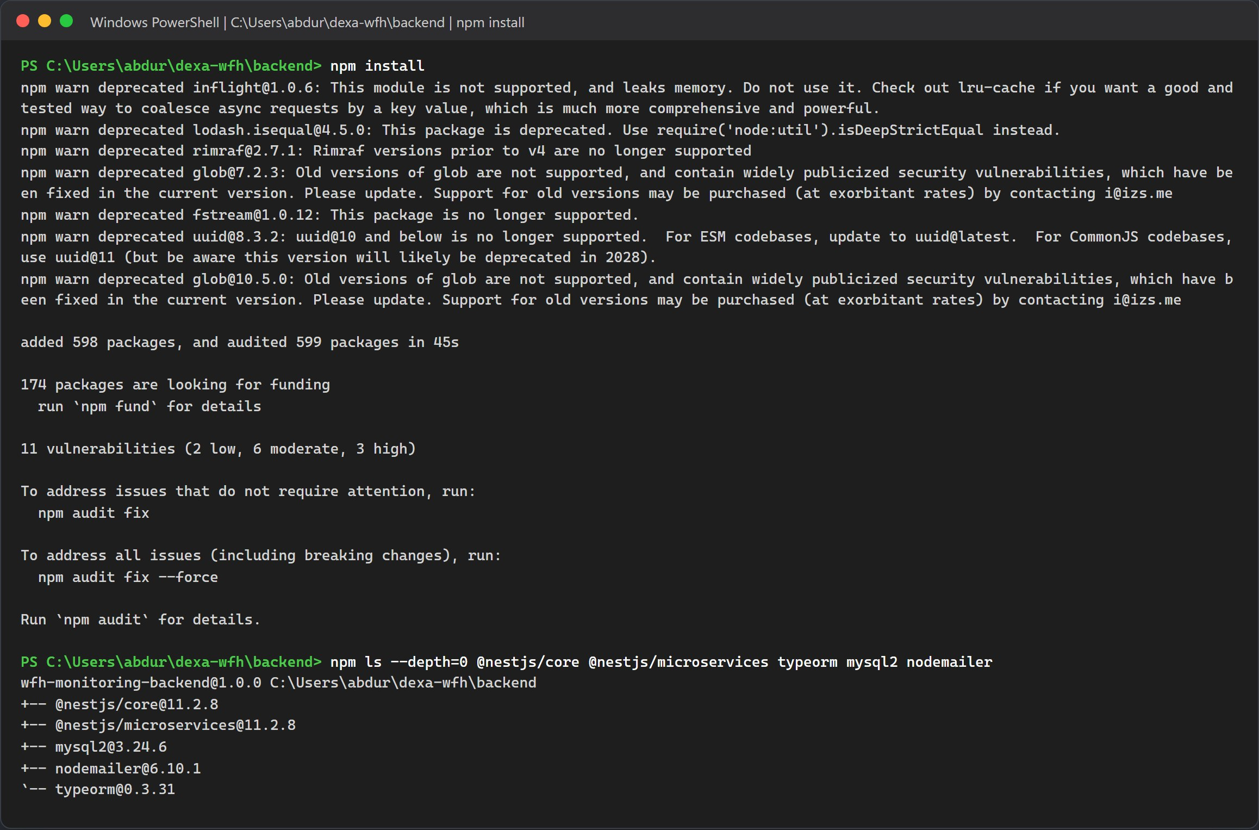
Figure 11.12: npm install finished in the backend folder, with the main NestJS, TypeORM, MySQL and mail packages confirmed.
npm run start:dev uses concurrently to run all three apps in watch mode. Each log line is tagged EMP, ATT or GW. There is no separate seed script here either. The employee service creates any missing tables and runs the seeder when it starts. On a fresh, empty database, start npm run start:employee first and let it finish before you start the other two.
In this mode the gateway saves uploaded photos to backend/uploads, because it uses the folder it was started from.
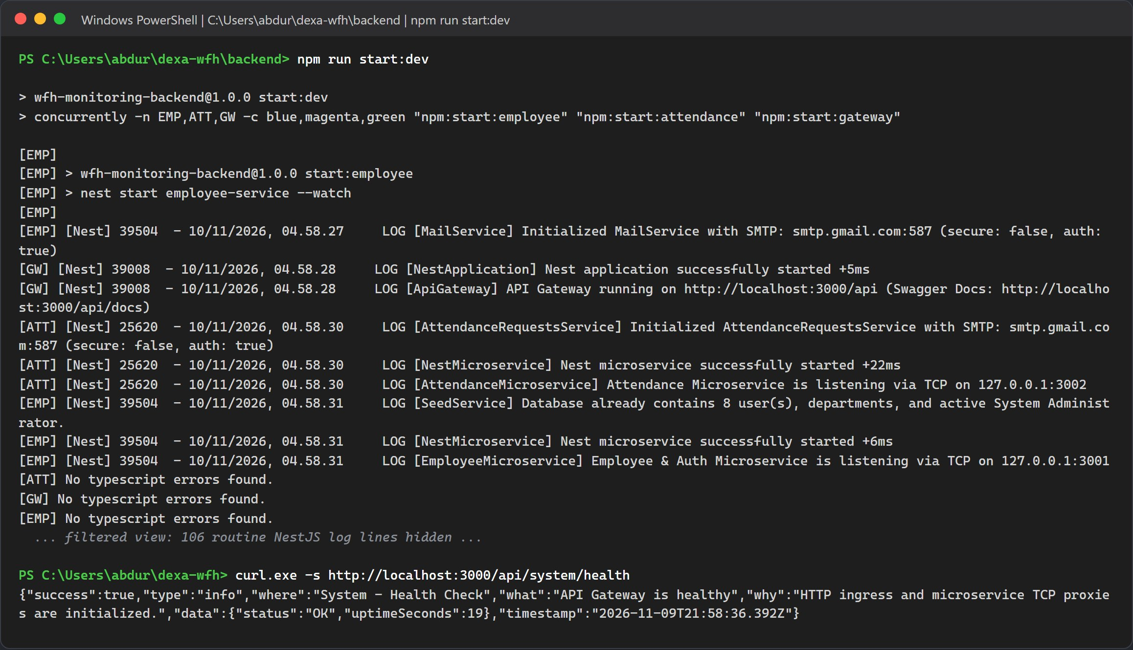
Figure 11.13: The employee service on TCP 3001, the attendance service on TCP 3002 and the gateway on HTTP 3000, followed by a health check. Routine route mapping lines are hidden.

Step 4: Install and Start the React Frontend
In a fourth terminal:
cd frontend
npm install
npm run dev

The dev server listens on port 5173 and forwards /api and /uploads to http://localhost:3000. You do not need a frontend .env for this.
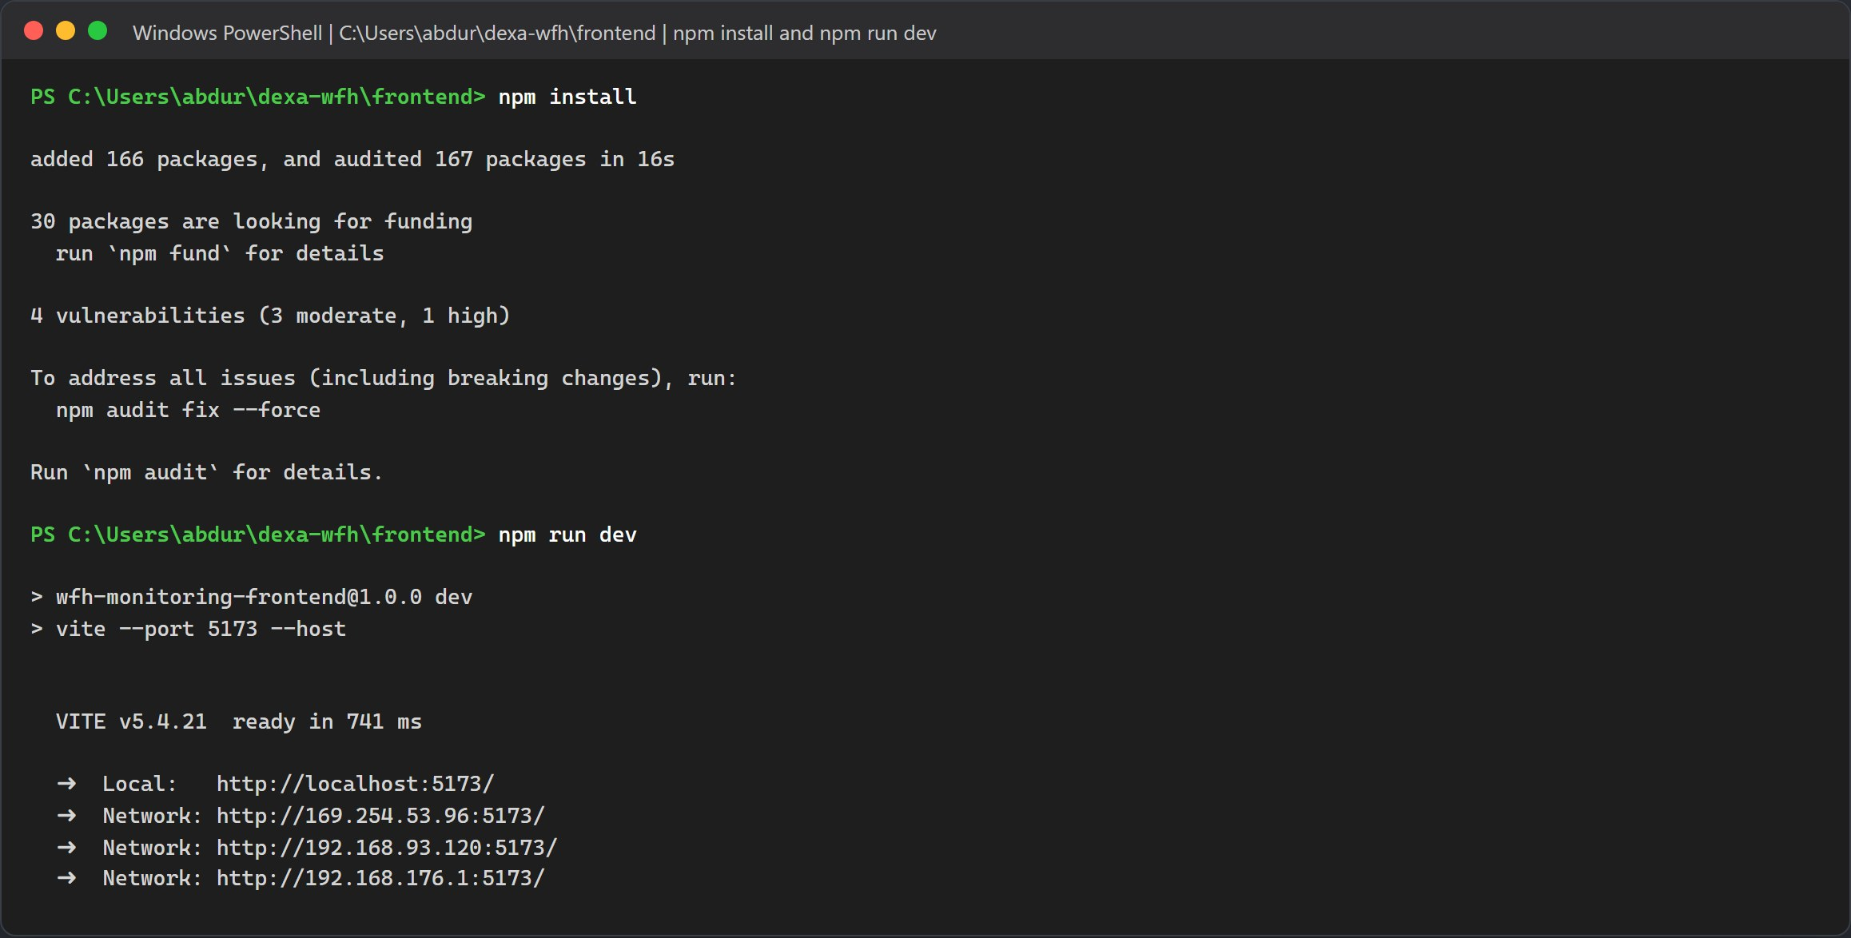
Figure 11.14: npm install added 166 packages, and Vite reported ready at http://localhost:5173.
Run the port check from section 11.2 again. All six ports should now be in use. In this method that means node on 3000, 3001, 3002 and 5173, python on 8000, and Docker on 3306.
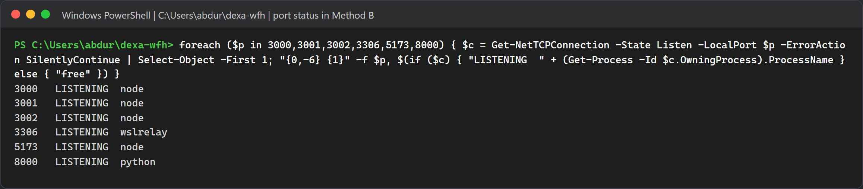
Figure 11.15: Every port in use, with the process behind each one.

Check the Installation in the Browser

The screenshots in this part were taken against the Docker stack from section 11.4. With Method B the same addresses give the same pages.

Step 1: Biometric Engine Swagger Page
Open http://localhost:8000/docs. You should see three endpoints: GET /health, POST /extract-embedding and POST /verify-face. The backend only calls the first two. It compares faces itself, in the attendance service, and accepts a match at a similarity of 0.45 or higher.
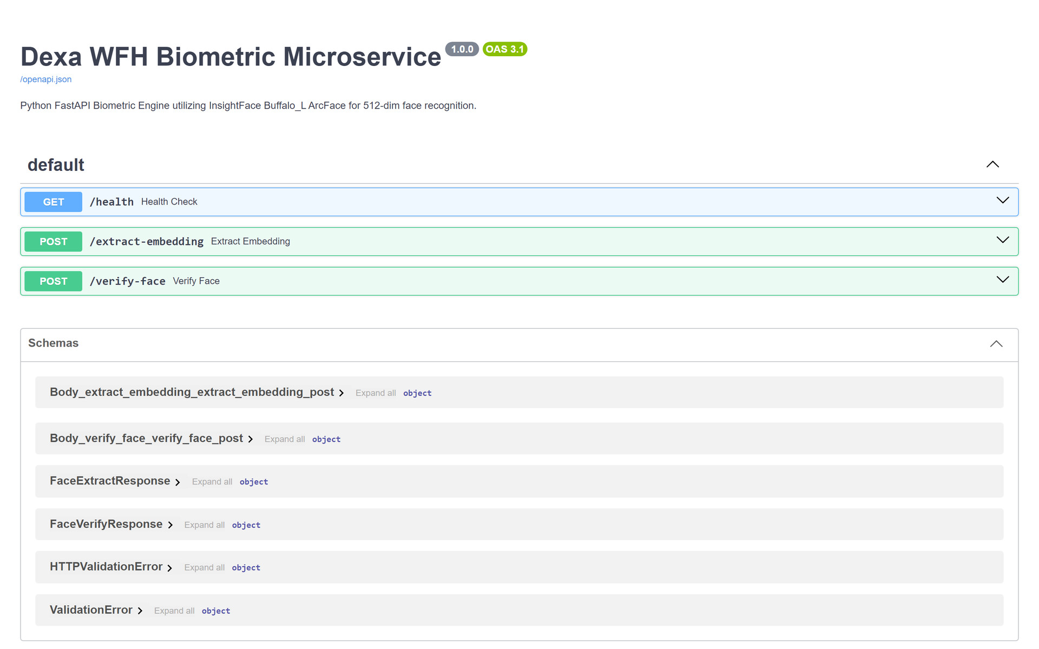
Figure 11.16: The FastAPI Swagger page of the biometric engine.

Step 1.5: One to One Face Check Against the Engine
This check talks to the face engine directly and writes nothing to the database. Put three photos in an empty folder: two of the same person and one of somebody else. The first call turns a photo into a 512 dimension ArcFace embedding. The next calls compare a new photo with that embedding by cosine similarity, which is the same check the attendance service runs at clock in and clock out.
curl.exe -s -F "file=@person_a_1.jpg" http://localhost:8000/extract-embedding -o ref.json
$ref = (Get-Content ref.json | ConvertFrom-Json).embedding
Set-Content -Encoding ascii emb.json (ConvertTo-Json -InputObject $ref -Compress)
curl.exe -s -F "file=@person_a_2.jpg" -F "reference_embedding=<emb.json" http://localhost:8000/verify-face
curl.exe -s -F "file=@person_b.jpg" -F "reference_embedding=<emb.json" http://localhost:8000/verify-face

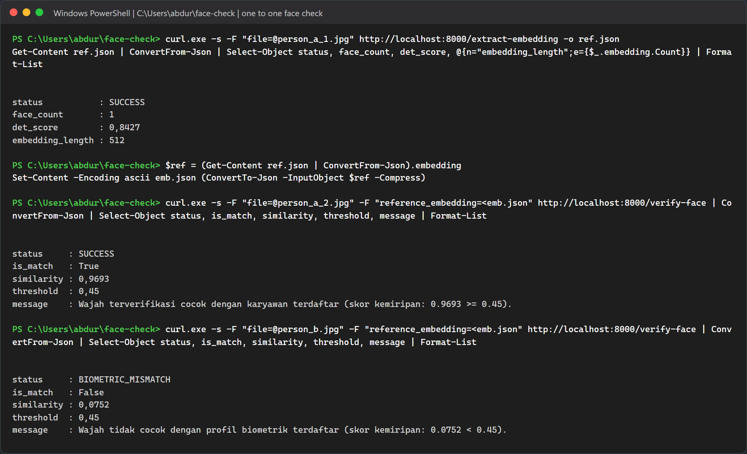
Figure 11.17: The same person scores 0.9693 and passes the 0.45 threshold. A different person scores 0.0752 and gets BIOMETRIC_MISMATCH. PowerShell prints decimals with a comma on this machine.
These are the numbers the system works with. The 0.55 value sometimes quoted for face matching is the detection threshold, not the match threshold:
Check | Value | Where it lives
Face detection confidence | 0.55, on a 320 x 320 detector input | det_thresh in biometric-service/service.py. A face below this score is not detected at all.
Clock in and clock out match (one to one) | similarity of 0.45 or more | attendance service, and the default threshold of POST /verify-face.
Duplicate check at enrollment (one to many) | below 0.50 unique; 0.50 up to 0.90 sibling tier; 0.90 or more identical | employee service, checked against every other active employee.
Live webcam photo time | within 5 minutes of server time | verifyPhotoTimestamp in libs/common attendance-rules.ts
Uploaded photo time | same WIB day, no older than 12 hours | same function. A photo outside the window is saved but marked as not verified.

Photo proof works like this. The portal draws every capture or upload onto an HTML5 canvas and burns in a watermark with the time, NIP, name, department and capture source, then sends that canvas JPEG. Because a canvas export carries no EXIF data, the gateway falls back to the capture time the browser sends in photoCapturedAt (for an upload, the file's last modified time). It only reads EXIF DateTimeOriginal, then CreateDate, then ModifyDate when an original JPEG reaches the API directly. The attendance service then marks the photo as verified or not verified with the rules in the table.

Step 2: API Gateway and The Microservice Links
Open http://localhost:3000/api/system/health. It returns a short JSON reply with "status":"OK".
Figure 11.18: The gateway health reply in the browser.
The health endpoint only proves that the gateway itself is up. It does not contact the microservices. To prove both TCP links work, call one endpoint that goes through each service:
- GET /api/system/policy reads the company policy through the attendance service on port 3002.
- POST /api/auth/login checks a password through the employee service on port 3001. HTTP 201 means the sign in worked.
curl.exe -s http://localhost:3000/api/system/policy
curl.exe -s -o NUL -w "HTTP %{http_code}" -X POST http://localhost:3000/api/auth/login -H "Content-Type: application/json" -d "{\"email\":\"sysadmin@dexagroup.com\",\"password\":\"AdminDexa2026!\"}"

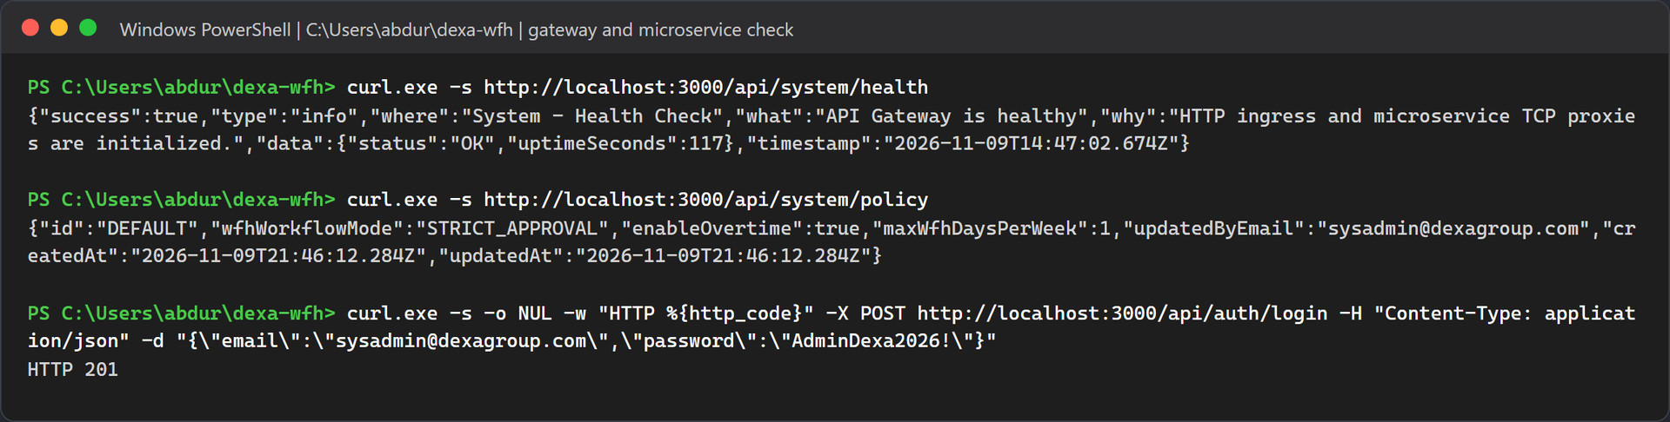
Figure 11.19: The policy comes back from the attendance service and the login succeeds through the employee service.

Step 3: Real Email Delivery
There is no local inbox to open. Every email goes through the SMTP account in .env, so open the mailbox you set in SMTP_OVERRIDE_RECIPIENT in Gmail or Outlook. Nothing arrives until the system sends something, so the next step sends a test email to prove the connection works. After that, one time codes, WFH notices, approval emails with their review links, and support tickets arrive in the same inbox, each with a yellow banner naming the demo account it was meant for.

Step 4: The Portal Sign In Page
Open http://localhost:5173. You land on the Dexa Group sign in page.
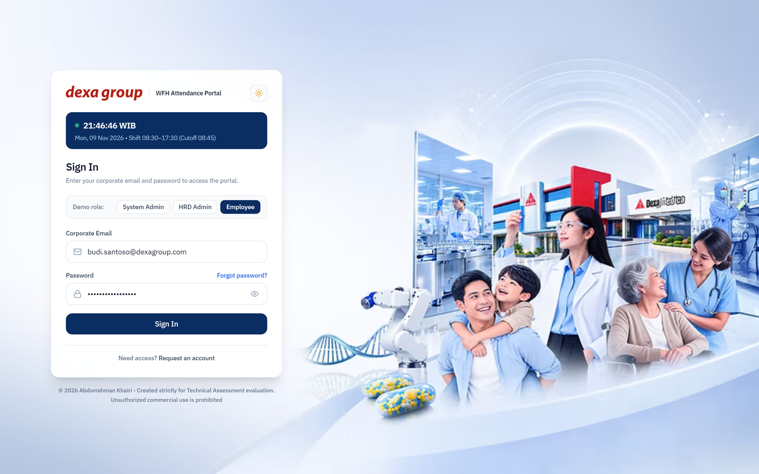
Figure 11.20: The WFH Attendance Portal sign in page.

Step 5: First sign in with a seeded account
These accounts come straight from the seeder in backend/apps/employee-service/src/seed/seed.service.ts:
Role | Full name | NIP | Department | Email | Password
SYSTEM_ADMIN | Abdurrahman Khairi | DEXA-SYS-001 | IT & Digital Innovation | sysadmin@dexagroup.com | AdminDexa2026!
HR_ADMIN | HR Admin One | DEXA-2026-001 | HRD & People Operations | admin.hrd@dexagroup.com | AdminDexa2026!
MANAGER | Manager One | DEXA-MGR-001 | IT & Digital Innovation | manager.it@dexagroup.com | ManagerDexa2026!
MANAGER | Manager Two | DEXA-MGR-002 | Finance & Accounting | manager.finance@dexagroup.com | ManagerDexa2026!
EMPLOYEE | Employee One | DEXA-2026-002 | IT & Digital Innovation | employee.one@dexagroup.com | EmployeeDexa2026!
EMPLOYEE | Employee Two | DEXA-2026-003 | Finance & Accounting | employee.two@dexagroup.com | EmployeeDexa2026!
EMPLOYEE | Employee Three | DEXA-2026-004 | Quality Assurance & R&D | employee.three@dexagroup.com | EmployeeDexa2026!
EMPLOYEE (not verified yet) | Employee Four | DEXA-2026-005 | IT & Digital Innovation | employee.four@dexagroup.com | set during verification

- The manager accounts only exist after the restart in section 11.4, Step 4.
- Employee Four signs in once, receives a fresh 6 digit code by email, and then chooses a password. The code is valid for 15 minutes. In Docker the code is not shown on screen, so the SMTP settings must work for this account.
- Every role except the System Admin is asked to register a face on the first sign in.
Sign in as the System Admin. No face step is needed for this account, and the portal opens straight on the Database Management page.
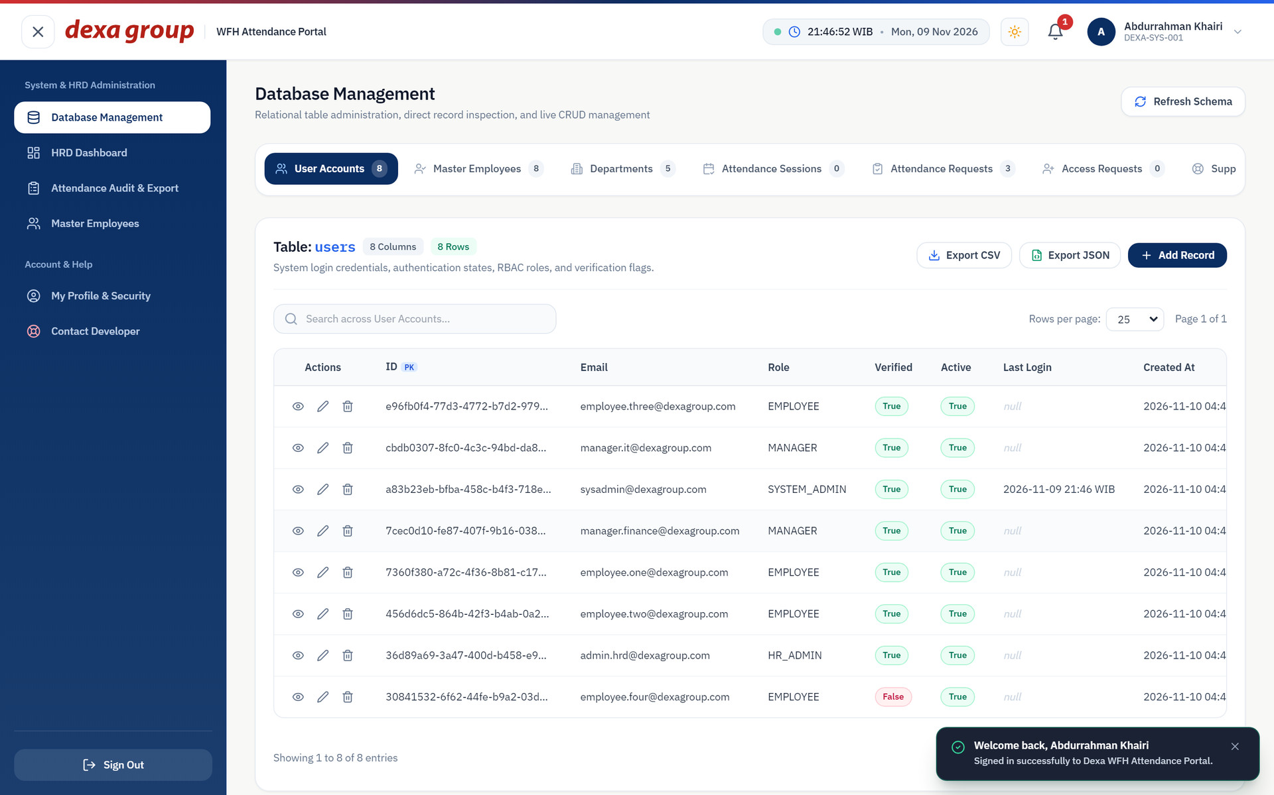
Figure 11.21: Signed in as the System Admin right after installation. The users table holds the eight seeded accounts.

Step 6: The Uploads Folder on Disk
Photos are stored in a tree: year, department, role folder, person, month. The role folder is manager for System Admins, HR Admins and managers, and employee for everyone else. File names carry a prefix, the person, the date and the time. The time in the file name is UTC, so it reads seven hours behind WIB.
To create the first file, the test run signed in as HR Admin One and registered a face. The gateway saved the enrollment photo straight away:
tree /F /A uploads

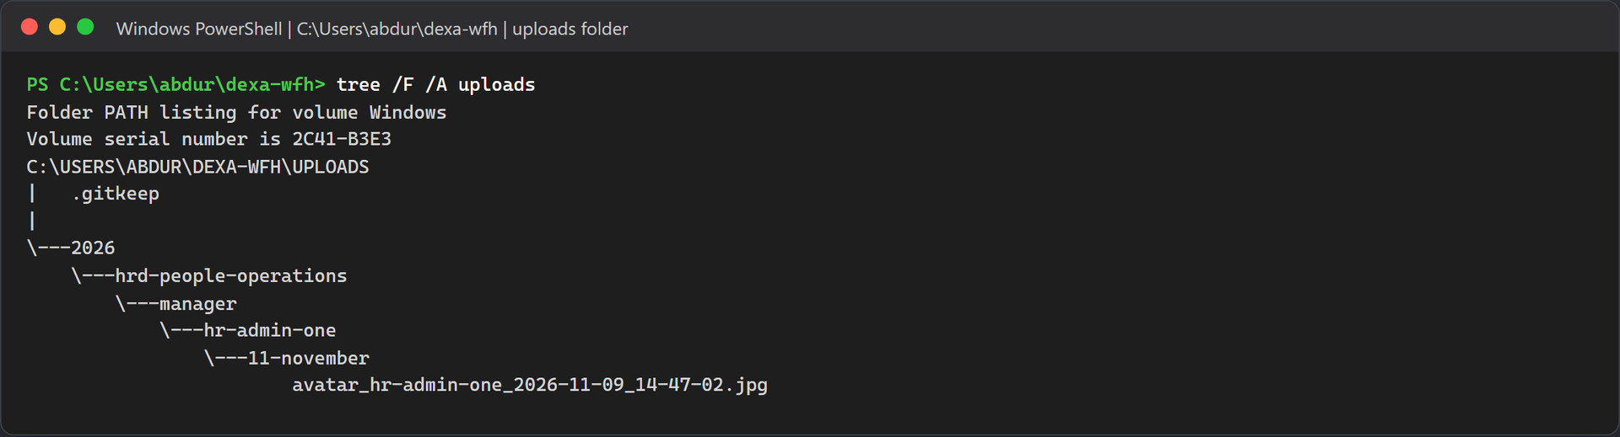
Figure 11.22: The uploads tree after the first face enrollment.
On macOS or Linux, use find uploads -type f. In Method B, look in backend/uploads instead.

Troubleshooting and Maintenance

The Camera Does Not Open
- Use http://localhost:5173. A LAN address such as http://192.168.x.x:5173 is not treated as secure, and the browser will block the camera there.
- In Chrome or Edge, click the site settings icon left of the address, set Camera to Allow, and reload. You can also open chrome://settings/content/camera or edge://settings/content/camera.
- On Windows, open Settings, then Privacy & security, then Camera, and allow access for desktop apps and the browser.
- Close Teams, Zoom or OBS if they are holding the camera.
- No camera at all? Use the photo upload option on the attendance page and give a reason. The upload is still accepted when its time is old, but it is marked as not verified unless it was taken on the same WIB day and no more than 12 hours ago. The face must still match your enrolled face.

The Face Model is Slow or Missing
- The model lives in %USERPROFILE%\.insightface\models\buffalo_l on Windows and ~/.insightface/models/buffalo_l on macOS and Linux. The zip is about 288 MB.
- If the download stalls, fetch https://github.com/deepinsight/insightface/releases/download/v0.7/buffalo_l.zip from another network or with a download manager, unpack it into that folder, and restart the engine.
- Docker mounts the folder as read only, so the container cannot download the model itself. Fix the folder on the host, then run docker compose restart biometric-service.
- The first load takes some time: about 28 seconds in Docker on the test machine. Give it a moment before the first face enrollment.

Duplicate Face Prevention and Sibling Exemption
This check needs a webcam and one real person. You enroll the same face on two accounts, watch the second attempt get refused, and then let HR allow it. Do it in this order:
- Enroll Employee One. Sign in as employee.one@dexagroup.com. The portal sends you to /auth/enroll-face. Capture your face and wait until the attendance page opens.
- Switch to Employee Four. Sign out and sign in as employee.four@dexagroup.com. This account is not activated yet, so it first asks for the 6 digit code sent by email (to your own inbox when SMTP_OVERRIDE_RECIPIENT is set) and a new password (see Step 5), and then opens the face page.
- Capture the same face. The system refuses the enrollment with HTTP 409 Conflict and shows this message, where X is the similarity score: Wajah sudah terdaftar! Wajah ini memiliki kemiripan biometrik X% dengan profil karyawan 'Employee One' (DEXA-2026-002). Jika Anda memiliki saudara kandung atau kembar di Dexa Group, hubungi HR Admin untuk mengaktifkan Sibling Biometric Exemption.
- Turn on the exemption. Sign in as admin.hrd@dexagroup.com, open Employee Management (/hrd/employees), edit Employee Four and switch Sibling Biometric Exemption on. The page calls PATCH /api/employees/:id/sibling-exemption, which only HR Admin and System Admin accounts may call.
- Enroll again. Sign in as employee.four@dexagroup.com and capture the face again. This time enrollment succeeds, and the employee service writes a SIBLING_EXEMPTION_APPLIED line to its log with the score and the name of the admin who approved it.
To see the result in the database:
docker compose exec mysql mysql -udexa_user -pdexa_password_2026 dexa_wfh_db -e "SELECT employee_code, full_name, is_sibling_exempt, face_embedding IS NOT NULL AS enrolled FROM employees WHERE email IN ('employee.one@dexagroup.com', 'employee.four@dexagroup.com');"

Note: A score of 90% or more is a different case
From 90% up, the message starts with "Wajah terdeteksi identik" instead, and the exemption does not help, because the system treats the capture as the same face registered twice. Whether two live captures of one person land below 90% depends on light, distance and pose. If you hit this block during the test, change the angle or the lighting a little and capture again.

Real Email Does Not Arrive
Start with the logs. On startup each service prints the SMTP host, port and whether it signs in, and every email ends in an [SMTP_SUCCESS] or [SMTP_ERROR] line:
docker compose logs employee-service | findstr /i "SMTP"
docker compose logs attendance-service | findstr /i "SMTP"

- Gmail error 535 5.7.8 "Username and Password not accepted". Gmail does not accept your normal Google password over SMTP. Turn on two step verification for the Google account, then open Google Account, Security, two step verification, and App passwords at the bottom of that page. Create an app password, paste the 16 characters into SMTP_PASS without the spaces, and run docker compose up -d.
- Gmail shows a different sender. Gmail rewrites the sender to the account in SMTP_USER unless the address is a verified alias. Set SMTP_FROM to your Gmail address.
- Outlook or Office 365 fails during STARTTLS. Keep SMTP_HOST=smtp.office365.com, SMTP_PORT=587 and SMTP_SECURE=false, so the connection starts in plain text and then upgrades with STARTTLS. With SMTP_SECURE=true on port 587 the handshake fails. For Microsoft hosts both services also force STARTTLS (requireTLS) and set the TLS cipher list to SSLv3. That is an OpenSSL cipher group kept for compatibility with Microsoft servers; it does not switch the connection to the old SSL 3.0 protocol.
- Outlook refuses a correct password. Microsoft has been turning off password sign in for SMTP on many accounts and tenants. This project signs in with a password only and has no OAuth2 support, so if your account or tenant has SMTP AUTH turned off, switch to Gmail with a 16 character App Password.
- Bounce notices after a support ticket. With SMTP_OVERRIDE_RECIPIENT set, the employee service changes the To address of a support ticket but keeps its CC list, which holds the HR Admin and sender addresses on @dexagroup.com. Real SMTP then reports those copies as undeliverable. The ticket itself still reaches your inbox.
- Nothing changed after you edited .env. docker compose restart keeps the old values. Run docker compose up -d so Docker recreates the containers with the new ones.

Face Enrollment Returns 409 Conflict
- "Wajah sudah terdaftar!" with a score from 50% to 89.9%. The new face looks like another active employee. If the two people really are siblings or twins, an HR Admin opens Employee Management, edits the employee who is enrolling and switches Sibling Biometric Exemption on. The employee then captures the face again.
- "Wajah terdeteksi identik" with 90% or more. The system treats this as one face on two accounts, and the exemption does not lift it. Only active employees take part in the comparison, so during testing you can deactivate the other account in Employee Management, or start again from an empty database with docker compose down -v.
- A 409 on an account that never enrolled before. Another active account already holds a similar face, often from an earlier test run. The SQL query in section 11.6, Step 2.5 shows which accounts have a face on file.
- The exemption switch is refused with 403. Only HR Admin and System Admin accounts may change it. Sign in with one of those roles.

A Port is Already Taken
# Windows
netstat -ano | findstr :3306
taskkill /PID <pid> /F

# macOS and Linux
lsof -i :3306
kill -9 <pid>

Local MySQL installs from XAMPP or Laragon often sit on 3306. You can stop them, or set DB_PORT=3307 in the root .env so Docker publishes MySQL on 3307. The containers keep talking to each other on 3306. The other host ports are fixed in docker-compose.yml. To move one, change the number on the left of its ports entry.

Useful reset and maintenance commands
Goal | Command
Stop everything and keep the data | docker compose stop
Remove the containers and keep the database | docker compose down
Wipe the database volume for a clean slate | docker compose down -v
Seed again from zero | docker compose down -v, then docker compose up -d, then docker compose restart employee-service once for the managers
Rebuild after code changes | docker compose up --build -d
Rebuild one service | docker compose up --build -d api-gateway
Follow the logs of one service | docker compose logs -f attendance-service
Open a MySQL shell | docker compose exec mysql mysql -udexa_user -pdexa_password_2026 dexa_wfh_db

Warning: Wiping the volume
docker compose down -v deletes every account change, attendance record, request and enrolled face for good. It does not delete the photos in uploads/. Remove those by hand if you want a truly clean start, and keep the .gitkeep file.

